Unit D: Energy and the Environment

Chapter 1: Dreams of limitless energy

Pages 468-521

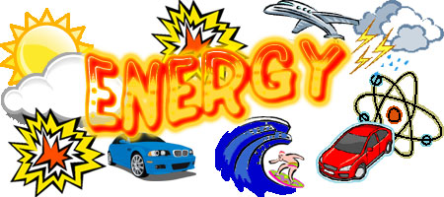

Name: ____________________________
Date: _____________________________
Introduction Activity!
Restaurants may have washrooms equipped with an electric hand dryer or paper towels for drying your hands. If you managed a restaurant and wanted to be conscious of energy use, which method of drying hands would you make available for employees and customers?
Complete the following table using check marks in either the “advantage” or “disadvantage” column.
Criteria | Electric Hand Dryer |  | Paper Towel
 | Advantage | Disadvantage | Advantage | Disadvantage
Ease of use
Willingness to use
Hygiene
Waste Produced
Environmental Impact
Total
Analysis:
1. Use the information in the following table to evaluate each method for drying hands based on cost. Based on this information, which method is preferred?
Description | Energy per Use (kJ) | Cost per 1000 uses
Non-recycled paper towel | 743 | $23
Recycled paper towel | 460 | $23
Standard electric dryer | 222 | $1.47
Low temperature, high wind dryer | 76 | $0.50

2. Identify which hand drying method you chose from your “advantage” and “disadvantage” chart on the previous page. Has your preferred choice changed now that you know the information from question 1?

3. Explain why paper towels use so much more energy that electric hand dryers.

4. In this situation, the environmental and economic perspectives are in agreement. The more environmentally friendly choice is also more economical. Give an example of an issue where the environmental and economic perspectives clash.

Energy on Demand

What is energy?

How do we get most of our energy?

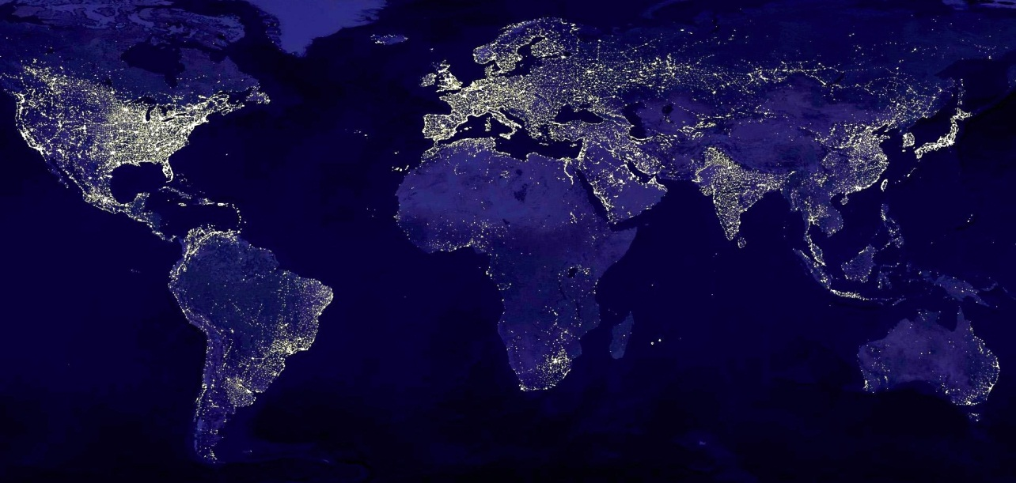

A composite of many satellite images show light from cities across Earth that is visible from space.

Some Terminology to know…

- ____________________________________: the ability to do work
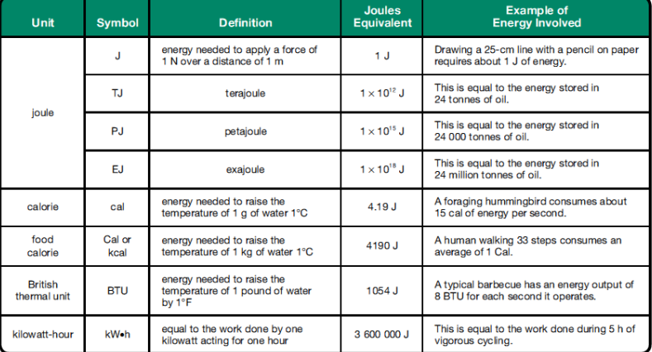

- ________________________________ – The amount per person (eg. Energy per capita = the amount of energy each person uses)

- __________________________________________ – total value of all goods and services produced by a country in a year

- _________________________________________ – how much energy is required per billions of dollars of GDP. (eg. Country with a high energy intensity would use a lot of energy to produce a little bit of goods and services)

  - Economies based on natural resources have a high energy intensity – a huge amount of energy is required to extract, refine and develop these resources. (Alberta has a very high energy intensity)

Factors Affecting energy use:
- ___________________________- Extreme climates tend to use more energy

- ___________________________ – refers to how much work is done (eg. How many cars are built, how many barrels of oil are extracted, how much money is invested etc.)

- __________________________ – the larger the population, the higher the energy use.

- _______________________________________ – as countries develop, they increase their use of natural resources. As standards of living increase, so does energy use.

- __________________________ – the more input energy that is transformed into useful output energy, the more efficient that device is.

  - High efficiency devices use less energy to do a job than do low efficiency devices.
    - Even the most efficient devices create some waste energy….

$$Efficiency=\frac{Useful output energy}{Useful input energy } x 100$$

Putting this all together…..

- USA has the world’s highest GDP, the world’s highest activity and the world’s largest total energy use

- HOWEVER….Canada actually has the higher per capita energy use than the USA…. SAY WHAT????!!!

Read through pages 470 – 479. As you read, make notes on each of the following sections and answer the questions.
- A Canadian Way of Life
  - Why is it that Canadians consume such a large quantity of energy?

  - Use figure D.1.2 on page 472 to answer the following questions:
    - Calculate the change in light-duty truck sales from 1990 to 1997.

    - Identify reasons used to justify the purchase of light-duty trucks and other larger vehicles.

    - Suggest reasons for the trend in light-duty truck sales shown after 1997.

- Gross Domestic Product (GDP)
  - Explain what a country’s GDP has to do with energy.

  - Explain how a country’s energy intensity relates to GDP. How is energy intensity determined?

  - Use the following table to calculate the energy intensities for each of the following countries.
Country | Energy use (EJ) | GDP (trillions of $US)
Kenya | 0.200 | 0.010
Sweden | 2.22 | 0.300
Canada | 13.80 | 0.753

  - Compare the energy intensities calculated in question 4. Do these values correspond with the tendency for countries with high-tech economies to have lower energy intensities?

  - Predict the change to Kenya’s energy intensity if farmers introduced techniques that increased crop productivity.

  - Suggest reasons why Canada – a developed country – has a high energy intensity.

- Calculate the energy efficiency of a water heater that uses 200J of energy to increase the thermal energy of water 55J.

- If an automobile engine is 20% efficient, calculate the useful output energy from 1kg of gasoline containing 44.5MJ of chemical potential energy.

- Improvements to energy efficiency from 1990 – 2003 were estimated to be 883PJ. If the estimated energy requirement of a small town is 47.9PJ, how many towns could be powered by this energy savings?

Summary Questions:
- Identify considerations, apart from energy use, that influence decisions about the purchase of products.

- Describe the trend of the world’s energy use from 1850 to the present.

- State an example of how a change in consumer preference led to an increase in the quantity of energy used by Canadians for transporting both people and products.

- The United States is Canada’s largest trading partner and shares many similarities in terms of lifestyle and culture.
  - Compare the total energy consumption of Canada to that of the United States.

  - Compare the per capita energy use of Canada to that of the United States.

  - Provide reasons for the differences between the per capita energy use of these two countries.
Use the following information to answer question 5. 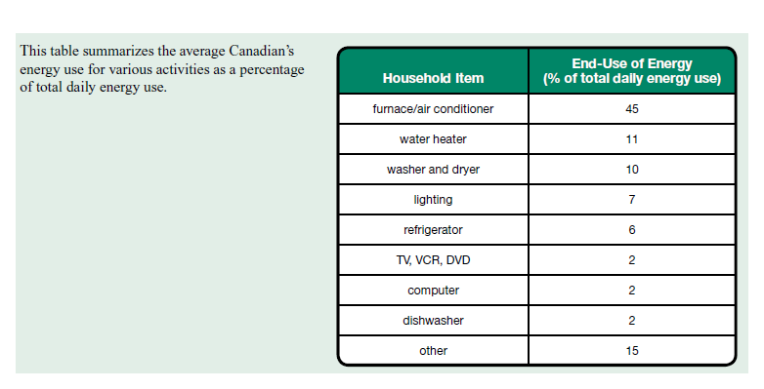

- For any four of the household items listed in the table, suggest one action that would reduce personal energy use.

Use the following information to answer questions 6 and 7. 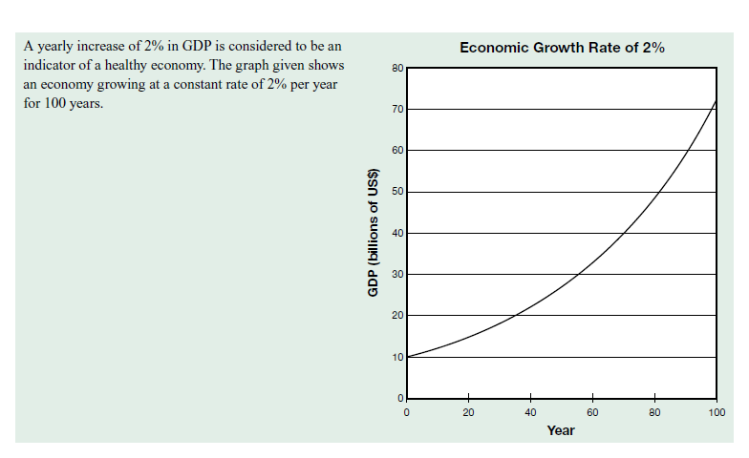
- Describe the pattern of change in GDP over the time shown on the graph.

- Discuss the implications that this type of economic growth would have in terms of total energy use.

Section 1.2 – Solar Fuel from the Past

- _______________________________________ – Energy stored in the bonds of chemicals
  - Different chemicals have different amounts of chemical potential energy.

    - Eg. Charcoal is more energy-rich than wood, but it is not used very often...why?
From Wood to Coal
- Benefits of wood:

- Benefits of charcoal:

- Coal
  - __________________________________ mineral found in Earth's crust
  - abundant supplies during Industrial Revolution made this the fuel of choice
  - Approximately ____________________________________ of electricity in Alberta is generated through the combustion of coal
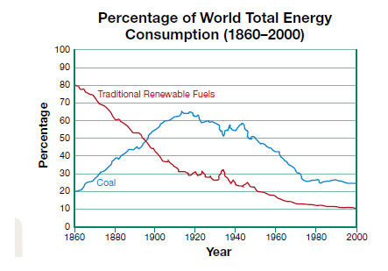

- Formation of coal
  - Begins in tropical, swampy areas with a lot of __________________ and _____________________________________
  - Thick layers of plant debris collect over years, forming _____________________.
  - Peat beings to decompose _________________________ (under low O₂ conditions)
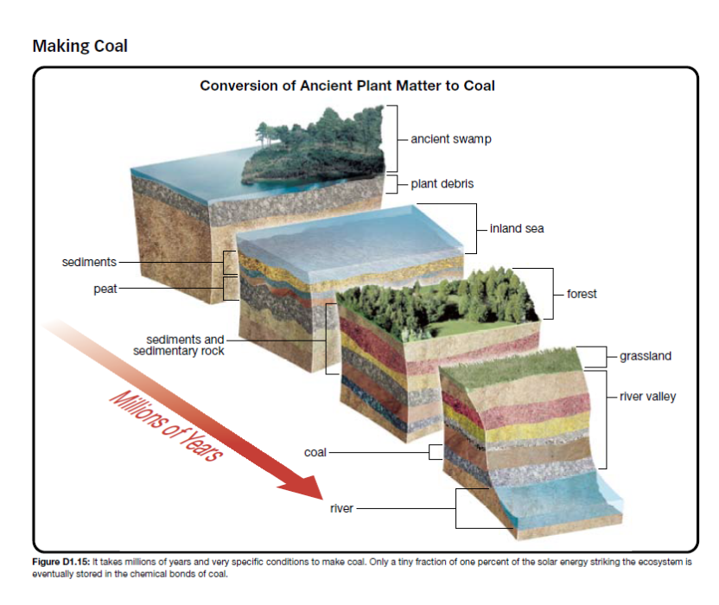
  - More layers cause the bottom layers to compress, beginning the millions of years transformation to coal.

- Mining of coal
  - ____________________________________ is most common
    - Layers of Earth above the cola deposit are stripped away, exposing a “river” of coal under the ground.
      - What are some pros and cons of this process?
______________________________________________________________________________________________________________________________________________________________________________________________________________________________________________________________________________
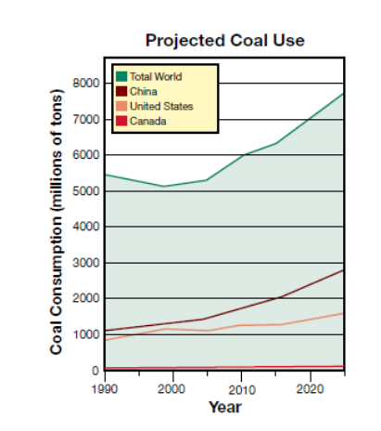

Use of coal around the world
= Increasing worldwide.
= Why???

______________________________________
______________________________________
______________________________________
______________________________________
______________________________________

Practice Questions: Page 483, #14-15 and Page 485, #16-17

Petroleum

- Petroleum (mixture of _____________________________________________)
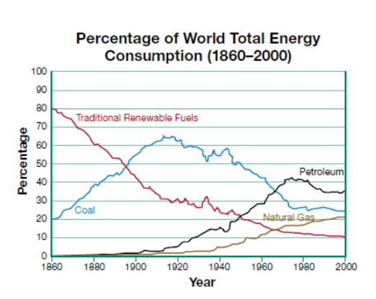
  - Petroleum is the top energy source worldwide

- Formation of Petroleum
  - Shallow tropical seas covered Alberta 360 million years ago, containing many ______________________________________
  - Photosynthetic plants trapped and stored solar energy
  - Over millions of years, the pressure from hundreds of meters of sediments covered the reefs
  - Under the right amount of __________________________ and ____________________________, the molecules containing the carbon from the organisms were converted into petroleum
  - As Earth’s tectonic plates move, the petroleum seeps from the rocks and forms larger pools.

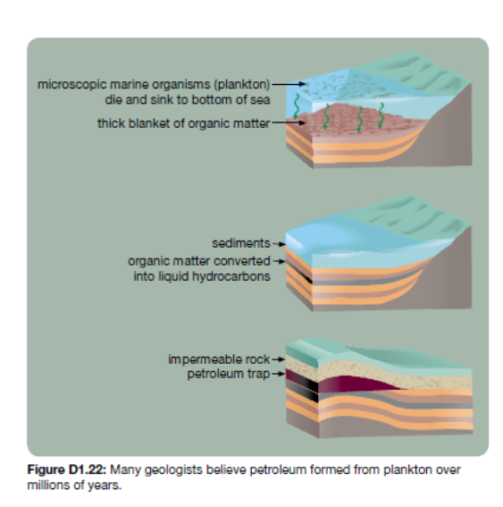

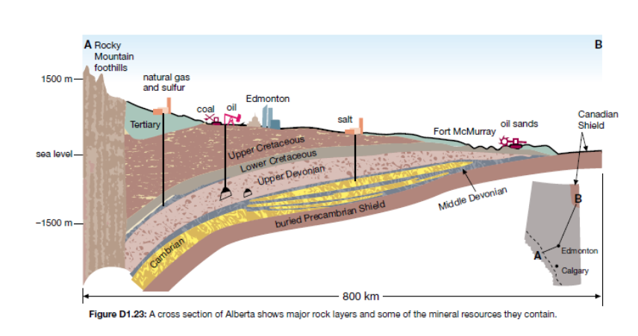
- Extracting petroleum
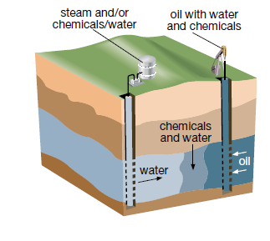
  - Often water, chemicals or gases are pumped into rock layers to force petroleum out of the reservoir.

- The Athabasca Oil Sands
= How do they differ from other petroleum traps?

= What issues are involved with extracting oil from the oil sands?

Practice Questions, Page 486, #18

- Natural gas
  - Mixture of hydrocarbons, mostly __________________ (but also smaller amounts of ___________________, _________________________ and ___________________________)
  - Formation is similar to petroleum but the key that determines the resulting material is temperature.
    - Natural gas forms under ________________________________________
  - Extracted by drilling underground then piped to buildings
  - Primary use is for heating

- Coalbed methane
  - Coal is a porous material that often has water trapped with the “holes”
  - The process that makes coal also produces methane and this methane dissolves in the trapped water
  - This water can be pumped out of the coal bed (as it is brought to the surface, methane vaporizes and separates from the water)
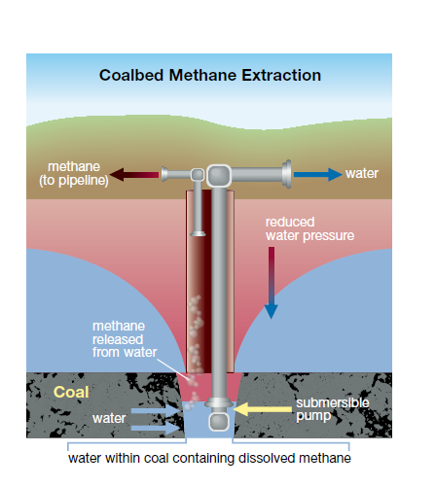

- Methane Hydrate
  - Methane trapped in ___________________
  - As the glaciers melt, what will happen to the methane in the environment?
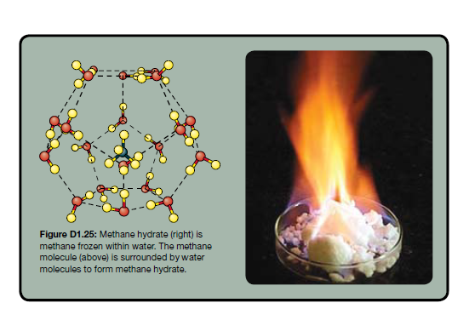

Wrap up information
- All of these fossil fuels are non-renewable
- Many scientists believe ________________________________ of the world’s supply has all ready been used…. And petroleum use is only increasing.
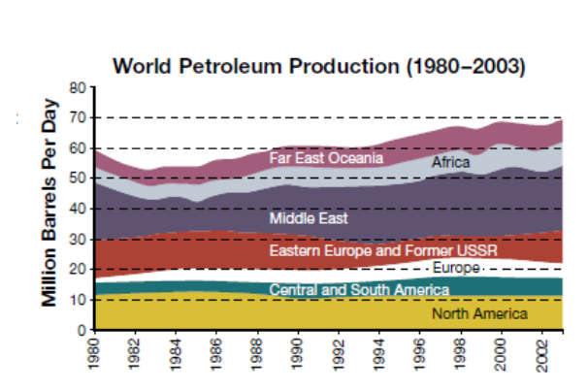
- Depending on whose research you read, the estimates vary on how long the petroleum will last...

Practice Problems, Page 490 # 1-10

Topic 1.3 – Harvesting Chemical Energy

Energy released in combustion reactions:
- Recall, hydrocarbon combustion requires ______________________________________ and produces _____________________________________________
- Combustion breaks chemical bonds in the fuel and forms new ones
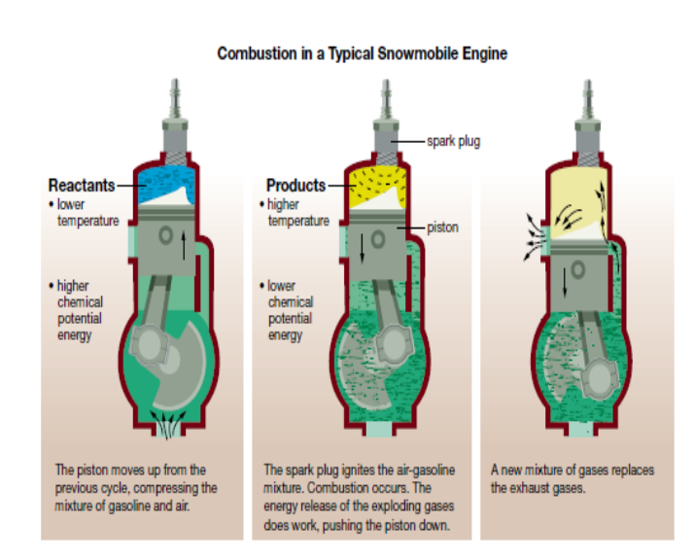

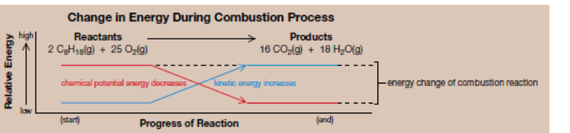
Questions from page 493

- What is the input and output energy associated with the operation of a snowmobile engine?

- Write a formula that could be used to determine the efficiency of the combustion of fuel in an engine.

- Heat of combustion
  - Recall, following combustion the products store LESS ____________________________________________ than did the reactants
  - The difference in the potential energies before and after the reaction ________________________________________________________________________
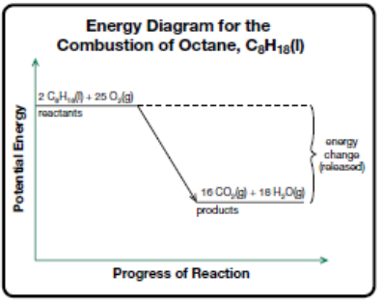

Hess’s Law
- _______________________________ represents heat of combustion (the amount of heat energy released during the combustion reaction)

- A compounds standard heat of formation (the energy required to form a compound) can be used to estimate its _______________________________________________
- Elements (when not combined in a compound) have a standard heat of formation of ___________________________.
- Using standard heat of formation of each compound allows for a comparison of the potential energy of the reactants and the products

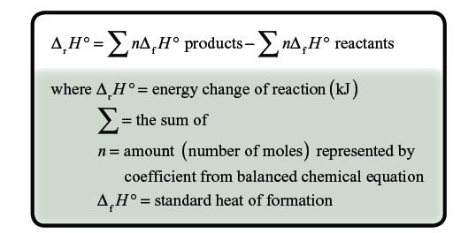

- We will be using page 5 of your data booklet A LOT today…. GET IT OUT!

Examples:
- Use standard heats of formation to calculate the energy change to create water.

- Use standard heats of formation to calculate the energy change for the combustion for methane.

- Calculate the heat of combustion for 1 mol of paraffin wax (C₂₅H_{52(s)}). Assume the heat of formation for paraffin wax is -1862.6 kJ/mol.
Now you try on your own….
- Balance the following combustion equations. Calculate the heat of combustion for each reaction
  - _____ C₂H₅OH_{(l)} + _____ O_{2(g)} ______CO_{2(g)} + ______ H₂O_{(g)}

  - _____ C₄H_{10(g)} + ______ O_{2(g)} ______CO_{2(g)} + _______ H₂O_{(g)}

  - _____ C₂H_{6(g)} + ______ O_{2(g)} ______CO_{2(g)} + _______ H₂O_{(g)}

Using pages 498-500, answer the following questions about thermodynamics.
- Laws of Thermodynamics
- First law –

- Second law –

- The laws are summarized as:
Input Energy = Useful Output + Waste Output

- Example:
- During a trip, a car uses 2.35x10⁷kJ of chemical potential energy. The car's engine is able to transform 4.73x10⁶kJ of that chemical potential energy into useful work.
a) Calculate the efficiency of the car

b) Use the first law of thermodynamics to determine the percentage of the car's input energy that is transformed into non-useful output energy. What are some of these forms of energy?

Practice Questions, Page 501, #1-10

Topic 1.4 – Harvesting Nuclear Energy

Page 502-521

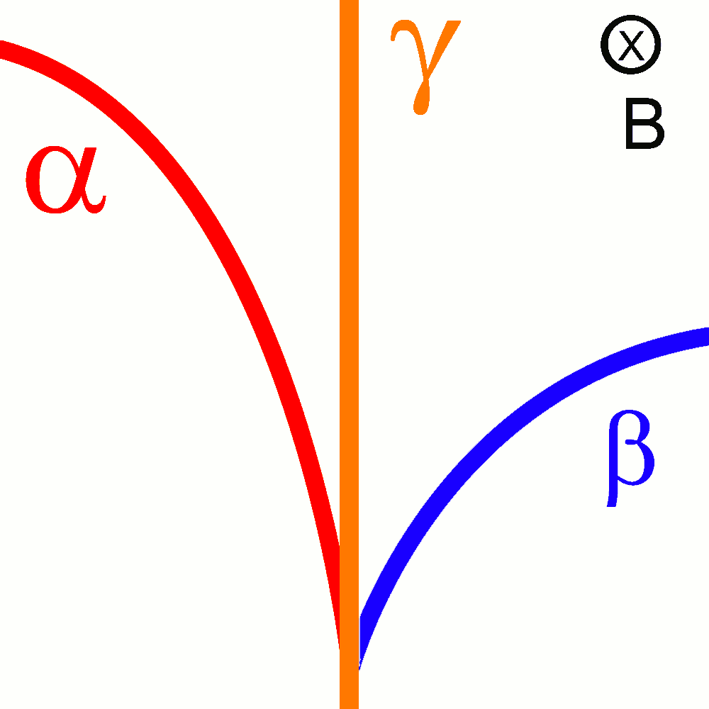

Name: ________________________________
Date: _________________________________

What do you remember?????

- Proton:

- Neutron:

- Atomic Number:

- Atomic Mass:

- Nucleons:

- Isotopes:

Nuclear Notation

- ______________________________ is a representation of an atom ${}_{Z}^{A}X$.

  - X = _______________________________
  - Z = _______________________________

  - A = ______________________________

Example:
Carbon-12 Carbon-14

Example of an atom:
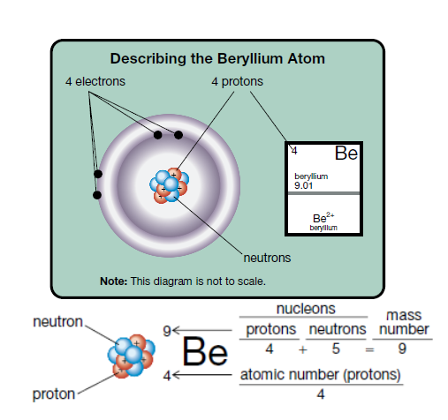

Radioactive Decay

- ______________________________: spontaneous change in which an unstable nucleus emits radiation.
  - How is a nucleus ever stable? Shouldn't protons repel one another?
    - In a stable nucleus, the _______________________ forces between the protons is balanced by an ________________________ force between the neighbouring protons and neutrons.
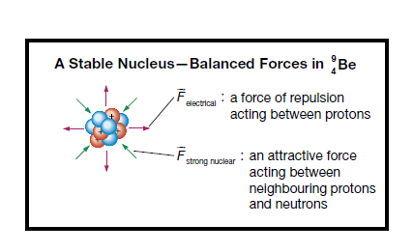
    - The attractive force between the nucleons is called a _________________________________________. Larger nuclei with a lot of protons need neutrons to increase the strong nuclear force.

  - Isotopes with fewer neutrons may be ______________________ and may undergo nuclear (radioactive) decay.
Alpha Decay

- ______________________________: a nuclei made of two protons and two neutrons, net charge of +2 (this is the same at the nucleus of a helium atom).

- ____________________________________: release of alpha particles during nuclear decay

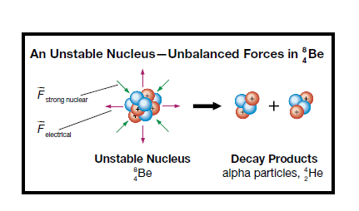
  - Example: Beryllium-8 is unstable. Beryllium-8 breaks apart into two alpha particles This element is unique in that it breaks into TWO alpha particles...usually only one product of the decay is an alpha particle.

Examples of Alpha Decay

- Many smoke detectors contain the isotope americium-241. Alpha particles emitted during the decay of americium-241 ionize molecules in the air, allowing an electric current to flow between two plates in the smoke detector. During a fire, smoke particles that come between these two plates interfere with the current, setting off the detectors alarm.
  - State the name of the process that produces alpha radiation.

  - Write the nuclear equation. Let ${}_{Z}^{A}X$ represent the unknown product.

- Write the equation for the alpha decay of polonium-210

- Write the equation for the alpha decay of uranium-232

- Write the equation for the alpha decay of thorium-232

- Write the equation for the alpha decay of radon-222

- Each of the following atoms is a product of an alpha decay reaction. Write a balanced nuclear equation for each.
  - Uranium-235

  - Plutonium-236

- Radium-226 is an unstable isotope that decays to radon-222.
  - Write a balanced nuclear equation for this process.

  - Identify the type of radiation produced by the decay of radium-226

Practice Problems:
Alpha Decay
Write alpha decay equations for these five nuclides.
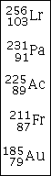
Here are five more to try:
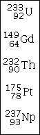
And here are five more:
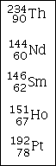

Beta Decay

- ________________________ is when a high-speed electron (charge of -1) is emitted from an unstable nucleus; the result of the change of a _______________ to a ________________ during a nuclear reaction.
- __________________________: stream of beta particles emitted from an _______________________________
  - Example: Beryllium-10 is unstable. During beta decay, one neutron is converted to a proton, resulting in the release of one electron.
    - This is represented by ${}_{-1}^{0}e$
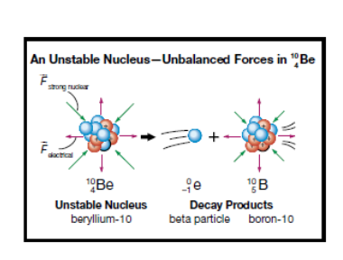
Examples of Beta Decay

- Carbon-14 is a radioactive isotope that emits beta radiation. Carbon-14 is found in the atmosphere and eventually finds its way into living systems. Once a plant or animal dies, the amount of carbon-14 remaining in the tissue can be used to estimate the number of years that have passed since the organism’s time of death. This is done by using the half-life of carbon-14. To get a clearer picture of human history, archaeologists use carbon-14 dating to estimate the age of ancient remains, like teeth or bone fragments. Use this information to write a balanced nuclear equation for the beta decay of carbon-14.

- Write equations for the beta decay of Thorium-234

- Write equations for the beta decay of Platinum-197

- Write equations for the beta decay of Krypton-87

- Write equations for the beta decay of silicon-32

- Gallium-71 is a product of beta decay. Use a balanced nuclear equation to determine the identity of the isotope that underwent nuclear change.

- Nickel-60 is a product of beta decay. Use a balanced nuclear equation to determine the identity of the isotope that underwent nuclear change.

Practice Problems
Beta Decay
Write out the full beta decay equation.
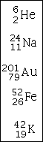
Here are five more to try:
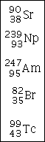
And here are five more:

Gamma Radiation

- Stream of gamma ______________________ (radiation) [recall, alpha and beta decay is a stream of ___________________________]

- Gamma is the most energetic type of EMR (very damaging if absorbed by living tissue)

- NO _________________, NO ___________________! (its just energy)

- Often emitted as an additional product of alpha and beta decay, but can be emitted on its own
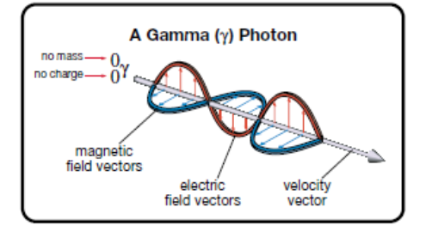

Examples:
- Cobalt-60 is a source of gamma radiation that is frequently used to treat patients with cancer. Machines used in modern cancer therapy can focus narrow beams of gamma radiation from over 200 cobalt-60 sources to destroy cancer cells deep within the patient.
  - Write a balanced nuclear equation to describe the emission of beta and gamma radiation from a cobalt-60 source.

- Antimony-126, a beta particle and a gamma photon are the three products of a nuclear reaction. Identify the isotope that undergoes a nuclear reaction to form these products.

- Polonium-218 emits an alpha particle and a gamma photon. Write the nuclear equation showing the decay of polonium-218.

Shielding Radiation

- Alpha, beta and gamma radiation are called __________________________________
- Each type of radiation is capable of penetrating certain materials. This means certain materials will _________________________ (block) some types of radiation, but not others
- How well a material shields radiation is determined by a ____________________________________ (it detects and measures radiation)
- How well a material shields radiation is important in making a decision about materials for transportation and storage of radioactive isotopes

Nuclear Fission

- Radiation emitted during alpha and beta decay produces radiation harmful to living things, but not enough energy to produce large amounts of useful energy
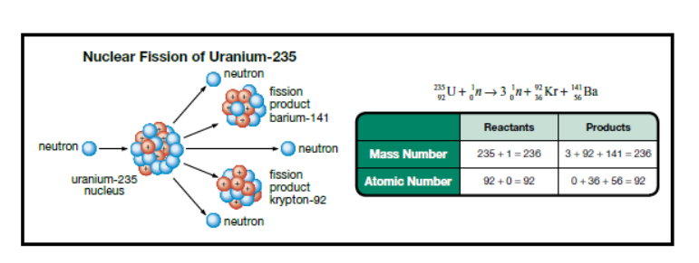
- Nuclear fission is the splitting of a large atom, releasing energy

- Large nucleus is struck by a _________________________, causing nucleus to split into two smaller nuclei (______________________________________).
Electricity Production - CANDU

- Fission reaction products have a lot of ______________________________. This energy causes water to boil, creating high-pressure steam.
- Steam causes turbines to spin, causing generators to spin, producing electricity
- Reactor uses ______________________________________________ (energy stored within the nucleus of atoms)

VIDEO – CANDU REACTOR
Questions to answer during video:
1. Compare coal-fired and nuclear power plants
Similar Components | Similar Processes | Unique processes
2. Identify two functions of heavy water in a CANDU nuclear reactor.

3. Explain “deference in Depth”

4. Justify the practices used to train nuclear-power operators, including a careful selection of experienced individuals and participation in intensive training programs.

Fission Practice

- The fission of uranium-235 can produce many different products. The following equations show one product of the fission of uranium-235. Use a balanced nuclear reaction to determine the unknown product ${}_{Z}^{A}X$ in each reaction.

  - ${}_{92}^{235}{U + {}_{0}^{1}{n → 3{}_{0}^{1}n + {}_{Z}^{A}X + {}_{53}^{ 137}I}}$

  - ${}_{92}^{235}{U + {}_{0}^{1}{n → 3{}_{0}^{1}n + {}_{Z}^{A}X + {}_{35}^{90}{Br}}}$

Controlling the Fission Reaction
- Energy released by a CANDU reactor is controlled by the mass of uranium-235 that undergoes fission

- Neutrons can be controlled by the use of ____________________________ (water made with heavier isotopes of hydrogen).
  - This _________________________________ acts to slow the neutrons before they strike the uranium
- If fission reactions are not controlled, huge amounts of energy can be released, resulting in a ___________________________________
- Nuclear bombs are also the result of _____________________________________ reaction
Mass-Energy Equivalence

E = mc²
- 7g of uranium (used in nuclear power plants) can release the same amount of energy as 556.5L of oil, 480 000L of natural gas or 807kg of coal.

- Albert Einstein's theory of ___________________________________ explains why this is. He predicted that mass could be converted into energy...
  - ∆E = ∆mc²

Examples:
- In the fission of 1mol of beryllium-8, the mass of the products is determined to be 2.29x10⁻⁵kg less than the mass of the reactants. Calculate the change in energy that corresponds with this change in mass.

- The fission of uranium-235 that occurs in a CANDU reactor involves the following reaction:
$${}_{92}^{235}{U + {}_{0}^{1}{n → 3{}_{0}^{1}n + {}_{56}^{141}{Ba} + {}_{36}^{92}{Kr}}}$$

Calculate the change in mass between the reactants and the products for this reaction and the corresponding energy change.

Practice:
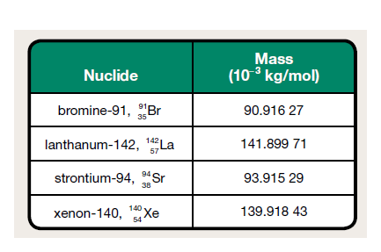
Calculate the change in mass and corresponding energy change per mole of uranium-235 in the nuclear reactions given. Use masses given in the data booklet and those provided in the following table.

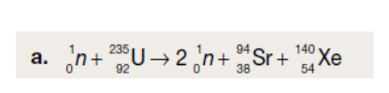

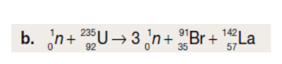

c. Calculate the change in mass that would correspond to a release of 2.0x10¹⁴J of energy.

Concerns with nuclear waste
- The products of nuclear fission may emit ionizing radiation for years

- The spent-fuel from nuclear reactors also contains some unreacted uranium-235
- Storage:
  - Initially stored ______________________________ (water absorbs thethermal energy and shields emitted radiation)
  - After a few years under water, transferred to above ground _____________________________________
  - Currently no long term storage in Canada - possible locations include deep under the __________________________________________
Nuclear Fusion

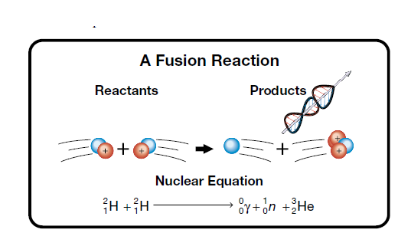
- Process where ______________________ are joined to form a __________________________ Energy is released during this process.

- Source of the ________________________________
Conditions required for fusion:
  - extremely high temperatures
  - high density of fuel ions
  - energy confinement
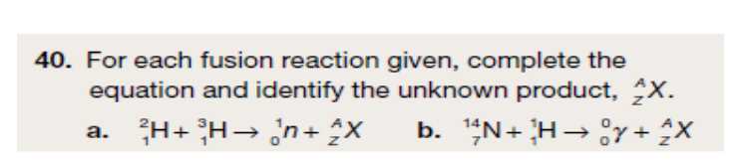

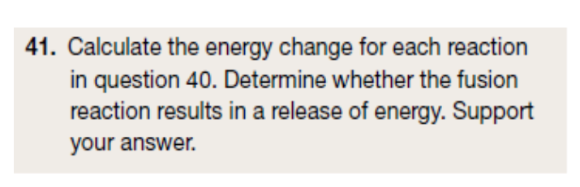

Heat of Combustion and
Name:
Nuclear Energy Review

- Determine the amount of energy released when the following fuels are combusted: Be sure to begin by writing out the equation showing the complete combustion of the fuel and balancing it!
  - Glucose

  - Octane

- For the isotope, ⁹²₃₆Kr, identify the
  - Atomic number

  - Charge

  - Mass number

  - Number of nucleons

- Define the following terms:
  - Radioactive decay

  - Nuclear fission

  - Nuclear fusion

- List the similarities and differences between a coal-fired power plant and a nuclear power plant.

- Describe how the fission reaction is controlled in a CANDU nuclear reactor.

- Identify and explain one risk and one benefit associated with the use of nuclear fission reactions for generating electricity.

- Complete each of the following nuclear reactions. Identify the unknown product and state the type of nuclear reaction shown.
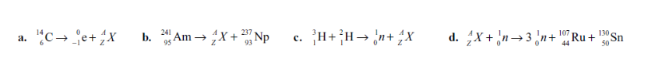

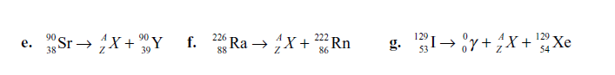

- Is nuclear energy from the fission of uranium a renewable or a non-renewable energy source? Provide a reason for your answer.

- A possible reaction for fusion power involves a fusion between helium-3 and deuterium nuclei. The products of the reaction are helium-4 and a proton.
  - Present the process as a balanced nuclear equation.
Chapter 2: Dreams of a Sustainable Future

Topic 2.1-2.1 Pages 524-556
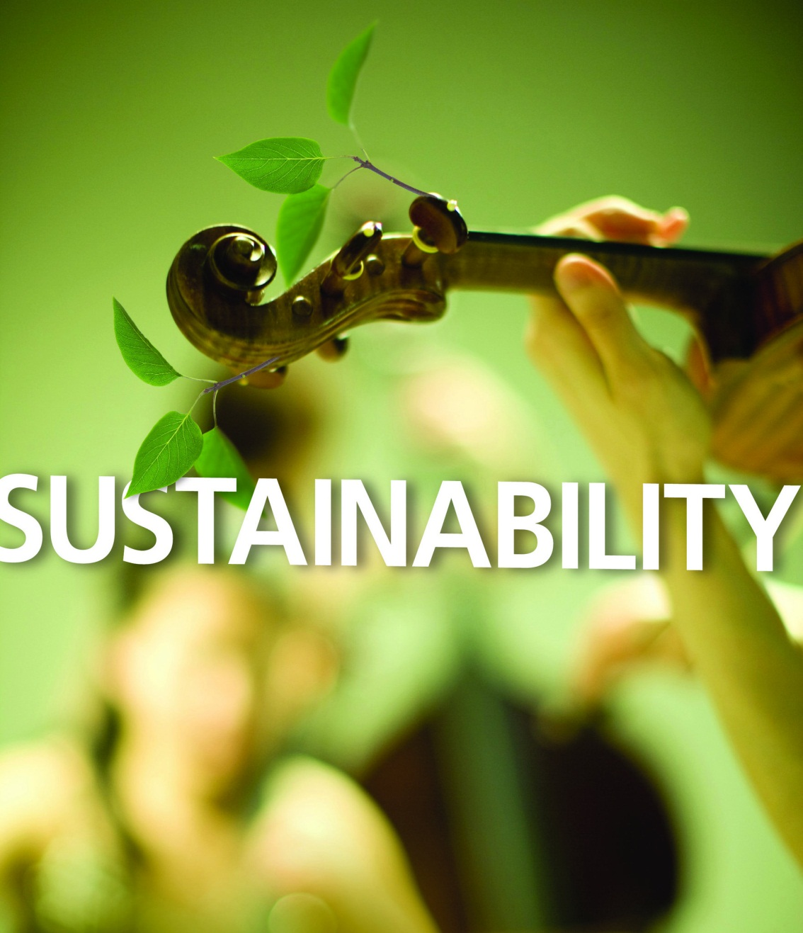

Name: _____________________________________________
Date: ______________________________________________

Okotoks – Moving Toward Sustainable Development

Purpose: You will watch a video to identify and analyze examples of sustainable development that have been utilized by the town of Okotoks, Alberta.
Analysis:
- Identify the natural resource that was chosen when the town of Okotoks established limits on its maximum size.

- Describe some of the strategies used to ensure the long-term sustainability of the resource identified in your answer to question 1.

- Identify the renewable-energy technologies used to meet the energy needs of municipal buildings in Okotoks.

- Describe how the design of municipal buildings has allowed for renewable-energy technologies to be used.
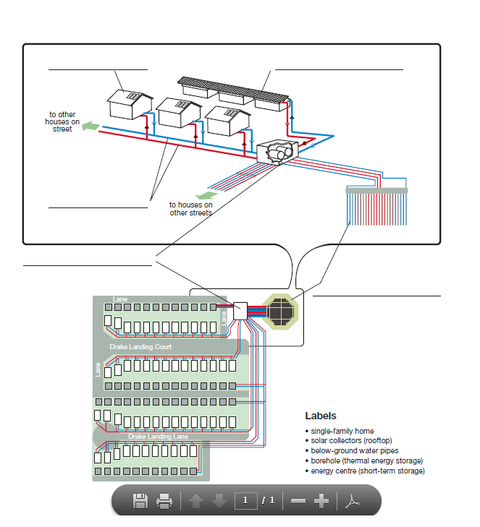
- Drake Landing Solar Community in Okotoks has taken a unique approach to utilizing the Sun’s energy. Match the following labels with the locations on the diagram of the energy capture and distribution system used at Drake Landing.

- Describe other features of the homes in Drake Landing Solar Community that enable them to reduce annual greenhouses emissions by 83%.

- Sustainable development involves consideration of other aspects of human activity in addition to energy. Communities like Drake Landing Solar Community can be rated in terms of how close they come to perfectly illustrating sustainable development. A score of10 out of 10 represents the ideal sustainable-development community, and a scare of 0 represents the complete opposite.
  - List the activities designed to reduce environmental impact in which the citizens of Okotoks participate.

  - Determine a score out of 10 for the Drake Landing Solar Community in terms of its ability to incorporate sustainable development. Justify your score.

  - Determine a score out of 10 for the community where you live in terms of its ability to incorporate sustainable development. Justify your score.

Sustainability

- An ecosystem that is capable of maintaining itself is called _______________________.
  - Baring disruption, as long as the Sun shines and matter continues to be cycled, an ecosystem will continue to exist.
- Because of our reliance on fossil fuels, out human settlements in industrialized countries are __________________________________
- We have seen that places like Okotoks, are balancing long term resources. We call this community an example of ______________________________________________
Types of Sustainability

- Ecological Sustainability (see the list on page 527)
  - Protection of __________________________________
  - Use of technology to maintain ___________________________, promote survival of _______________________________ and _________________________________________

- Societal sustainability (see the list on page 527)
  - All people can support themselves with a reasonable ___________________________ so that families have access to _____________________________.
  - Shows respect for the diversity of the cultural values within the community

- Economic sustainability (see the list on page 528)
  - Adequate employment opportunities for the population and opportunities for economic growth

Determining Sustainability of Technologies

Checklist Instructions

step 1: Write the name of the energy technology you will be evaluating.

step 2: Apply a weighting for each type of sustainability—ecological, societal, and economic—based on its relative importance. Record these values in the first column of the checklist. Note: The weightings for all three categories should add up to 100.

step 3: Read the focus question and specific indicators for each type of sustainability in the second column of the checklist. Score the energy technology against each specific indicator listed as follows:

- Statements deemed true receive a score of 2.
- Statements deemed false receive a score of 0.
- Statements deemed uncertain (neither completely true nor false) receive a score of 1.

Record these scores in the third column of the checklist.

step 4: Add the scores of the specific indicators to obtain a total score, and record it in the appropriate space in the checklist.

step 5: Calculate the percentage for each type of sustainability using the formula given in the checklist. Record this value in the appropriate place.

step 6: Calculate a weighted score for each type of sustainability by multiplying the percentage score calculated in step 5 by the weighting for the type of sustainability determined in step 2.

step 7: Calculate the overall score of the technology using the formula given in the checklist. Record this value in the appropriate place.

step 8: Review the values calculated in steps 4, 5, and 7, and write a brief summary of your assessment. Include reasons for the scores provided against difficult criteria and for your overall assessment of the sustainability of this energy technology.

step 9: Compare your results with those of other students. Account for any similarities and differences.
Determining Sustainability of Technologies

Checklist

TECHNOLOGY: NUCLEAR FISSION
Type of Sustainability | Criteria | Score
Ecological Sustainability  Weighting = ____ | Focus Question: Does the use of the technology protect resources (e.g., water, land, air, and biodiversity)?  Specific Indicators: This technology… | True = 2  Uncertain = 1  False = 0
 | …is based on a renewable energy resource
 | …maintains the quantity of surface water
 | …maintains the quality of surface water
 | …does not contribute to acid deposition
 | …does not contribute to the presence of persistent organic pollutants in water, soil, or air
 | …does not contribute to the presence of heavy metals in water, soil, or air
 | …recycles liquid and/or solid waste products
 | …does not contribute to deforestation or habitat destruction
 | …does not contribute to greenhouse gas emissions
 | …does not contribute to emissions of ozone-depleting materials
 | …does not contribute to emissions of particulate matter
 | …does not contribute to photochemical smog
 | …does not threaten the survival of species at risk
 | …does not contribute to the destruction of fragile ecosystems
 | …does not contribute to the release of ionizing radiation
 | …does not contribute to the mass of radioactive waste produced
 | Total Ecological Indicators
 | Percentage (total indicators ÷ 32 × 100%)
 | Weighted Score (percentage × weighting)

Societal  Sustainability  Weighting = ___ | Focus Question: Does the use of the technology promote improved human health, education and opportunities for training, standard of living, and respect for diversity of cultural values within society?  Specific Indicators: This technology… | True = 2  Uncertain = 1  False = 0
 | …does not decrease life expectancy through exposure to pollution
 | …stimulates a healthy economy, enabling adequate health care
 | …requires a highly trained workforce
 | …requires the workforce to adapt to change through continuous training
 | …reduces excessive land use (e.g., urban sprawl)
 | …encourages per capita energy consumption to be reduced
 | …stimulates a healthy economy, enabling affordable housing
 | …requires co-operation of diverse cultural groups in decision making
 | Total Societal Sustainability
 | Percentage (total indicators ÷ 16 × 100%)
 | Weighted Score (percentage × weighting)
Economic  Sustainability  Weighting = ___ | Focus Question: Does the use of the technology result in greater opportunities for employment, economic growth, increased GDP, and optimum locations and scheduling for production?  Specific Indicators: This technology… | True = 2  Uncertain = 1  False = 0
 | …supports full-time employment for the population
 | …enables a higher proportion of the workforce to be paid reasonable wages
 | …has a relatively low cost per megajoule (MJ)
 | …enables development of other industry or opportunity
 | …reduces the import of energy, contributing positively to the GDP
 | …enables the export of energy, contributing positively to the GDP
 | …can be used in a variety of locations that are well-suited to industry
 | …allows for continuous, around-the-clock production
 | …does not decrease the availability of natural resources
 | Total Economic Sustainability
 | Percentage (total indicators ÷ 18 × 100%)
 | Weighted Score (percentage × weighting)
Overall Score for Technology (Ecological + Societal + Economic)

Overall Assessment of the Sustainability for this Energy Technology

Alternative Sources of Energy

Part A: Geothermal Energy (Pages 530-532)
- Explain the source of geothermal energy.

- What are some uses for the energy released from geothermal energy?

- What are some drawbacks to using geothermal energy?

- What are some positives to using geothermal energy?

Part B: Tidal Energy (Pages 532-535)
- Explain what causes tides.

- Explain (not just define) what creates tidal energy.

- Explain how tidal energy is used to generate electricity.

- What are some drawbacks to using tidal energy?

- What are some positives to using geothermal energy?

Topic 2.2-The many forms of Solar Energy

Part A – Passive Solar Energy (Page 536-537)
- Using an example, explain what passive solar energy is.

- Using a diagram, explain how passive solar energy can be used in a home.

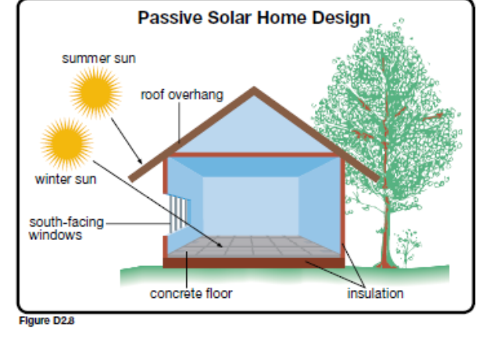

Part B – Active Solar Energy (Page537-538)
- Using a diagram, explain how active solar heating is used in a home.

- Describe the design of a solar heat collector.

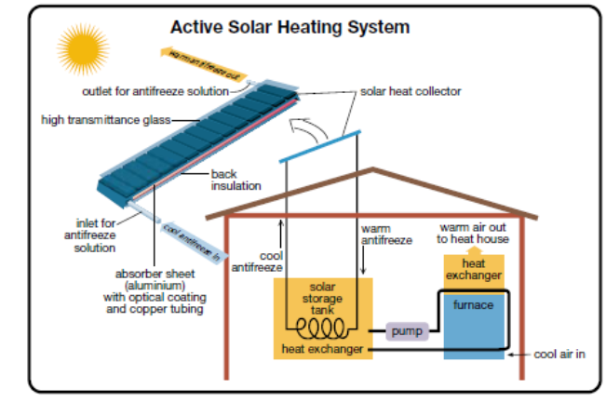

Part C – Earth Energy Systems (Page 538)
- Explain why the ground is considered to be a “single giant solar heat collector.”

- Using a diagram, explain how Earth energy systems can be used to heat a home.

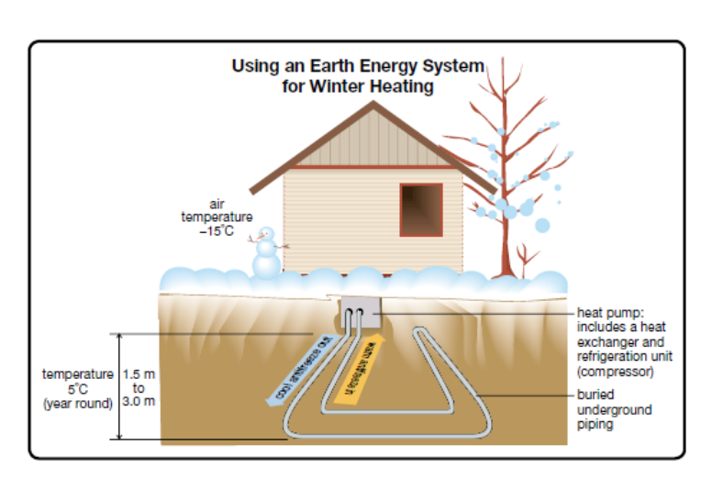

Part D – Photovoltaic Cells (Page 540)
- Describe how a photovoltaic cell functions.

- Photovoltaic cells produce no emissions, yet they are not used very commonly. Provide some reasons why.

- Give some examples of uses for photovoltaic cells.

Analysis (Page 539)
- Explain how passive solar heating and other solar-energy systems involve the use of a renewable energy source.

- Explain how Earth energy systems are a technology based on a renewable energy source.

Use the following graph to answer questions 3 and 4
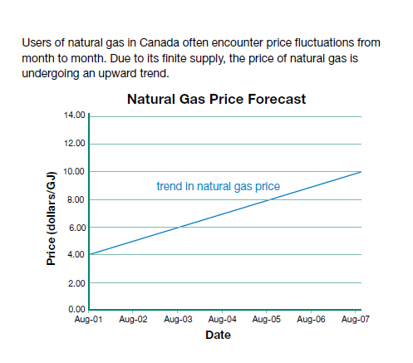
- State two reasons why natural gas prices fluctuate.

- Many consumers are concerned about increasing heating costs. Do you think that the cost of an earth energy system would fluctuate in a manner similar to natural gas prices? Provide a reason for your answer.

Part E – Hydroelectricity (Pages 541-543)
1. Prepare a risk-benefit analysis of hydroelectric dams.

Risks Benefits___________________

2. Complete the following table showing the variety of perspectives (and concerns) considered in the decision.

Perspective | Examples
Ecological

Economic

Societal

Part F: Wind Energy (pages 545 - 546)

- Describe the factors that make the area around Pincher Creek/Lethbridge well-suited for harvesting wind energy.

- Explain how a wind turbine functions to create electricity. Include a diagram!

- Describe the limitations (drawbacks) to using wind energy.

- Describe the advantages to using wind energy.

And finally, the last of the alternative energy sources…. Biomass and Hydrogen

Read pages 546 – 554 and create your own notes explaining these final two sources of energy.
A) Biomass
- The difference between biomass and fossil fuels is…

- Why is combustion of biomass considered a “carbon-neutral” process? Is this actually true in practice?

- Biofuels are…

- What are the main criticisms with using biofuels?

B) Hydrogen

- Using a diagram, explain how a hydrogen fuel cell functions.

- What are the main advantages to using hydrogen as a fuel? Disadvantages?

- Look at the diagram on page 552 of your text book…explain the energy transformations required to operate a hydrogen fuel cell (beginning with the source of the hydrogen).

