Chapter 2: Organic Chemistry

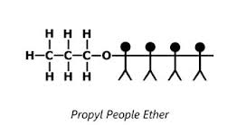
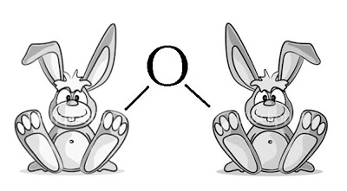

Name: _____________________________________________
Date: ______________________________________________
Naming…….

On page 9 of your data booklet is everything you will need for organic chemistry naming.
-ane, -ene, -yne
Name | Formula
METH | 1 Carbon
ETH | 2 Carbons
PROP | 3 Carbons
BUT | 4 Carbons
PENT | 5 Carbons
HEX | 6 Carbons
HEPT | 7 Carbons
OCT | 8 Carbons
NON | 9 Carbons
DEC | 10 Carbons

- SINGLE BONDS End with _______________________________
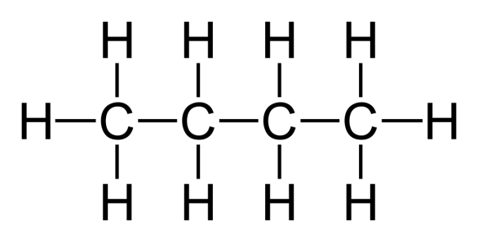
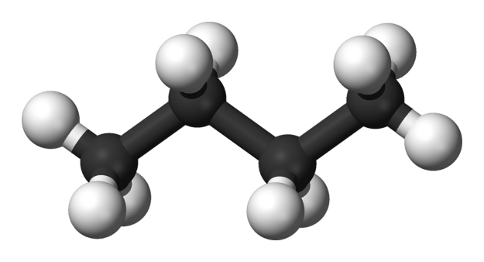
__________________________________________________________________________________________________

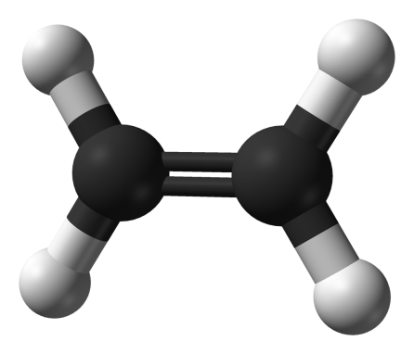
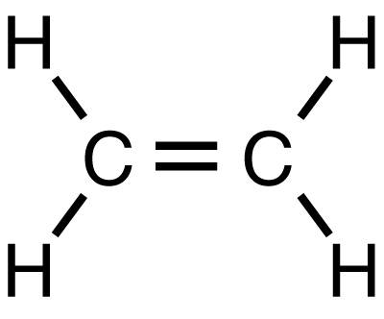
- DOUBLE BONDS End with _____________________________________

__________________________________________________________________________________________
- TRIPLE BONDS End with ________________________________________
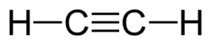
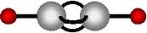

__________________________________________________________________________________________

Saturated vs. Unsaturated:
- ____________________________________ - only single bonds between carbon atoms

- ________________________________ - one or more double or triple bonds between carbon atoms

How do we know how to draw them with a single, double or triple bond?
Alkane
C_{n}H_{(2n+2)} All single bonds
Alkene
C_{n}H_{(2n)} One double bond, all the rest are single
C_{n}H_{(2n-2)} One triple bond, all the rest are single
Alkyne

Examples: Will there be single, double or triple bonds???
- C₆H₁₄

- C₆H₁₀

- C₅H₁₀
Practice Drawing:
Chemical Formula | Drawing | Saturated or Unsaturated
C₅H₁₂
C₅H₁₀
C₅H₈
C₆H₁₄
C₆H₆ (circular)
Benzene
C₆H₁₂

**HOW DO WE KNOW HOW MANY HYDROGENS TO ATTACH TO A CARBON????? IS THERE A MAXIMUM???
Alkanes
- saturated hydrocarbons
- generic formula is C₂H_{n+2}
- find the longest continuous chain of carbons...this is the parent chain. Name it by the number of carbons (1=meth, 2=eth, 3=prop...see pg. 9 of data book). End the name in 'ane'
Examples:
C-C-C-C C-C-C C-C-C-C
C C
C

Branched Alkanes:
- alkane with smaller carbon groups attached (___________________________________)
- Find the longest continuous chain of carbon atoms - this is the _______________________________.
- Name the parent chain just like you would for the continuous alkanes
- Circle the branches (alkyl groups)
- Name each alkyl group using the prefix that corresponds to the number of carbons (1 = meth,
2 = eth...) and use the suffix 'yl’
- Number the carbons on the parent chain to show the location of each alkyl group (number them so that the alkyl groups occur at the lowest carbon number possible)
To put the name all together:
- start with the alkyl groups. Put them in alphabetical order (order them by the alkyl, not the carbon number).
- number the alkyl groups, using commas between numbers and hyphens between numbers and letters.

Examples:

Branched Alkenes and Alkynes
- Alkenes - unsaturated hydrocarbon containing one or more carbon-carbon double bond

- Alkyne - unsaturated hydrocarbon containing one or more carbon-carbon triple bond
Naming these branches:
- alkenes end in “ene,” alkynes end in “yne”
- the double or triple bond must be included in the parent chain (it cannot be in a branch)
- number the chain so that the carbons with the double or triple bond receive the lowest number possible
- write the name of the parent chain. Indicate where the double or triple bond is by including the number in between the prefix and the suffix.
  - Eg. but-1-ene --the double bond is between carbon 1 and 2
- Find any branches off of the parent chain and name them in the same way as you did for alkanes.

Some More Examples:
C – C – C
C – C – C
C – C

C
C = C – C – C – C – C
C

C
C
C – C – C – C – C = C
C
C
C
C – C – C – C – C – C = C
C
C
Working Backwards:
6 – ethyl-4,5-dimethyloct-2-yne

Practice Questions: Page 245, #1-2

Quick Review: Naming Hydrocarbons

Write the systematic names for the following hydrocarbon compounds.
H H
H – C – C – H _________________________________________
H H

H H H
C = C – C – H __________________________________________
H H

Draw the structural diagram for each compound given.
2,2-dimethylpropane

2-methlyprop-1-ene

Benzene

- A _________________________________________ is a hexagonal arrangement of 6 carbon molecules.
  - The ring is arranged like this:
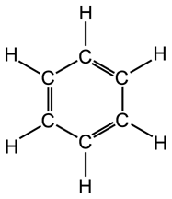
- Benzene may also have alkyl or other ______________________________________ as branches.
  - For example:
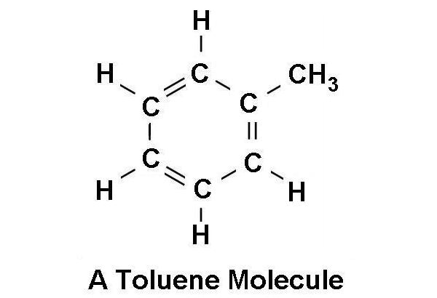
- Benzene rings may also be called __________________________ or ___________________________
- Despite having double bonds, benzene is a very _____________________________________
  - Benzene demonstrates ___________________________________ - the 'extra' electrons are shared by all the carbons...in other words, the true structure cannot be accurately represented by any one structure.
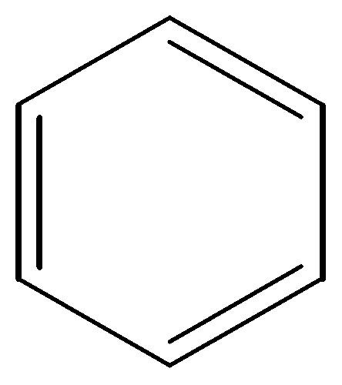
- Benzene may also be represented like this:
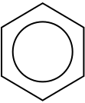

Problems with Benzene

- Naturally occur in ____________________________________ and _______________________ (gasoline and diesel is a mixture of hydrocarbons, including aromatics).
- Evidence indicates that benzene is a __________________________________ - this has led to a decrease in the amount of aromatics now present in gasoline
- Also evidence that exposure effects the body's production of __________________________________
Gasoline and Oil Spills
- Some aromatics are ______________________________________...this leads to concerns about these compounds leaching into the water system when there is a petroleum spill
- When there is a spill on the ground, it must be cleaned up through the process of ________________________________ (breakdown of hydrocarbons)
  - ________________________________________ can be broken down quickly by soil bacteria
  - ________________________________________ are much more stable and take much longer to break down (they are termed persistent organic compounds, or POCs).
Benzene in Food?
- Incomplete combustion of oils in food can produce _______________________________________________________ (PAHs). (Think charred steak...)
- PAHs are also found in the particulate emissions from combustion of hydrocarbons
- There is evidence that PAHs may interact with DNA and cause _________________________________.
Practice Questions: Page 247, #3-4

Functional Groups
- A functional group is an arrangement of single atoms or groups of atoms, other than carbon or hydrogen, attached to an organic molecule.
Examples of functional groups that we will be covering:
- Halogenated hydrocarbons
- Alcohols
- Carboxylic Acids
- Esters
Halogenated Hydrocarbons

- These are regular hydrocarbons where the hydrogen’s have been substituted for an element from the halogens
  - Chlorine, Fluorine, Bromine and Iodine
Naming Halogenated Hydrocarbons:
- Name the parent chain (just like in alkanes/enes/ynes)
- Find all side chains (just like before!)
  - For halogens, they will be named as follows
    - F – fluoro
    - Cl – chloro
    - I – iodo
    - Br – bromo
- If one halogen appears more than once, use the appropriate prefix (di, tri....)
- Number your carbons to have functional groups on lowest address (just like we did with branches) (if there are double or triple bonds, the bonds take priority.
- If there is more than one halogen, order them alphabetically.
Examples:
F
F – C – F ____________________________________________________________
F

Cl F
F – C – C – Cl ____________________________________________________________
Cl F

Cl
Cl – C – Cl ____________________________________________________________
Cl

Br
C = C – C – C – C – C – C – C ____________________________________________________________
Br

F F
C = C ____________________________________________________________
F F

Chlorofluorocarbons (CFC’s)
- Synthetic organic molecule where hydrogen molecules are replaced with chlorine and fluorine (also called ___________________________________)
- Commonly used in ____________________________ and ___________________________________ units
- CFCs are linked to depletion of the ozone layer

How is Ozone (O₃) Created?
- O₂ in the stratosphere is exposed to UV radiation, initiating the development of O_{2.}

Reactions between O₃ and CFC’s
- UV radiation releases a Cl atom from CFC
  - Free Cl atom decomposes ozone
    - Cl(g) + O₃(g) ClO(g) + O₂(g)

- There is also the natural decomposition of ozone occurring
  - O₃(g) + UV O₂(g) + O(g)

- Free O atom reacts with ClO, regenerating the free chlorine atom, allowing the cycle to continue
  - O(g) + ClO(g) Cl(g) + O₂(g)

Assignment: You are going to use your textbook from pages 253-261 to answer the following questions regarding ozone depletion and CFC’s.
- CFCs and Ozone
  - Define the following terms:
    - Stratosphere

    - Ozone layer

    - Free radical

    - Antioxidant

- There are reactions between ozone and CFCs. Use diagrams, words and chemical reactions (see pages 253 and 254)

- The reaction described about is cyclical in nature. Explain why.

- Monitoring ozone – how do we determine the thickness of the ozone layer (page 257)

- International agreements – What is being done to prevent the use of CFC’s in order to save our ozone layer? (Page 258)

Practice Problems: Page 257, #10, 11

Section 2.2 – Alcohols, Carboxylic Acids and Esters
Alcohols
- Alcohols are a group of organic molecules that have a __________________________________________________ attached to a hydrocarbon
- A Hydroxyl functional group is an ___________________________________
- Often times you will see it written as ______________________________where R is your hydrocarbon
H H H
H – C – C – C – O – H HYDROXYL FUNCTIONAL GROUP
H H H
Naming Alcohols
- Find the hydroxyl functional group (OH) Circle it!
- Determine the parent chain, numbering to place the hydroxyl group on the lowest number
- Name the parent chain as we did before
- Change the ending to 'ol' to indicate that it is an alcohol
Examples:
H
H – C – O – H ___________________________________________________________
H
H H
H – C – C – O – H ___________________________________________________________
H H
H
H O H
H – C – C – C – H ____________________________________________________________
H H H

Draw the following propan-1-diol
Practice Problems: Page 266, #18-20

Carboxylic Acids

- Vinegar (Ethanoic Acid) is a carboxylic acid
- Take a look at the structural diagram of vinegar and think about how it is different than an alcohol
H O
H – C – C
H O – H

- Alcohols can be converted to carboxylic acids by adding certain types of _________________________
- Ethanol (alcohol because of the “ol”) is converted into ____________________________ (vinegar)
- Carboxylic acids contain both a _______________________________________ (OH) and a _________________________________________ (C=O).
  - The hydroxyl group and the carbonyl group together form a _________________________________ (this is what makes a carboxylic acid).

SPECIAL NOTE ABOUT CARBOXYLIC ACIDS:
- Any carboxylic acid can react with water to form _____________________________________ (H₃O⁺)
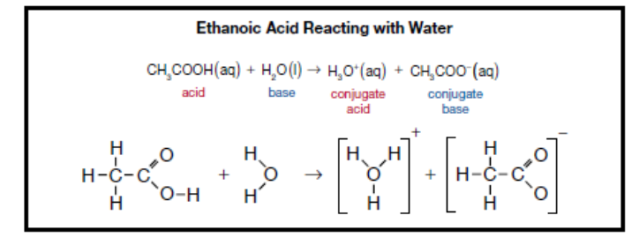
Naming Carboxylic Acids:
- They are named the EXACT same way as alcohols, except instead of an “ol” ending you will use an
“ioc acid” ending
- You will never need the address of the carboxyl group because of the double bond. The carbon would be completely overloaded if you tried to put the carboxyl group in the middle of the chain.
Examples:
H O
H – C – C ____________________________________________________
H O – H

O
H – C ___________________________________________________
O – H

Working Backwards: Draw – Propanoic Acid

Practice Problems: Page 267: 21, a, b
HINT: The chemical formula for lactic acid is C₃H₆O₃

Practice Problems: Page 268, #22

Esters
- An ester is an organic compound formed by chemical reactions between an _____________________________ and a ___________________________________________
- Esters are used for ____________________________ and ____________________________________
- Reaction of the carboxylic acid and the alcohol also creates a water molecule
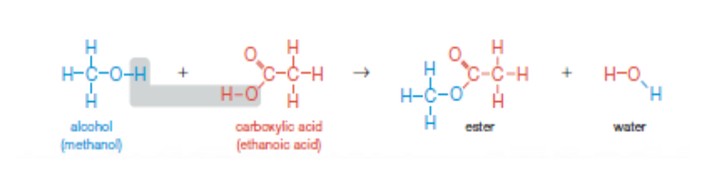
Naming Esters
- You must be able to identify both the alcohol and the carboxylic acid component of the ester
- Locate the ester functional group.
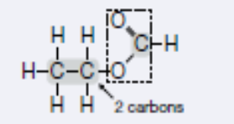

- The part of the molecule attached to the __________________________________________________
  - Name this with the appropriate prefix (it will be named like the alkyl groups...eg. methyl, ethyl, propyl...)
- The part of the molecule with the carbon attached to the double bonded O is the carboxylic acid.
  - Name this with the prefix for the number of carbons (eg. methan, ethan, propan...)
- Put the name for the alcohol and the acid together, make the ending “oate”
Examples:
H H O
C – H
H – C – C – O ____________________________________________________
H H
H H H O H
C – C – H
H – C – C – C - O H ____________________________________________
H H H

H O
H – C – C ______________________________________________
H H
H O – C – C – H
H H

H H H H
H – C – C – C – O – C – C – H ______________________________________________
H H O H
H – C – H
H – C – H
H
Practice Problems: Page 273, # 23a, b, c, 24, a, b

Polyesters

- ________________________________________ - large molecule formed by chemically combining many smaller molecules
- _____________________________________ - material able to be shaped or moulded with or without heat (a synthetic polymer)
- _____________________________________ - polymer containing many ester functional groups (created from the reaction of many alcohols and carboxylic acids)

There are functional groups at both ends of the molecule, allowing the molecule to grow in both directions. This results in the strength of plastics.
Bioplastics
- _______________________________________________________ produced by plants or bacteria that can be used in place of synthetic polymers
- _______________________________________________ are produced by extracting a polyester compound from certain plant tissues.
- Synthetic polymers are NOT biodegradable, bioplastics are.
Section 2.3 – Understanding Exposure
Use pages 279-298 to help fill in the following information about exposure. Ask questions if you are unsure.
A. Off-gassing -
1. Definition –

2. Concerns –

Do Page 280 - # 25 and 26

B. Pesticides –
1. Definition -

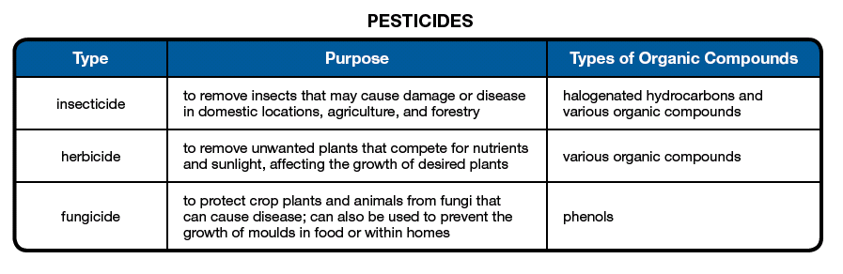
2. Types - (See chart below – I am not going to make you write all of this down)
3. Considerations when using pesticides –
a) specificity -
i) target specificity -

ii) broad spectrum pesticide -

b) toxicity –
i) definition -

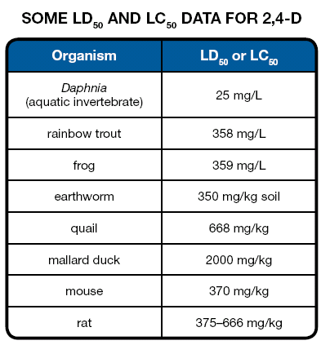
ii) LD50 and LC50
* define LD50

* define LC50

c) combined effects – (see the did you know too!) (page 285)

d) drift, grasshopper effect and persistence
i) drift –
* define –

* concerns –

ii) grasshopper effect -
iii) persistence -
* define -

* concerns -

e) water quality
i) fertilizers and organic matter -
* How do fertilizers and organic matter contribute to algal bloom and eutrophication of lakes?

* What are dangers of algal bloom to humans and to species living in the lakes?

* What is BOD?

* What does a high BOD mean in terms of water quality?

* What is the biggest concern of releasing raw sewage into water supplies?

Do Page 289 # 30

f) resistance
i) Describe how a resistance population may result because of pesticide use.

ii) How are toxic substances categorized by the government?
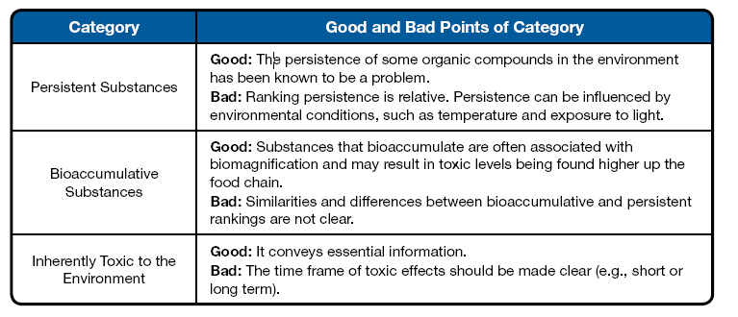

UNIT B: CHEMISTRY REVIEW!
Chemistry and the Environment

1. Use the information in the following table to help you identify the following 4 unknown solutions. Sodium chloride (NaCl), hydrochloric acid (HCl), potassium hydroxide (KOH) and glucose (C₆H₁₂O₆).

Data collected in the lab when testing four unknown solutions.

Solution | Litmus reaction | Conductivity in solution | Name of compound
1 | 7 | Doesn’t conduct
2 | 7 | Conducts
3 | 10 | Conducts
4 | 3 | Conducts

2. How many grams of NaCl(s) would you need to use to make 300mL of 1.2 mol/L solution? (21.03g)

3. Complete the following table with as many properties as you can think of.

Properties of acids and bases.

4. Give the BrØnsted-Lowry definition of
a) a base

b) an acid

5. Identify the BrØnsted-Lowry acids, bases, conjugate acids and conjugate bases in the following equations.

- NH₃(g) + HOH(l) NH₄⁺ (aq) + OH⁻ (aq)

- HCl(aq) + HOH(l) H₃O⁺(aq) + Cl⁻ (aq)

- Complete the following table.

pH | [H₃O⁺] (mol/L)
5.7
 | 2.9 × 10 ⁻⁴
9.6
 | 6.45 × 10 ⁻¹⁰

- A 25 mL solution of HCl(aq) is neutralized by 18 mL of a 1.0 mol/L NaOH(aq) solution using phenolphthalein as an indicator. What is the concentration of the HCl(aq) solutions?

- Use the following table to determine the concentration of an unknown solution of NaOH(aq).

Titration of 10.0 mL of NaOH(aq) with 0.250 mol/L HCl(aq).
Trial | 1 | 2 | 3 | 4
Final buret reading (mL) | 11.3 | 21.9 | 32.5 | 43.1
Initial buret reading (mL) | 0.1 | 11.3 | 21.9 | 32.5
Volume of HCl(aq) added (mL) | 11.2 | 10.5 | 10.6 | 10.6

- An acid has a pH of 3.2. What is the [H₃O⁺(aq)]?

- Define a buffer.

- If bromothymol blue is blue in a solution and phenolphthalein is colorless in the same solution, what range of pH is possible for the solution?

- What are some methods of reducing sulfur dioxide emissions and nitrogen oxide emissions? Explain when you would use the different types of technologies.

- What family of chemicals has contributed to the depletion of our ozone? Describe the chemistry of how ozone is depleted (you may want to use chemical equations), why there is such concern over the depletion of the ozone and if anything can or has been done to help fix the problem.

- Complete the following table for hydrocarbon derivatives.
Group (family) | Functional group | General formula | Naming Rules
Alcohols
Carboxylic acids
Esters
Halogenated hydrocarbons
- Name the following hydrocarbon derivatives and state the family they belong to.
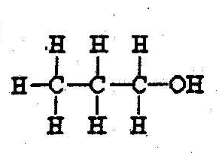
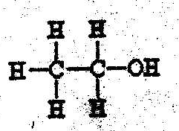

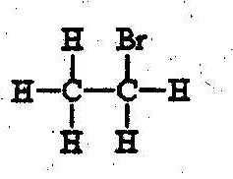
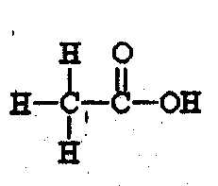

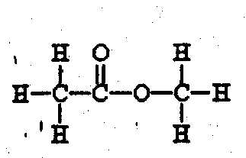
Other places to get practice questions:
https://questAplus.alberta.ca
- Click on “practice tests”
- Click on “grade 12”
- Scroll down to “Science 30”
- Click on “Unit B Chemistry Test 1” or “Unit B Chemistry Test 2”

Google: Released Alberta Diploma Exams
- Click on second link down “Alberta Education – Released Materials”
- There are old diploma exams listed – just look for Science 30 (you can practice the chemistry sections (and the biology sections for that matter)

