Unit A: Maintaining Health

Science 30
Chapters 1 (Pages 4-75)
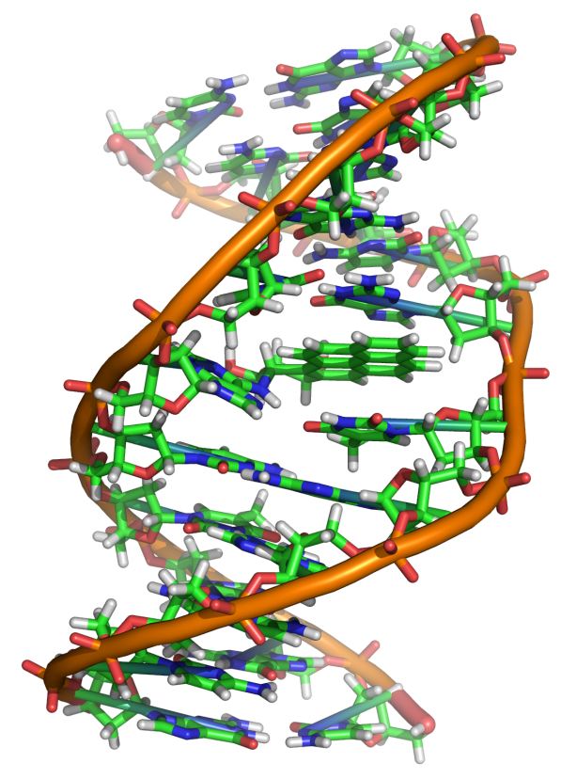

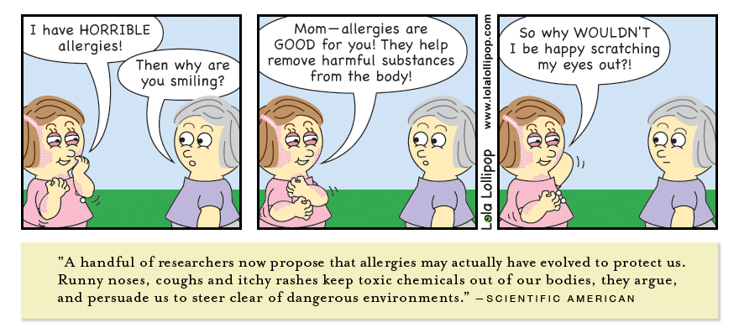

Name: ____________________________
Date: _____________________________
Chapter 1 – Circulation and Immunity
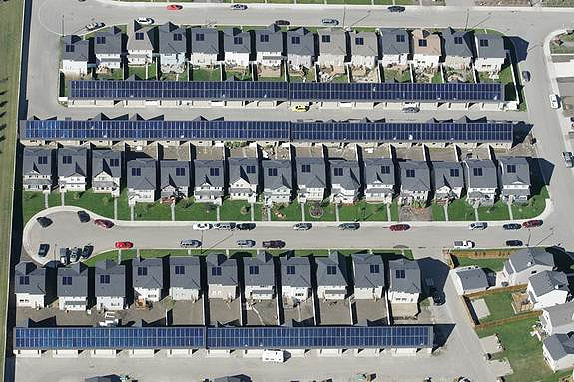
Comparison – City vs. Body

The human body is made up of trillions of cells closely packed together. These cells are similar to the closely packed houses that make up a city. Each house’s inhabitants generate wastes that must be regularly removed, and each house requires a constant supply of water and energy (natural gas and electricity). The houses are often far from the source of the needed supply or the waste disposal site. Like houses, cells generate wastes and require constant supplies. An efficient network for transporting materials is required to keep both cells and house functioning properly. Blood vessels in the human body function very much like highways, roads and pipes that serve cities and towns. Notice that no home in the photo is far from a road. In your body, no cell is more than two or three cells away from a blood vessel. Like roadways, there are one-way blood vessels, major and minor blood highways, and even the occasional traffic jam as blood vessels break or clog.

Topic 1.1 – The Heart
The Circulatory System
- Large organisms have an “internal transport system” known as the ________________________ or _____________________________.
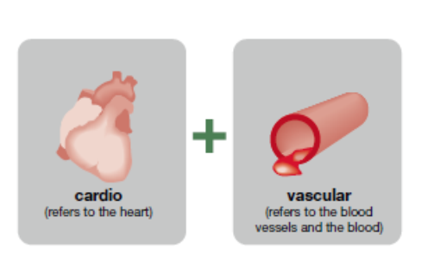
The main roles of the circulatory system:
1. Transport and delivery of _______ and nutrients and removal of _________ and waste from body cells.
2. Transport and delivery of ________________________ (like Hormones) throughout the body.
3. Distributes _________________________
4. Defends against _____________________________.
Some CRAZY ideas about the heart
- _________________________ believed a person's emotions, wisdom and personality was in the heart, not the brain. When someone died they believed the heart was weighed to determine a person's fate after death.
  - “Speaking from the heart”

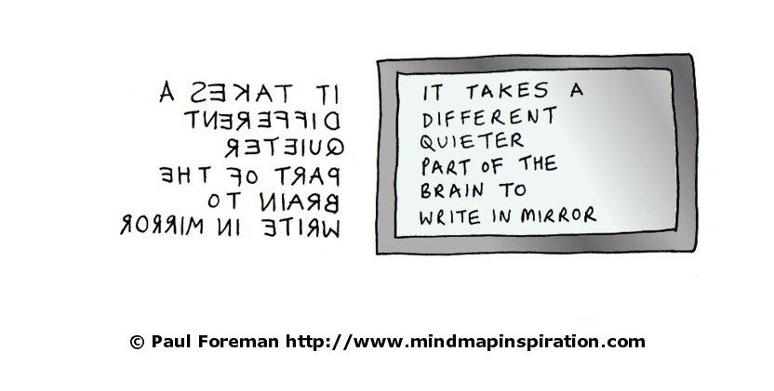
- In 2nd century Greece, physician's like __________________ believed the heart had two chambers and that food was turned into blood by the liver and then used up in the body. They also believed that the heart sucked blood from the veins and used it up. These ideas lasted for 1500 years (until it became more acceptable to perform human dissections)

- _____________________ was one of the first to dissect human cadavers and made many discoveries, but had to keep them secret because experiments on humans was not 'allowed.' To keep his work secret he used a type of mirror image writing.

More Recent Ideas About the Heart
- _______________________________ discovered:
  - __________________________ existed in both heart and veins to control blood flow
  - Heart ____________________________ the same blood over and over again
  - ______________________________ (the volume of blood pumped by the heart in one minute which is equal to the product of stroke volume and heart rate).
Cardiac Output
- Volume (IN _______________) of blood pumped through the heart in ONE _____________!
  - Adult male pumps out 70 mL of blood per beat (___________________) and the average resting heart rate is 72 beats/minute
  - Adult female pumps out 60 mL of blood per beat (___________________) and the average resting heart rate is 72 beats/minute.

The CARDIAC OUTPUT Calculation

Cardiac Output = Stroke Volume (L) x beats per minute

Example Problem: (Page 9)

A typical human male has a stroke volume of 70 mL per beat and a resting heart rate of 72 beats per minute.

a) Calculate the cardiac output. Express your answer in liters per minute.

Note: The final answer is rounded to two significant digits since the given values in the question are expressed to two significant digits.
Cardiac Output Information:
MedicineNet.com

Cardiac Output Video:
Study.com

Practice Problems – Page 9: Questions 1-5

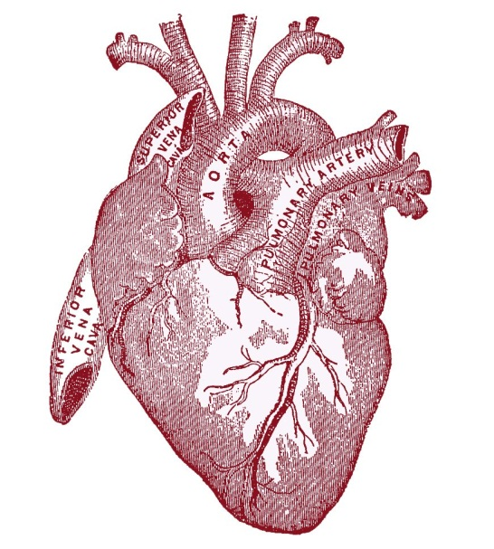
The Heart: An Amazing Pump
- The size of your ___________________________ is about the size of your heart.
- Your heart beats over _______________________ per day and ________________________________ in a lifetime.
- The heart is located almost in the center of the chest (not the left side)
  - Doctors listen to your heart on the left side of your chest because your heart is tilted slightly left – who knew?
Heart Diagram
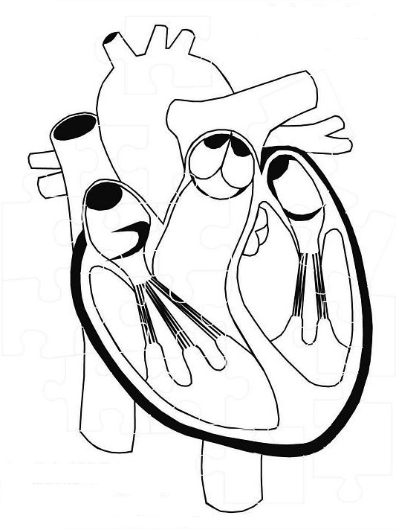
Using page 11 to help you, label the parts located in the word box. Take note of where the oxygenated blood (red) and deoxygenated blood (blue) come from and go to.
Word Box
Aorta
Superior Vena Cava
Inferior Vena Cava
Right Atrium
Right Ventricle
Left Atrium
Left Ventricle
Pulmonary vein
Pulmonary artery
Septum
Heart Valves

Quick Vocab:
- Septum: a thick wall of muscle that divides the left and right sides of the heart
- Atrium: The smaller upper chamber that receives blood returning from the heart
- Ventricle: The larger v-shaped bottom chamber that pumps blood from the heart
- Heart Valves: thin flaps of tissue in the heart that open and close to ensure the proper direction of blood flow.
Blood Flow through the Heart
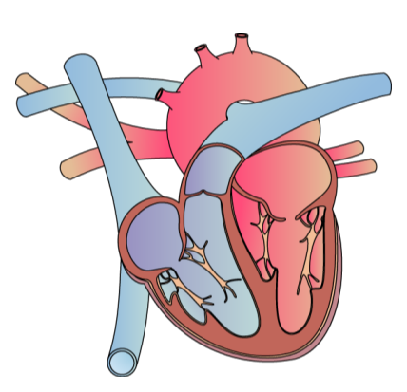 | Stage 1:
 | Stage 2:
 | Stage 3:
 | Stage 4:
 | Stage 5:
 | Stage 6:
The beating Heart
- This looks like a step by step process. In reality, ________________________________________. When the right atrium relaxes, so does the left (so they both fill with blood). When both atria contract, both AV valves open, filling both ventricles together.
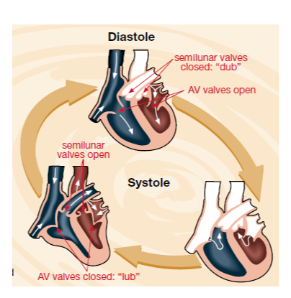
Two parts to the heart beat
1) Diastole - _____________________________ (the valves are open and the relaxed heart chambers fill with blood)
2) Systole - _______________________________ (atria contract, push blood into ventricles, then ventricles contract and push blood out of heart)
The 'lub-dub' sound of your heart is from the closing of the valves during contraction.
Factors Affecting Heart Rate:
- _____________________________ (eg. fear/excitement increases rate)

- _____________________________ (eg. excess heat increases heart rate in an attempt to increase blood flow to dissipate heat)
- _________________________________ can actually increase stroke volume (heart muscle become more elastic, but not larger)

- The more ____________________________ a person is, the lower their resting heart rate.

Topic 1.1 Summary:
Beliefs about the heart and the circulatory system have changed over time. William Harvey was the first person to prove that blood circulated around the body in a closed system of vessels. The pump that drives the circulatory system is the heart. The output of blood from the heart depends on how many times the heart contracts and how much blood it moved with each contraction. The atria contract simultaneously, followed by the simultaneous contraction of the two ventricles. This two-part contraction creates a “lub dub” sounds due to the functioning of the heart’s valves.
The heart rate is affected by emotion, temperature, exercise, fitness level, sleep, hormones, chemicals, drugs, and alcohol. By monitoring the heart rate during exercise programs, appropriate levels of exertion can be ensured. Heart rate is a key indicator of cardiovascular fitness.
Parts of the heart:
Innerbody.com

Blood Flow through the Heart:
Medical Institution.com

Blood Flow through the Heart
KhanAcademyMyMedicine.com

Practice Problems: Page 19, 1-3

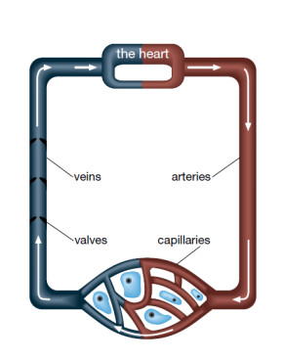
Topic 1.2 – Blood Vessels
Three types of blood vessels:
- Artery – Carry blood ______________________ from the heart

- Vein – Carry blood ___________________ the heart

- Capillary - _____________ blood vessels, connecting smallest part of artery to smallest part of vein. This is where _________________________ between blood and tissue occurs.

Using page 22, fill in the following table.
Type of blood vessel | Description
Artery
Vein
Capillary
Vena Cava (superior & inferior)
Pulmonary Artery
Pulmonary Vein
Aorta
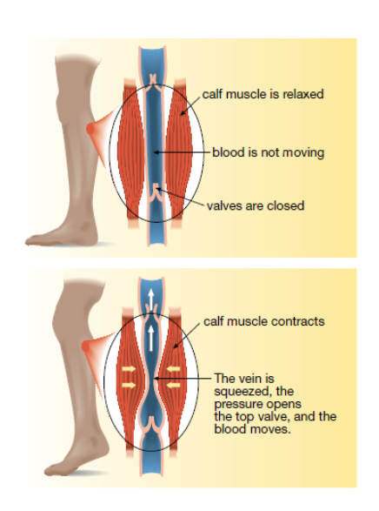
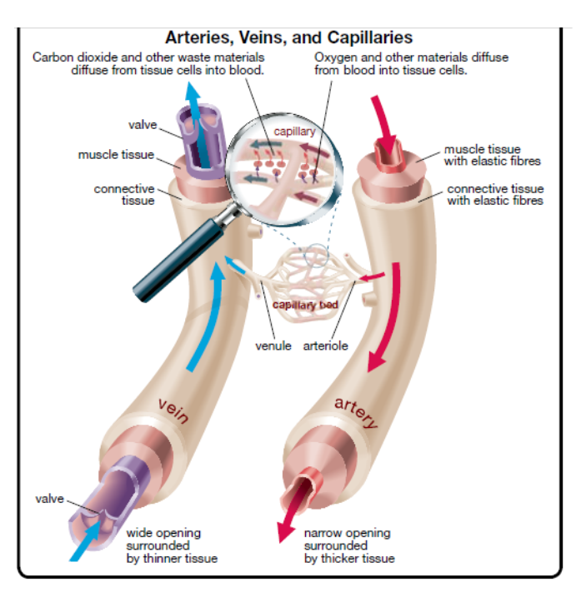
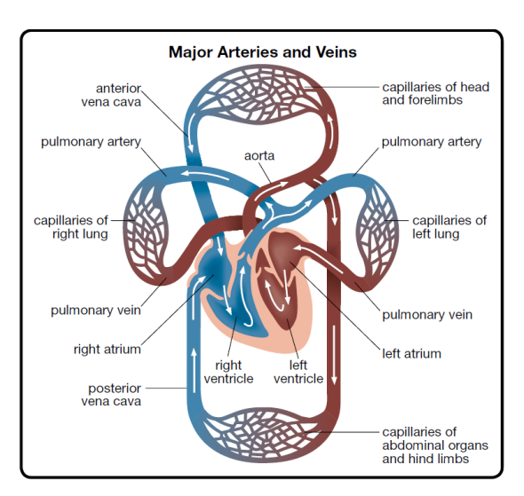
ARTERIES:
- Arteries have ________________________ to withstand the pressure of the pumping heart.
- Arteries all carry __________________ blood except for the __________________________.
- Arteries get smaller and smaller as they head away from the heart
  - As they get smaller, the start to branch into _______________________ which are small enough to connect to capillaries.
VEINS:
- Blood leaves capillaries and flows into “baby” veins called __________________ (connect to larger veins).
- There is not as much ______________________ in the veins as in arteries so the walls do not need to be as thick.
- The blood in the veins must make its way back to the heart by using __________________.
  - This is done because veins have small ____________________ in them so the blood does not go backwards.
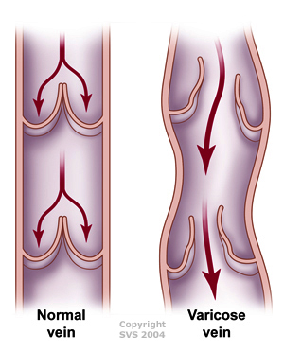
Varicose Veins
- If veins become _____________________ and the valves are _____________________, blood in the veins pool.
- This causes the veins to become raised.
  - This is _______________________________
Blood Flow through vessels:

Varicose Veins Info:
WebMd.com

Practice Problems: Page 23, Questions 11-14
: Page 24, Questions 15-19

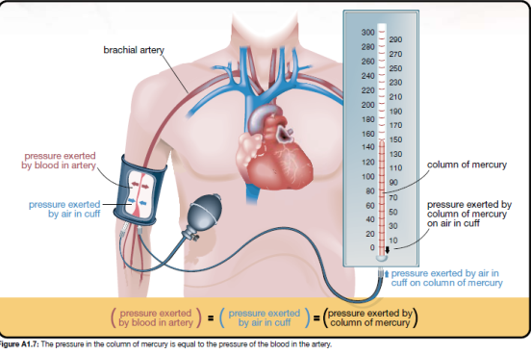
Blood Pressure:
- Pressure exerted by blood against the walls of blood vessels (typically a major artery)

- Measured in _____________ (millimeters of mercury)

- Unit for measuring pressure in terms of the height of a column of mercury that can be supported by that pressure

- Your heart both ________________________ and ________________________ as it pumps blood so your blood pressure reading with have TWO numbers.
The two numbers of blood pressure:
- Systolic Pressure: the pressure in the arteries when the heart is _______________________
  - Normal range for adults between _________________________________

- Diastolic Pressure: the pressure in the arteries when the heart is _______________________
  - Normal range for adults between ______________________________
Blood Pressure is written as systolic pressure over diastolic pressure.

Example: 100/60

- Hypertension: abnormally ______________________________ – values greater than 140/90
  - Caused by ___________________________________, anxiety, exercise, excess blood in vessels, thicker than normal blood, kidney disease, caffeine (and other stimulants)...
  - Prolonged high blood pressure can cause blood vessels to burst (if happens in brain, causes a stroke)

- Low blood pressure: - not enough blood can get to all areas of body, causing ____________________________ and/or _______________________________

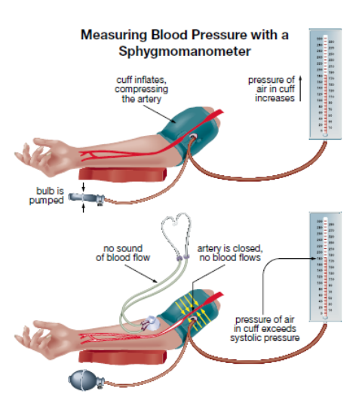
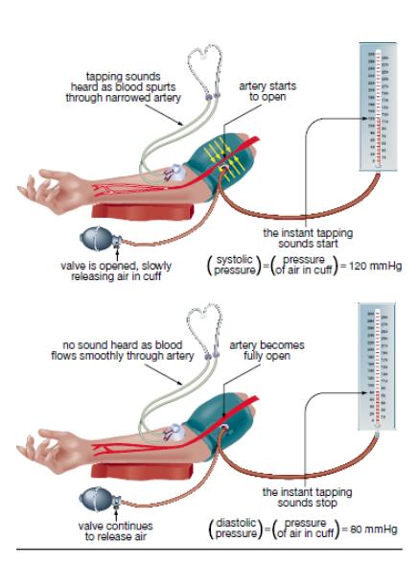
Measuring Blood Pressure:

Topic 1.2 Summary:
The circulatory system’s basic components are the heart, the blood vessels, and the blood. In this section you learned that vessels in the circulatory system are defined by their size and the direction in which they carry blood, relative to the heart. The vessels are specialized for their specific functions. Capillaries are uniquely designed for the exchange of nutrients between the body’s cells and the circulatory system. Because matter exchanged between capillaries occurs by diffusion, every cell in the body must be close to a capillary.
The pumping of the heart’s ventricles exerts pressure on blood, and this pressure is then transferred to the artery walls. Blood pressure has two readings. The systolic reading is the artery pressure when the heart’s ventricles are contracting. The diastolic reading is residual artery pressure when the heart’s ventricles are relaxed. When listed separately, the units of millimeters of mercury are included with each of these pressure valves. When communicated together, the units are usually omitted and the pressures are communicated as systolic pressure over diastolic pressure.
Blood Pressure Cuff How To Use:
PolyFit.com

Blood Pressure – What can go wrong?
American Heart Association

Practice Problems: Page 29, questions 20 and 21.
Extra Practice: Page 33, questions 1-6

Topic 1.3 – Blood
- Blood may look like a liquid with a uniform red color – IT IS NOT!!!!!!
- If you let a blood sample sit for a while or spin a blood sample in a machine called a ____________________________________ the blood separates into layers
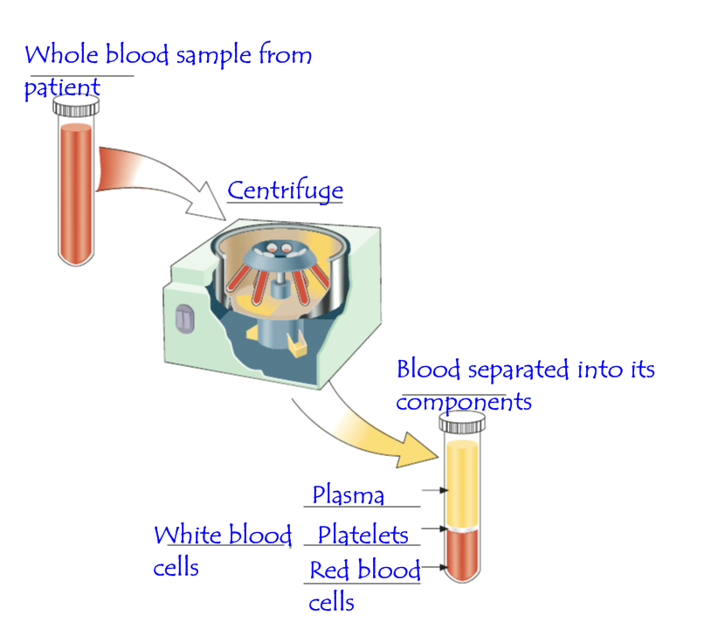
The parts of blood:
1. Plasma
- the __________________________ part of the blood
- about ________of blood volume
- it contains things like:
  - blood cells
  - carbon dioxide
  - urea
  - hormones
  - nutrients, vitamins and minerals
  - proteins
2. Red Blood Cells - erythrocytes
- about __________ of the blood volume
- they live about _______________
- they are produced in the __________________________________
- they do not contain a ______________________
- they transport oxygen - they contain hemoglobin which carries oxygen. When hemoglobin is attached to oxygen it is called _____________________________.
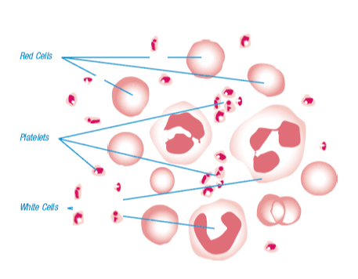
- they have a biconcave shape - this make it easy for them to move through the blood vessels and it also gives them a lot of surface area to exchange gases
3. White blood cells - leukocytes
- less than ___________________ of the blood volume
- live _______________________
- produced in the ________________________
- they have a _______________________
- too many of them may signal an infectio
4. Platelets
- When you get a cut, the bleeding usually stops after a short amount of time because proteins in your blood plug the damaged vessels.
  - ____________________________ – a protein present in blood that plugs damaged blood vessels.
- When a blood vessel is damaged, the fibrinogen creates a thread-like-protein called ________________________.
  - The fibrin make a sort of web in your blood vessel that traps red blood cells
  - The fibrin creates a _____________________________ (a jelly-like mass consisting mainly of red blood cells)
___________________________: a blood disorder involving the blood’s reduced ability to clot, which can lead to excessive bleeding
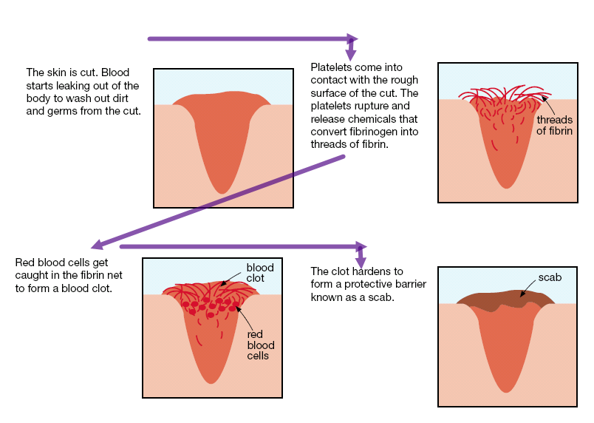

Topic 1.3 Summary:
The typical human body contains about 5L of blood that transports materials around the body to help prevent disease. Blood is a mixture of living and non-living components: red blood cells, white blood cells, platelets, and plasma.
The disc-shaped red blood cells are full of a molecule called hemoglobin, which allows these blood cells to carry and transport oxygen to the body’s cells. While blood cells are designed to help protect the body from disease-causing organisms. Platelets are the blood parts that make blood self-sealing. When there is a cut, platelets form a clot to stop the loss of blood – people with hemophilia lack key factors in their blood that help form clots. Plasma is a yellowish liquid that the blood cells and platelets float in. Many substances are dissolved in plasma, including glucose, urea and hormones.
Practice Problems: Page 41, #1-5

Topic 1.4 – Cardiovascular Diseases and Disorders
What is cardiovascular Disease?
- ______________________________ is one of many disorders that affect the ________________________ and/or the ____________________________________
  - Heart disease, strokes and varicose veins
Some terminology:
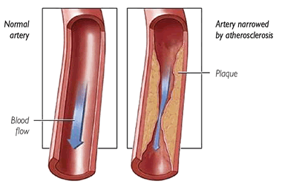
- ________________________: A waxy, fat-like substance present in the cell membrane of every body cell and in food from animal sources. Too much can be BAD!
- ______________________: a semi-hardened accumulation of substances originally suspended in a fluid.
  - As plaque accumulates, the artery starts to narrow
- _________________________: (LDL) a blood protein that carries cholesterol in the bloodstream from the liver to the rest of the body.
  - Too much LDL in the blood leads to deposits on the walls of arteries – THIS ________________________________________
- _________________________________: (HDL) a blood protein that carries cholesterol in the bloodstream from the body cells to the liver
  - High levels of HDL in the blood means it is less likely that deposits will form on the walls of arteries – THIS IS _________________________________
Cardiovascular Disease | Description of disorder | Heart disease | Blood Vessel Disease
Atherosclerosis | Hardening of arteries due to accumulation of fatty deposits
Coronary Heart Disease | Restricted blood flow through coronary arteries resulting in chest pain and heart attack
Heart Attack | Clot in a coronary artery cuts off blood supply to heart muscle and tissue dies
Stroke | Sudden loss of brain function caused by an interruption in blood flow to the brain
Aneurysm | Bulging or weakness in wall of artery or vein
Valvular heart disease | Diseases of heart valves leading to narrowing, leaking, or improper closed in valves
Septal Heart Defects | Opening within septum that allows blood to flow between left and right ventricles of heart

****NOTE:**** The cramping pain a person feels caused by a narrowing of blood vessels that supply blood to the heart is called ________________________________________
How does a clot happen?
- When plague and build up in arteries becomes hard and jagged, ______________________ that are passing through can be ruptured which release the thread like ________________ which starts the ____________________________.
- Once the fibrin has formed its “web”, red blood cells can no longer get to where they need to go.
  - If the red blood cells are blocked from getting to the heart, the result is a ______________________________
  - If the red blood cells are blocked from getting to the brain, the result is a ______________________.
Fats and Cholesterol in the Bloodstream:
INTERESTING NOTE: Inuit people typically get 50% of their calories from fat...how is it possible that they have a very low occurrence of cardiovascular disease????
Almost 75% of your cholesterol is actually manufactured in your liver....so its not so much about cutting out all cholesterol from your diet...its about the KIND of cholesterol you eat!

- The answer lies partly in the TYPE of fats that are eaten:
- ___________________________ only single bonds between carbon atoms. Difficult to breakdown, lead to an increase in ________________________.
- _____________________: contain one (or more) double or triple bond between the carbon atoms. Easier to break down, some may lead to an increase is ___________.
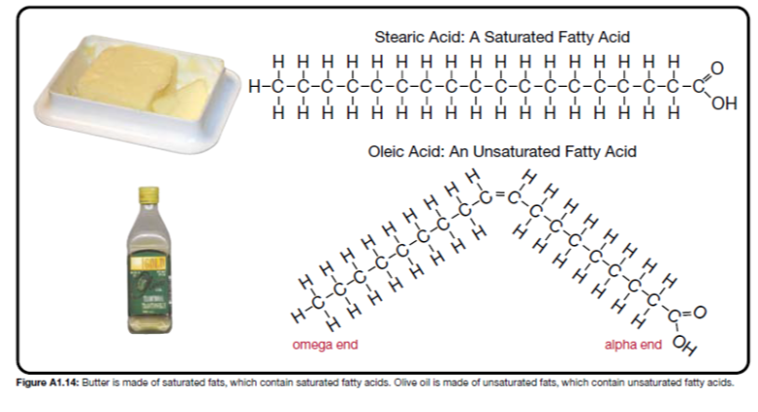
- ____________________: unsaturated fat goes through hydrogenation (H atoms are added). Lead to an increase in ______________________.

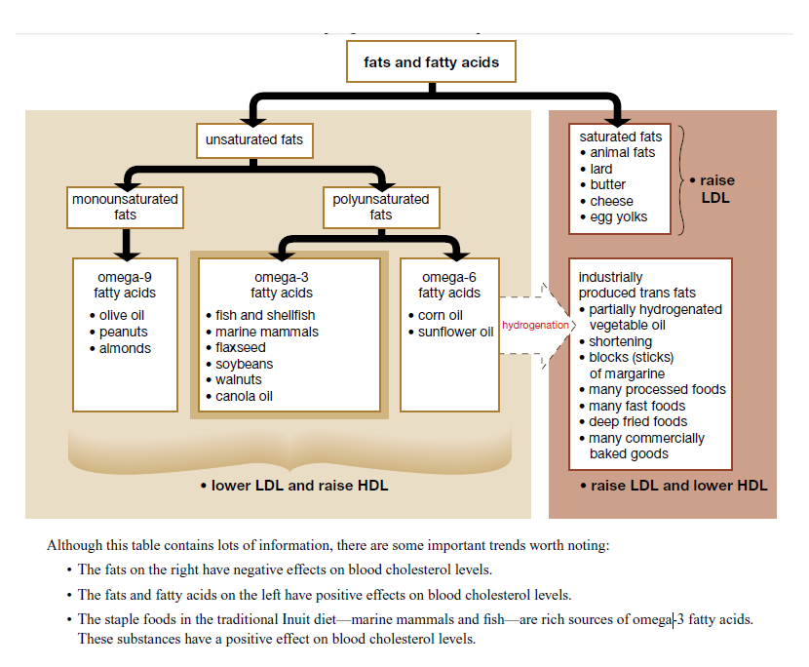
Essential Fatty Acids
- Certain fats are essential for good health (they help form cell membranes, help with brain and nerve function and to help produce certain hormones).

- _____________________ and _______________________ are obtained only through the foods you eat - your body _________________________ manufacture them.

Omega-3
- certain types of omega-3 fatty acids come only from marine sources (they actually help the fish and marine mammals survive in cold water)
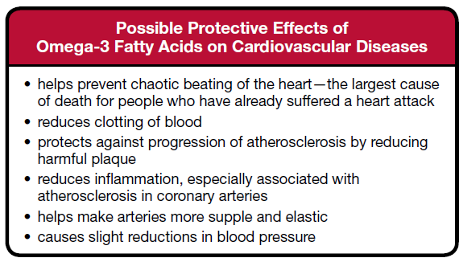
- research indicates that these particular omega-3 fatty acids MAY provide the following protective effects to the cardiovascular system:

Risk Factors of Heart Disease:
- over 65 years old
- family history of cardiovascular disease
- diet high in cholesterol
- diet high in saturated fats
- overweight
- little physical activity
- high blood pressure
- smoker (or exposure to second hand smoke)
- stress
- excessive alcohol use
Topic 1.4 Summary:
Diseases or disorders of the heart and blood vessels that impair the functioning of the cardiovascular system are called cardiovascular diseases. Your risk for developing a cardiovascular disease may depend upon inherited genetic factors and lifestyle choices.
Atherosclerosis is a condition where a buildup of fatty substances, called plaque, coats the lining of arteries. This results in impaired circulation and heart pain (angina). Atherosclerosis can lead to the production of blood clots and even a vessel blockage. A blood clot in the coronary artery can cause a heart attack or, if it’s located in the arteries leading to the brain, can cause a stroke.
Cardiovascular Diseases: What can go wrong?
Science of Nutrition

Practice Problems: Page 54, #1-6

Try This Activity - Analyzing Nutrition Fact Labels
p.50
Data Table
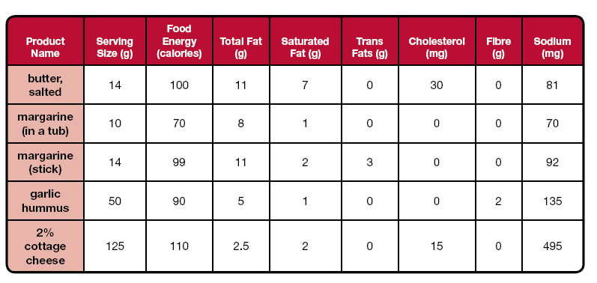

Analysis
1. Rank the products in amount of cholesterol per gram of product and amount of saturated fat per gram of product.

Identify which of the spreads would be best for someone trying to lower the blood cholesterol level.

2. A diet that includes lots of salty food causes sodium levels in the bloodstream to elevate. The body responds by adding more water to the bloodstream in an attempt to dilute the sodium concentration. Therefore, the volume of the blood increases.
a. Explain why a diet that contains many salty foods leads to higher blood pressure levels.

b. Identify which food items are best suited for someone diagnosed with high blood pressure.

3. Bile, mostly made of cholesterol, is a substance that helps to digest fat. Soluble fibre is found in foods like apples, brown rice, and beans. When soluble fibre passes through the digestive tract, it can help trap bile in the intestine— this allows bile to be excreted along with other wastes.

a. Explain how soluble fibre helps to reduce blood cholesterol levels.

b. Identify what food items contain significant amounts of fibre.

4. Other than differences in dietary content, list some factors that may influence consumer choice in terms of buying one of these products.

Topic 1.5 – The Immune System
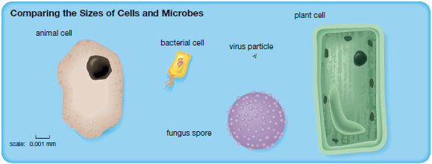

Types of Pathogens
- ________________________ - anything that causes disease
  - Examples: Viruses, protozoans, fungi, bacteria
- ________________________ - organism that carries disease causing pathogens from one person to another

- Bacteria
- Small, single celled organism with _____________________ and _____________________
- Genetic material is floating in cytoplasm (no nucleus)
- Reproduce rapidly by ____________________________ and can grow exponentially
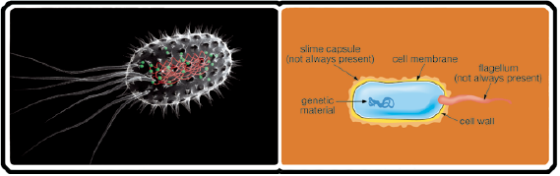
- ____________________________ can be used to kill bacteria

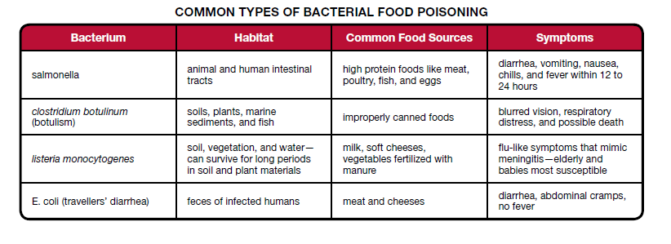

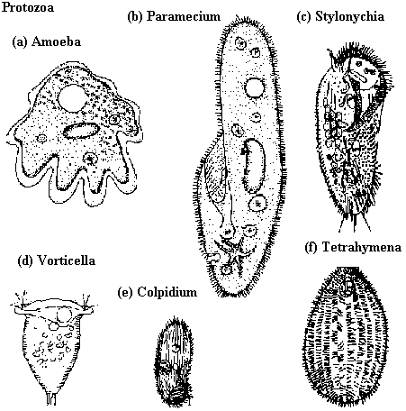
- Protozans
- Microscopic, single celled organisms that have a ____________________
- Many can only divide (reproduce) when inside a ___________________ (many live as parasites)
- Difficult to treat diseases without harming the ______________________
- ______________ is caused by a protozoan

- Fungi
- Organisms that absorb food in solution directly through their cell walls and __________________________
____________________________
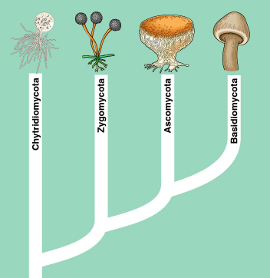
- Typically live off remains of _____________________ organisms, but some are parasitic
- Molds, mushrooms and yeast cells are examples of fungus
- ________________________ is a fungal disease

- Viruses
- ____________________________ consisting of a protein coat surrounding genetic material that divides (reproduces) only within the cells of a living organism.
- Extremely ________ (1/100 the size of a bacteria)
- Antiviral drugs are used to try to stop the infection of cells by viruses (and to stop the development of new virus particles)
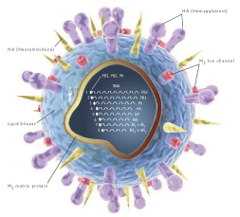
- Example - H1N1, ____________________, HIV/AIDS
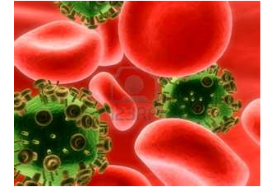

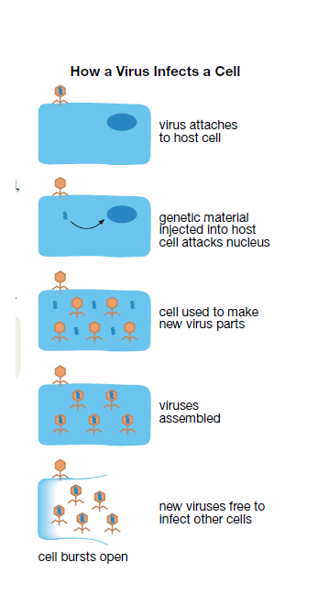

The body’s first line of defense:
- The Body’s First Line of Defense
  - ___________________
    - Waterproof
    - acidic - sweat and oils
    - heals quickly - platelets
    - good bacteria
- ___________________ - hairs and mucus
- ___________________ - hairs and wax (modified sweat glands)
- ___________________ - tears (antiseptic)
- ___________________ - acids
How do pathogens spread?
- Spreading Pathogens
  - _________________________ - sneezing/coughing sprays the particles in the air
  - ______________________ - touching someone or something that has the pathogen in it
    - washing your hands is a great way to help prevent this type of transfer
  - bacteria in the _____________________ we eat
  - ______________________________ - viruses like HIV and hepatitis C can be spread through the blood stream
  - ___________________________ - eg. malaria parasite - carried in mosquito saliva and transferred during a bite
The Immune Response
Use Page 64 and 65 to help you complete the chart below.
Sketch of Components | Name of Component(s) | Role(s) in the Immune System
 |  | Allow white blood cells to recognize foreign invaders
 | Macrophage
 |  | Identify antigens of foreign invaders and signal response of B-cells and killer T-cells
 | B-Cell
 |  | Attach to antigen of foreign material
 | Killer T-Cell
 | Memory B-Cell and Memory T-Cell
 |  | Signal for immune response to end

Vaccinations
- ________________________ of an altered/weakened form of pathogen OR an inactivated toxin

- Antigens on surface of injected pathogen allows body to undergo immune response
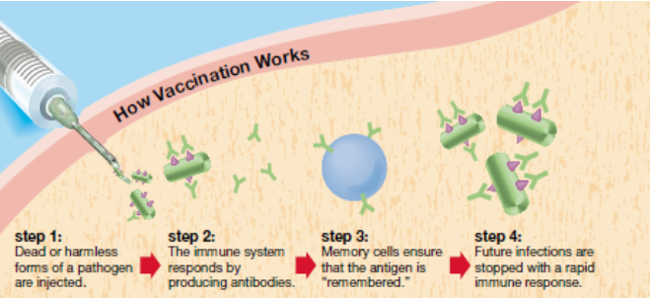
- Some pathogens require ______________________________ to ensure that memory cells stay present in blood stream.

Inoculation
- Similar to vaccination, but antigen is introduced into body through ____________________________________, while vaccinations are injected via needle under the skin
Autoimmune Diseases:
- Disorder in which the immune system produces antibodies ___________________________________________________
  - Examples:
    - ___________________________________ (white blood cells attack bone and cartilage cells)
    - ___________________________________ (white blood cells attack parts of the nervous system)
    - ___________________________________ (body manufactures antibodies directed against the pancreas)

Autoimmune Disease Info:
Healthline.com

Immune Response
Crashcourse.com

Chapter Review Questions: Page 71, #1-9

