**Science 30 Unit 4 Review**

**Example Diploma Questions**

**Energy sources and uses are of concern to scientist throughout the world.**

1. Which of the following graphs represents the world’s use of energy over the last century?

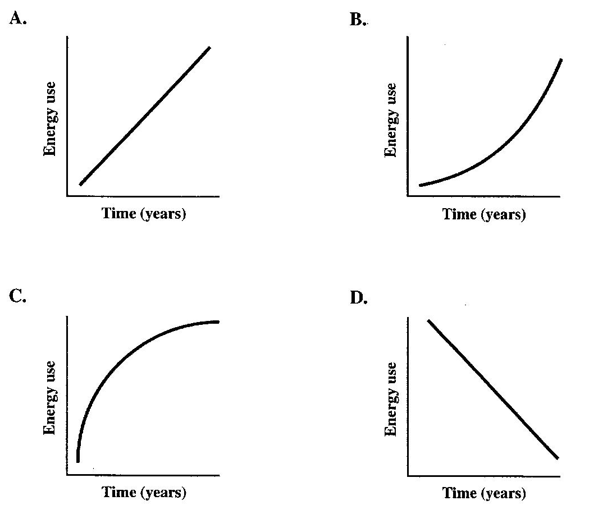

*Use the following graph to answer the next question.*

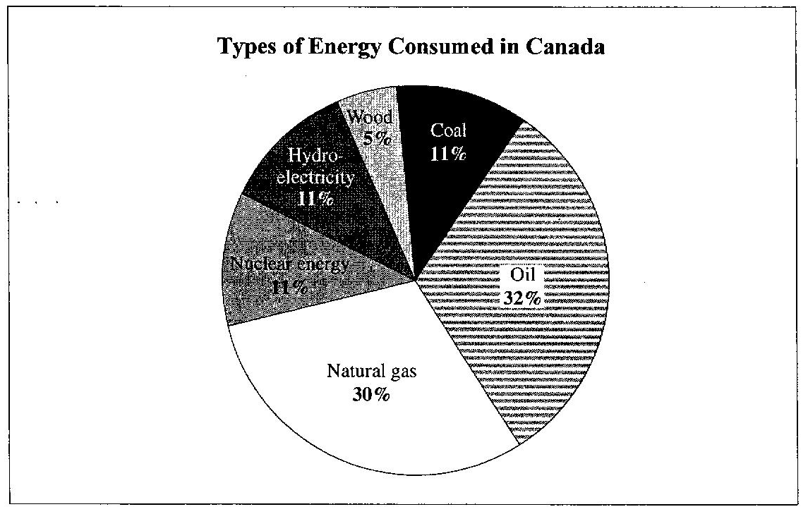

2. Of the types of energy consumed in Canada, fossil fuels account for approximately

A. 40%

B. 60%

C. 70%

D. 80%

*Use the following equation to answer the next question.*

**Butane Combustion Reaction Equation**

C4H10 (g) + O2 (g) → 4CO2 (g) + 5H2O (g)

**Numerical Response**

1. For each mole of butane burned, the quantity of energy released is __­­­___ × 103 kJ.

*Use the following to answer the next two questions.*

One of the waste gases produced at a wastewater treatment plant is methane. the combustion of methane, represented by the balanced chemical equation below, is an important process that provides energy for the operation of the treatment plant.

**Combustion of Methane**

CH4(g) + 2O2(g) → CO2(g) + 2H2O(g)

3. The energy released when one mole of methane undergoes combustion is

A. 560.0 kJ

B. 802.3 kJ

C. 836.3 kJ

D. 951.9 kJ

4. It is better to burn methane rather than release it into the atmosphere because methane

A. is a powerful greenhouse gas

B. destroys a large amount of ozone

C. significantly contributes to acid deposition

D. effectively blocks the passage of ultraviolet radiation

*Use the following information to answer the next question.*

### Four Types of Energy

1. Solar
2. Electrical
3. Kinetic
4. Thermal

**Numerical Response**

2. The sequence in which the types of energy listed above are converted in a wind turbine is ______, ______, ______, and ______.

*Use the following information to answer the next question.*

An experiment is designed to measure the efficiency of different photovoltaic cells in providing electricity.

### Variables in the Experiment

1. Amount of electric current
2. Intensity of the sunlight
3. Type of solar panel
4. Angle of light striking the panel

**Numerical Response**

3. Match each of the variables listed above with the type of variable listed below.

Manipulated _____________ (Record in the **first** column)

Responding _____________ (Record in the **second** column)

Controlled _____________ (Record in the **third** column)

Controlled _____________ (Record in the **fourth** column)

*Use the following equation to answer the next question.*

**Cellular Respiration Reaction Equation**

C6H12O6(s) + 6O2(g) → 6CO2(g) + 6H2O(l) + energy

5. A reaction that produces the same products as does cellular respiration is the

A. formation of esters

B. neutralization of an acid

C. process of photosynthesis

D. combustion of fossil fuels

6. In passive solar heating, the windows of a house have a function that is similar to that of

1. infrared rays
2. Earth's surface
3. Ultraviolet rays
4. Earth's atmosphere

7. Which of the following balanced equations represents a nuclear reaction that does **not** occur in the sun?

A. He + n → He

B. H + H → He + n

C. He + H → Li + n

D. U → Th + H

8. In a CANDU reactor, the **main** function of heavy water is to act as a

1. fuel
2. buffer
3. moderator
4. proton donor

9. A balanced nuclear reaction equation that represents the reaction that occurs in a fission reactor, such as the CANDU reactor, is

A. H + H → He

B. H + H → He + n

C. U + n → Kr + 3 n

D. U +  p → Kr + 3  p

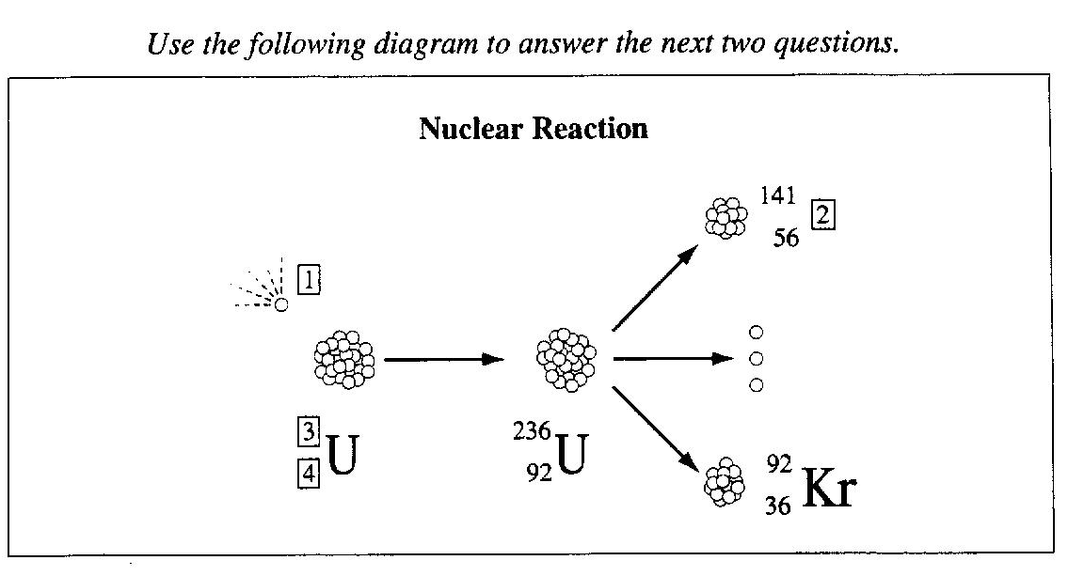

**Numerical Response**

4. Match each boxed number on the diagram above with its appropriate label listed below.

235 ______ (Record in **first** column)

92 ______ (Record in **second** column)

Neutron ______ (Record in **third** column)

Barium ______ (Record in **fourth** column)

10. *The reaction above represents a ___i___ reaction and would normally occur in ii .*

The statement is completed by the information in row

|  |  |  |
| --- | --- | --- |
| **Row** | *i* | *ii* |
| A. | fusion | nature |
| B. | fission | nature |
| C. | fusion | a CANDU reactor |
| D. | fission | a CANDU reactor |

*Use the following information to answer the next question.*

# Reaction Equation Representing Hydrogen Fusion

4H → He + 2 + *e*

**Numerical Response**

5. In a fusion reaction, mass is converted into energy. In the reaction represented above, when one mole of He is formed, the energy released is ______ × 1012 J.

11. What mass of fuel must be converted in a nuclear reaction in order to produce 8.60 × 109 J of energy?

A. 9.56 × 10 –8 kg

B. 14.3 kg

C. 28.7 kg

D. 7.74 × 1026 kg

12. The source of the sun's radiant energy is nuclear fusion reactions. The difference between nuclear fission and nuclear fusion is that

A. fission involves the splitting of nuclei; whereas, fusion involves the joining of nuclei

B. fusion involves the splitting of nuclei; whereas, fission involves the joining of nuclei

1. fission absorbs energy; whereas, fusion releases energy
2. fusion absorbs energy; whereas, fission releases energy

13. The original energy source of tidal energy and the original energy source of coal-fired electrical energy are, respectively,

A. the sun’s magnetic field and the sun’s gamma radiation

B. the sun’s gravitational field and the sun’s gamma radiation

C. the sun’s magnetic field and the sun’s electromagnetic radiation

D. the sun’s gravitational field and the sun’s electromagnetic radiation

14. The main reason that governments fund research and that researchers strive to improve efficiencies in electricity-generating technologies is to

A. ensure optimal global use of energy with minimal environmental impact

B. ensure that the use of neon-renewable resources continues to increase

C. maximize environmental change at a minimum cost

D. maximize the use of nuclear energy

15. When propane burns at a high temperature, nitrogen oxides are released into the atmosphere. When nitrogen oxides react with water, they cause

1. acid rain
2. global warming
3. destruction of the ozone layer
4. biomagnification of heavy metals

16. The **main** reason that sulfur should be removed from coal is to

1. reduce the SO 2(g) emissions that occur when coal is burned
2. make the coal burn hotter, which makes it more efficient
3. purify the water released by coal mining operations
4. recover the sulfur for industrial purposes

*Use the following information to answer the next two questions.*

**Some Energy Conversion Devices**

I Generator

II Biogas digester

III Diesel engine

IV Solar panel

V Nuclear reactor

17. In the list above, a device that is used to convert mechanical energy into electrical energy is numbered

A. I

B. II

C. III

D. V

18. In the list above, a device that uses fossil fuels as input energy is numbered

A. II

B. III

C. IV

D. V

19. Which of the following types of power causes the **least** environmental impact when used to generate electricity?

A. Coal power

B. Solar power

C. Hydro power

D. Nuclear power

**Many scientific concepts and principles can be applied to a greenhouse setting.**

20. Panes of glass in a greenhouse are coated with a substance that blocks ultraviolet radiation from entering the greenhouse. The effect of this glass coating is similar to the effect of

1. solar wind in space
2. curtains on windows
3. clouds on a sunny day
4. ozone in the upper atmosphere

21. A greenhouse operator noticed that a large amount of blue-green algae was growing in the damp areas where fertilizer had been spilled. An example of a similar situation is

1. increased growth in a forest affected by global warming
2. improved crop production as a result of the greenhouse effect
3. excessive growth of aquatic weeds in the warm water discharged from a power plant
4. excessive growth of aquatic weeds in an area where waste from a sewage treatment plant is discharged

22. A major environmental concern related to the burning of coal to produce electricity is the emission of

A. SO2(g) and NOx(g)

B. ground-level ozone

C. nitrates and phosphates

D. chloroflourocarbons (CFC’s)

23. All sources of energy must go through conversions in order to yield electrical energy for consumption. The type of energy used to generate electricity in both a coal-burning plant and a hydroelectric plant is

A. nuclear

B. thermal

C. chemical

D. mechanical

24. One of the most powerful arguments against increasing the use of nuclear energy involves the risks associated with

1. acid deposition
2. global warming
3. photochemical smog
4. radioactive substances

*Use the following information to answer the next question.*

**Some Electrical Energy Sources**

I CANDU reactor

II Wind generator

III Coal-burning power plant

IV Geothermal power plant

V Hydroelectric power plant

VI Tidal power plant

25. Of the energy sources listed above, two that depend on gravitational forces are sources

A. I and II

B. II and IV

C. IV and V

D. V and VI

*Use the following information to answer the next question.*

The following nuclear reaction equation represents the fusion reaction that occurs in the sun.

4H → He + 2 *e* + energy

26. Which of the following statements describes the fusion reaction represented by equation given above?

A. The reaction consumes energy.

B. Mass is conserved in the reaction

C. The mass of the products is greater than the mass of the reactants

D. The mass of the reactants is greater than the mass of the products.

27. Cobalt-60 is sometimes used in the treatment of cancer. When cobalt-60 decays, it produces beta particles. A nuclear equation that represents this decay is

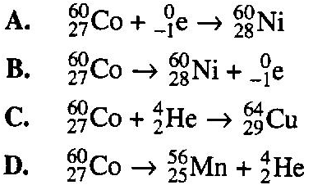

28. A type of pollution associated with both coal-fired power plants and nuclear power plant is

A. acid deposition

B. thermal pollution

C. particulate pollution

D. photochemical smog

*Use the following list to answer the next question.*

**Source of Energy**

1 Biomass

2 Coal

3 Moving water

4 Natural gas

5 Nuclear isotopes

6 Ocean tides

7 Wind

**Numerical Response**

6. The four renewable sources of energy listed above are _____, ______, _____, and _____.

**Answer Key**

**Multiple Choice** **Numerical Response**

1. B 1. 2.65, 2.66, 2.87 or 2.88

2. C 2. 1432

3. B 3. 3142 or 3124

4. A 4. 3412

5. D 5. 2.39

6. D 6. 1367

7. D

8. C

9. C

10. D

11. A

12. A

13. D

14. A

15. A

16. B

17. A

18. B

19. B

20. D

21. D

22. A

23. D

24. D

25. D

26. D

27. B

28. B