Heat of Combustion and
Nuclear Energy Review

- Determine the amount of energy released when the following fuels are combusted: Be sure to begin by writing out the equation showing the complete combustion of the fuel and balancing it!
  - Glucose

  - Octane

- For the isotope, ⁹²₃₆Kr, identify the
  - Atomic number

  - Charge

  - Mass number

  - Number of nucleons

- Define the following terms:
  - Radioactive decay

  - Nuclear fission

  - Nuclear fusion

- List the similarities and differences between a coal-fired power plant and a nuclear power plant.

- Describe how the fission reaction is controlled in a CANDU nuclear reactor.

- Identify and explain one risk and one benefit associated with the use of nuclear fission reactions for generating electricity.

- Complete each of the following nuclear reactions. Identify the unknown product and state the type of nuclear reaction shown.
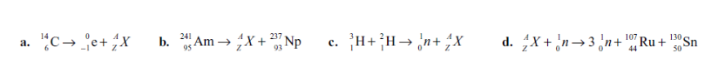

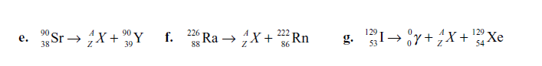

- Is nuclear energy from the fission of uranium a renewable or a non-renewable energy source? Provide a reason for your answer.

- A possible reaction for fusion power involves a fusion between helium-3 and deuterium nuclei. The products of the reaction are helium-4 and a proton.
  - Present the process as a balanced nuclear equation.

