Chapter 2: Genetics

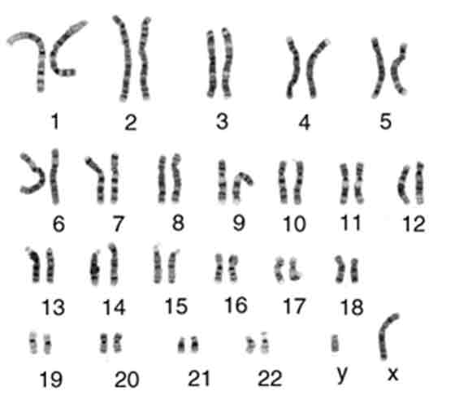
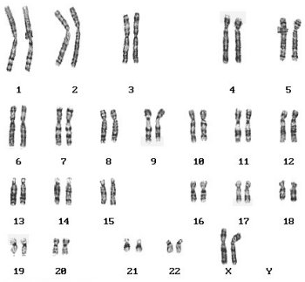

Female Karyotype
Male Karyotype

Name: __________________________________
Date: ___________________________________

Introduction Activity:
A combination of different physical characteristics makes each person unique. Many physical differences – such as the color of eyes, hair and skin – are due to slight differences in the genetic information that each individual received from his or her biological parents. One characteristic determined by your genetic information is the ability to roll your tongue.

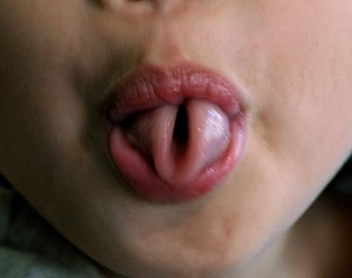
Discussion Questions:
Male Karyotype
1. Were you able to roll your tongue?

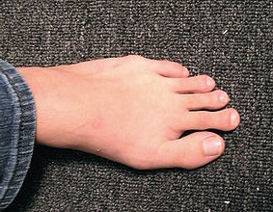
2. Are more people in your class tongue rollers or non-tongue rollers? What is the most common characteristic?

3. Do you think that if a non-tongue roller practiced a lot, this person could roll his or her tongue?

4. Is there a benefit to being able to roll your tongue?

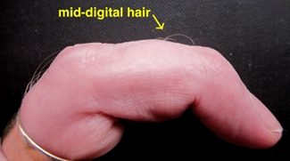
5. Speculate about the answers to the following questions:
a. Can a child have the ability to roll her tongue even if neither biological parent is able to?

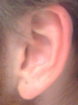
b. Could two tongue-rolling parents have a non-tongue rolling child?

Topic 2.1: What is Genetics?

__________________: the scientific study of how genes work to determine characteristics and to resolve how genetic information gets passed on from parent to offspring

Chromosomes:
- Located in a cell’s nucleus
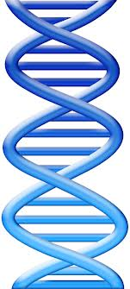
- A chromosome is a strand of ______________ (deoxyribonucleic acid) that contains the instructions for making proteins
- Humans have ___________________ of chromosomes (That’s 46 total!)
- You have 23 chromosomes from your biological _________________ and 23 chromosomes from your biological _____________________.
Genes:
- A ________________________ is a section on a chromosome that carries instructions for a specific protein

DNA:
- _________________________________________________
- A twisted ladder-shaped (________________________) molecule that contains genetic information of cells.
- Made up of ____________________ which are made up of ____________________.

An Analogy:

A chromosome is like a cookbook – it has a whole bunch of instructions for making different things. A gene is like one specific recipe – it is instructions for making one thing.

Karyotype
- Chromosomes are investigated using a karyotype
  - May be used when diagnosing _______________________________
  - May be performed on a child, adult or an unborn fetus (______________________)

- In the nucleus, the chromosomes are NOT neatly organized.
  - They kind of look like a pile of spaghetti
- A ______________________________ is an image of all the chromosomes in one nucleus that have been matched up into pairs
  - Arranged from
    - smallest to largest length
      - The longest is labeled “1”
    - the pattern of dark bands produced on each chromosome when they are stained
    - the position of the _____________________________
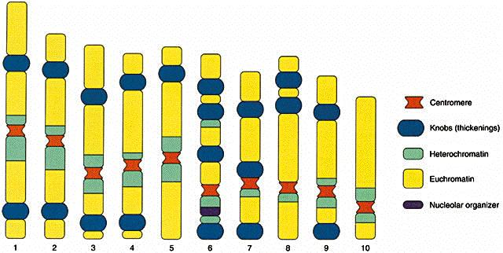

- The last two chromosomes in a karyotype are the _____________________________
  - These determine the organism’s gender
Gender
- If an individual has ____________________________ the sex will be _________________
- If an individual has _________________________________ the sex will be _________________
  - The Y-Chromosome is always considerably smaller than the X so it is a challenge to match.

Human karyotyping activity

Instructions: Log onto the following website…
http://www.biology.arizona.edu/human_bio/activities/karyotyping/karyotyping2.html

- Read the history for Patient A, then complete the karyotype. You will need to match the given chromosomes into the partially completed karyotype. Then, answer the questions that follow.
  - Read the instructions on how to use proper notation to describe the karyotype. Write down the proper notation for this individual.

  - Using the information given, what diagnosis to you give this patient?

- Repeat the same process for Patient B.
  - Write down the proper notation for this individual.

  - Using the information given, what diagnosis to you give this patient?

- Repeat the same process for Patient C.
  - Write down the proper notation for this individual.

  - Using the information given, what diagnosis to you give this patient?

Patient A's Karyotype
 | _______  1 | ________  2 | ________  3 |  |  | ________  4 | ________  5
________  6 | ________  7 | ________  8 | ________  9 |  | ________  10 | ________  11 | ________  12
________  13 | ________  14 | ________  15 |  | ________  16 | ________  17 | ________  18
 | ________  19 | ________  20 |  | ________  21 | ________  22 |  | ________

Interpreting the karyotype
Lab technicians compile karyotypes and then use a specific notation to characterize the karyotype. This notation includes the total number of chromosomes, the sex chromosomes, and any extra or missing autosomal chromosomes. For example, 47, XY, +18 indicates that the patient has 47 chromosomes, is a male, and has an extra autosomal chromosome 18. 46, XX is a female with a normal number of chromosomes. 47, XXY is a patient with an extra sex chromosome.
A 1. What notation would you use to characterize Patient A's karyotype?

Making a diagnosis
The next step is to either diagnose or rule out a chromosomal abnormality. In a patient with a normal number of chromosomes, each pair will have only two chromosomes. Having an extra or missing chromosome usually renders a fetus inviable. In cases where the fetus makes it to term, there are unique clinical features depending on which chromosome is affected. Listed below are some syndromes caused by an abnormal number of chromosomes.
A 2. What diagnosis would you give patient A?
____________________________________________________________________________________________________________________________________________________________________________________
Diagnosis | Chromosomal Abnormality
Normal # of chromosomes | patient's problems are due to something other than an abnormal number of chromosomes.
Klinefelter's Syndrome | one or more extra sex chromosomes (i.e., XXY)
Down's Syndrome | Trisomy 21, extra chromosome 21
Trisomy 13 Syndrome | extra chromosome 13

Proteins
- There are over 25,000 genes located on our 46 chromosomes
  - This means there are over 25,000 proteins created in our bodies
    - INTERESTING! If we could take all of the water out of our bodies, almost 50% of the dry mass left behind would be proteins

Roles of Proteins: (More proteins on Page 83)
Type of Protein | Role of Protein | Example
Enzyme | Enzymes speed up chemical reactions where molecules are broken apart of put together | Amylase is a digestive enzyme in your saliva that breaks down long starch molecules into shorter, more digestible glucose molecules.
Structural | Structural supports and frameworks are created to attach to other proteins | Keratin is a structural protein that mkes up your hair and nails. Collagen is a structural protein that provides a framework for skin and internal organs
Transport | Materials are moved with the cell or body | Cell membrane proteins form channels and pumps in the cell membrane to help needed materials flow into the cell and unwanted materials flow out of the cell.
Hormone | Hormones act as signals to co-ordinate and regulate activities in the body | Insulin is a hormonal protein that regulates blood sugar. Insulin is produced in the pancreas and moves in the blood stream to other organs to influence their use of glucose.

Making More Chromosomes:

Using Page 84 and 85, answer the following questions about mitosis and meiosis.

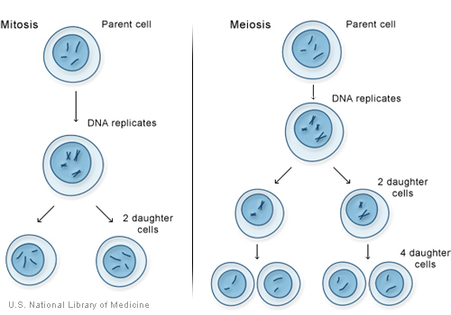

When a cell divides, it must provide genetic information to each of the new cells that form from the cell division. This means that exact copies must be made of the long strands of DNA within each of the chromosomes. Depending upon the type of cell, there are two ways in which this process can occur. These methods are mitosis and meiosis

Mitosis:

Vocabulary:

Autosomal Cell: ____________________________________________________________________________________________________________________________________________________________________________________

Homologous Chromosome:

______________________________________________________________________________________________________________________________________________________________________________________________________________________________________________________________________________

Replicate:

____________________________________________________________________________________________________________________________________________________________________________________

Daughter Cells:

____________________________________________________________________________________________________________________________________________________________________________________

Mitosis:

____________________________________________________________________________________________________________________________________________________________________________________

Diploid Cells:

____________________________________________________________________________________________________________________________________________________________________________________

Asexual Reproduction:

____________________________________________________________________________________________________________________________________________________________________________________

Questions:
- What kind of cell (autosomal cell or sex cell) does mitosis duplicate?

____________________________________________________________

- Draw a DETAILED diagram of Mitosis explaining clearly what is happening at each stage.

Meiosis:

Vocabulary:

Gamete (Sex Cell): ____________________________________________________________________________________________________________________________________________________________________________________

Meiosis:

______________________________________________________________________________________________________________________________________________________________________________________________________________________________________________________________________________

Crossing Over:

____________________________________________________________________________________________________________________________________________________________________________________

Haploid Cell:

____________________________________________________________________________________________________________________________________________________________________________________

Questions:
- What kind of cell (autosomal cell or sex cell) does meiosis duplicate?

____________________________________________________________

- Draw a DETAILED diagram of meiosis explaining clearly what is happening at each stage.

A WAY TO REMEMBER:
Mitosis is remembered as “mi TWO sis” | Meiosis is remembered as “mei ONE sis”
Produces diploid cells (2n), with two copies of each chromosome | Produces haploid cells (1n), with one copy of each chromosome

Fertilization:
- When chromosomes in a male gamete and a female gamete are joined together, diploid cell is formed
  - This cell will undergo mitosis to produce a new individual with a combination of characteristics from the mother and father
- Sexual reproduction results in almost limitless combinations of genetic material from the two parents
- Crossing over serves to increase the variation of the genetic material even more.
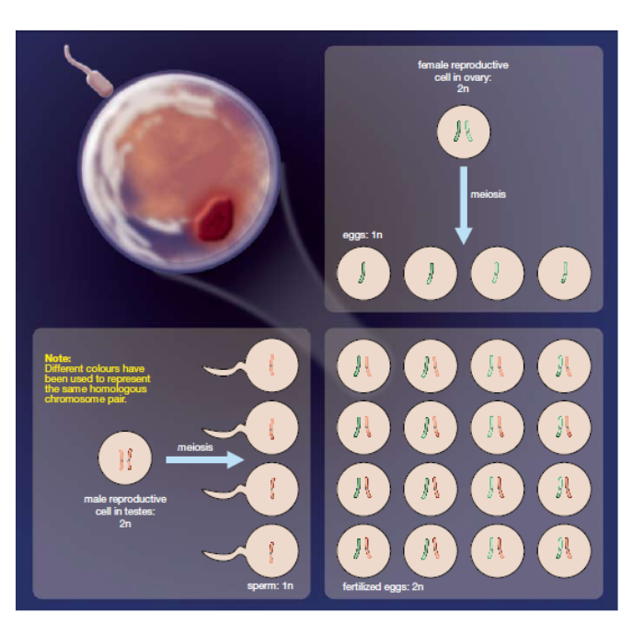
Questions for Review: Page 92 Questions 1-5

Quick Review:
MITOSIS: Use Page 84 if you can’t remember.
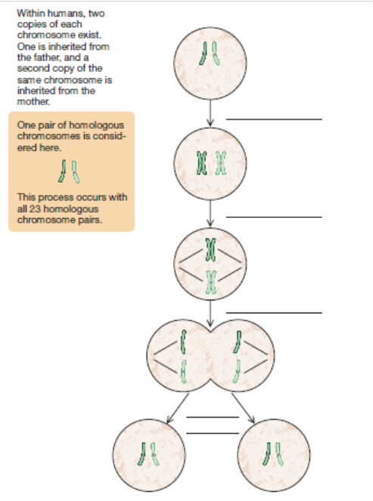
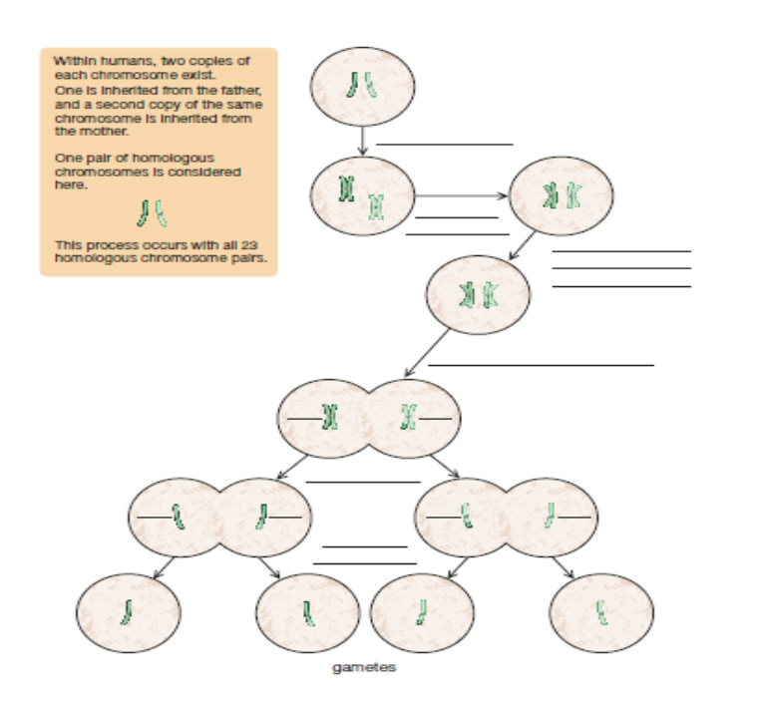
Meiosis: Use page 85 if you can’t remember

Topic 2.2 – Inheritance
__________________________________________________: Choosing individuals with useful characteristics to produce a more desirable plant or animal stock.
Inheritance:
- First ideas about inheritance came from selective breeding
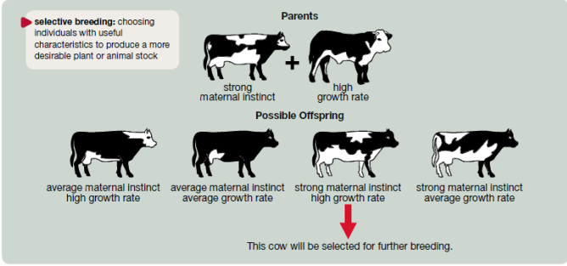
  - People chose the characteristics wanted in offspring and breed only parents with desired traits.

Discovering Genes
- ________________________________ (the father of genetics) came up with the first explanation for why certain traits are passed on by observing pea plants.
- Mendel decided to use pea plants at first because:
  - They were easy to grow in _____________________________________________
  - Their reproduction could be ____________________________________________.
- Mendel transferred pollen from one plant to another – he called this ________________________________________________
- He also allowed some plants to _____________________________________________ (transferring pollen from one plant to the female part of the same plant.
What he noticed:
- Purple Flower or White Flowers
- Round Seeds or Wrinkled Seeds
- Yellow Seeds or Green Seeds

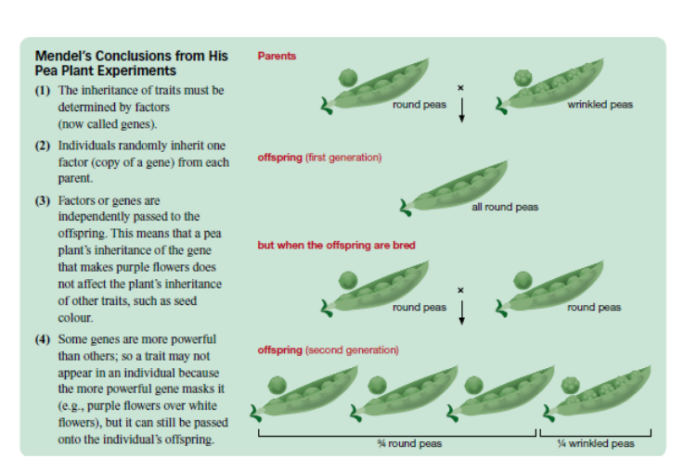
Traits:
- _________________________________________________________: traits acquired during a person’s lifetime because of experiences, education, and upbringing, such as a scar from a cut of the ability to speak a certain language
- ____________________________________________________: traits genetically passed on from one generation to the next, such as a certain blood type of eye color.
Alleles:
- Alternate forms of a gene.
- Consider a trait like your thumb….
  - One allele creates a straight thumb while the other creates a hitch-hikers thumb
- You get one allele from dad and one allele from mom.

Some Vocabulary:
__________________________________________________________________
- If you have the dominant allele, you will show the dominant trait
- If you have no dominant allele (only have recessive alleles), you will show the recessive trait

_____________________________________________________________
- Your two alleles are the SAME (two dominant or two recessive)

_____________________________________________________________
- Your two alleles are different (one dominant and one recessive – you will show the dominant trait).

_____________________________________________________________
- Alleles you have (your genes)

_____________________________________________________________
- The appearance of the genotype (how you look/act)

Punnett Square:
- Used to determine the possible genotypes of offspring from parents with known alleles

How to use a punnett square:

- Draw a square and then label each row and column with the alleles of each gamete.
- Fill in the square with the offspring genotype
- Determine the fraction of the offspring with each genotype. This fraction is the same as the probability of an individual offspring possessing a particular gene.

Examples:
Information:

One DOMINANT allele, P, codes for purple flowers, while the other RECESSIVE allele, p, codes for white flowers

Suppose two pea plants each have the allele P that codes for purple flowers and the allele p that codes for while flowers. Let these two plants be the parent generation.
- Determine the color of the flowers in each of the parent pea plants

- Set up a chart (punnett square) to show all the possible outcomes of fertilizing a gamete from one plant with a gamete from the other.

- Use the chart you developed in (b) to determine the percentage probability that a plant in the first generation of offspring will have white flowers.

- Suppose the two parent plants produced twelve plants in the first generation of offspring. How many of these plants would you expect to have white flowers?

Homozygous vs. Heterozygous
Heterozygous Parents

Possible Outcomes:

Homozygous Dominant Parents

Possible Outcomes:

Homozygous Recessive Parents:
Possible Outcomes:

Practice Questions: Page 97 #16-17

Genotype vs. Phenotype
- An organism’s genotype is a description of the alleles that it possesses.
  - The ____________________________________ for tongue rolling couple be homozygous dominant (RR) heterozygous (Rr) or homozygous recessive (rr)
  - The _________________________________ would be either tongue rolling or non tongue rolling
Practice problems: Page 98: Questions 18-19

Multiple Allele and Sex Linked Traits
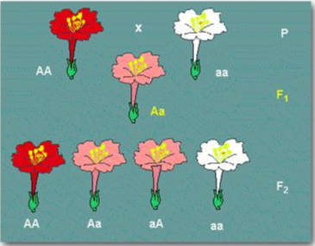
________________________________________: cross between organisms with two different phenotypes produces offspring with a THIRD phenotype (a blend of the parental traits)

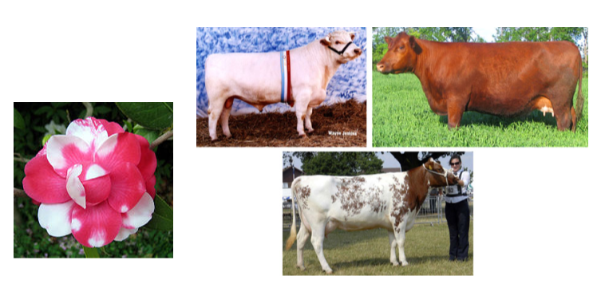
________________________________- A cross between organisms with two different phenotypes produces offspring with a THIRD phenotype in which both of the parental traits appear.

Multiple Allele Traits:
- A number of traits are the result of more than two alleles. Such traits are said to have multiple alleles for that trait.
- _______________________________________________- is an example
  - There are four different types (A, B, O and AB).
Table of Blood Types
Genotype | Phenotype
OO | Blood Type O
AA or AO | Blood Type A
BB or BO | Blood Type B
AB | Blood Type AB
Examples:
- A man with type O blood marries a woman with heterozygous Type A blood. What are the possible genotypes and phenotypes of the children?

- A woman with type O blood and a man who is type AB are expecting a child. What are the child’s possible blood types?

- Jill is blood type O. She has two older brother (who make her crazy!) with blood types A and B. What are the genotypes of their parents?

- A test was done to determine the biological father of a child. The child’s blood type is A and the mother is B. Dude #1 has type O blood and dude #2 has blood type AB. Who is the father?

Sex Linked Traits
- The genes for these traits are on the ___________________________________________.
  - Because males only receive one X chromosome, they are more likely to inherit disorders passed on to them from their mother (who may be a carrier)
- In humans, ___________________________________________________is a recessive sex-linked trait. It is found on the X chromosome, not the Y
  - Because males only have on X, they have a much greater chance of having red-green color blindness.
  - Females would have to be homozygous recessive in order to have red-green color blindness.
Examples:
A homozygous woman who has two alleles for full-color vision has children with a color blind man.
- Describe the genotype of each parent

- Build a punnett square to predict the possible genotypes of their children

- Use the punnett square to explain why the sons have full color vision even though their father in color blind

- Use the punnett square to explain why the daughters are carriers for the color blind allele, even though they have full color vision.

Practice Questions: Page 101: 23-26

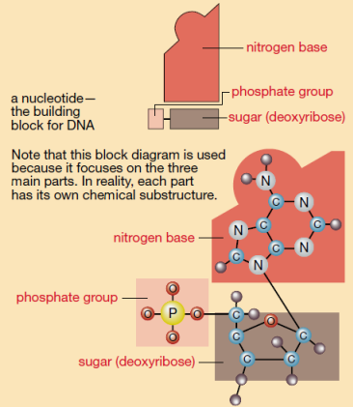
Section 2.3 – DNA
The structure of DNA
- Deoxyribonucleic Acid AKA: DNA
- DNA is composed of chemical units called ______________________________________.
  - Each nucleotide contains:
    - A phosphate molecule
    - A ______________________ (called deoxyribose)
    - Nitrogen Base
      - Adenine (A)
      - Thymine (T)
      - Guanine (G)
      - Cytosine (C)

- _________________________ and ________________________ parts of separate nucleotides bond to one another to form the “backbone” (or the sides of the ladder)
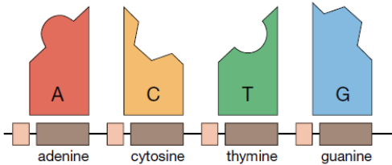

- _________________________________ pair up to form the other sides of the DNA molecule
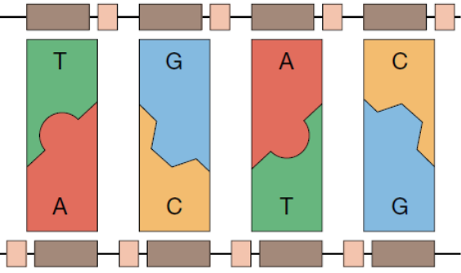
  - A and T (or T and A)
  - C and G (or G and C)

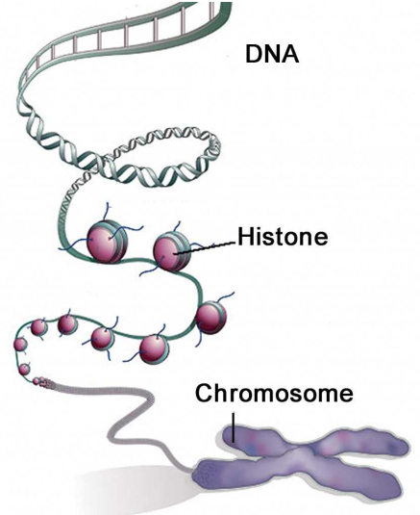
- DNA from just one human cell would stretch out to be over 2m long. HOW CAN THIS FIT INTO A CELL???
  - _______________________
_______________________ shape makes it more compact
  - DNA wraps around protein spools called _____________________

WHO DISCOVERED WHAT DNA LOOKS LIKE?

- ____________________________ – discovered a 1 to 1 ratio of A to T and C to G
- ____________________________ – took X-ray pictures of DNA and found the image that was left was in the shape of an ‘X’
- _______________________________________ – were given credit for discovering the double helix structure of DNA (would not have discovered this without the work for Franklin)
Practice Problems: Page 109 – 27-32

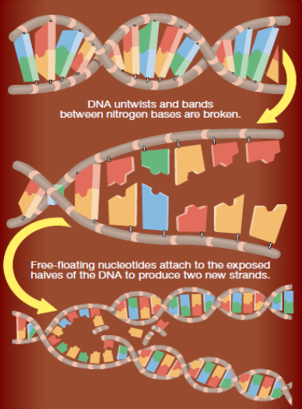

DNA replication:
- Before an organism can grow, the DNA must be copied (remember what happened in MITOSIS???)
  - DNA untwists
  - DNA unzips
  - Free floating nucleotides attach to exposed bases
  - Two resulting DNA molecules coil back up

DNA REPLICATION ACTIVITY and VIDEO….

The Genetic Code:
- The arrangement of nitrogen bases in your DNA determines the proteins that will be produced in your man.
Protein Synthesis:
- DNA is a set of instructions directing your body
- Your genes (located on chromosomes) are specific segments of DNA that code for specific proteins and determine your traits.
- Proteins are chain-like molecules made of smaller units called amino acids (if the protein is the product created from the recipe, the amino acids are like the separate ingredients)
- You cell reads the nitrogen bases in groups of three, called DNA triplet codes.
  - Each group of three nitrogen bases codes for a specific amino acid (these can be found in your data booklets)
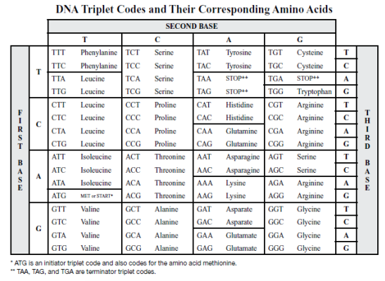
- There are combinations that identify the ______________ and the __________ of a gene
EXAMPLES: What are the amino acids for the following code of DNA?
ATGCAYGCATTATAA
PRACTICE QUESTIONS: Page 114, #33-34
PRACTICE QUESTIONS: Page 115, #1

Section 2.4 – Mutations and Genetic Diseases
Mutations:
- Mutations are like _____________________________ in a word-processing document
- A __________________ in the base sequence of DNA that can be passed onto offspring
  - Most are just a small change in DNA
  - They may occur ___________________ (spontaneously), or be induced by _____________________________________ such as X-rays, UV rays, chemicals...
- Mutations provide variations in a population that may lead to ________________________________. This means they may drive the evolutionary process.
- Some mutations occur in portions of DNA that don't code for proteins.
  - Cells may correct minor mutations.
  - Some mutations may be ______________________________ (they cause a gene to stop working or to work differently
Types of Mutations:
- ______________________________________________________________________
  - One nitrogen base (nucleotide) is substituted for another during DNA replication
    - CGTATCGAC (Original Strand)
    - CGTAACGAC (Replicated Strand)
  - Only one triplet is affected. This changes the structure and possibly the functioning of the protein

- ______________________________________________________________________
  - Deletion of a nitrogen base
    - CGTATCGAC (original strand)
    - CGTTCGAC (Replicated strand)
  - All of the triplets following the deletion will be altered.

- _______________________________________________________________________
  - A nitrogen base is added to the DNA sequence
    - CGTATCGAC (original Strand)
    - CGTAATCGAC (replicated strand)
  - All of the triplets following the addition are affected
FACTS:
- If a mutation occurs in only a few ____________________________ (body) cells, the cell will likely die and have little effect on the organism.
- If the mutation occurs in the ______________________________ (egg or sperm), it can pass onto offspring, resulting in a genetic disease.
  - ________________________________________ is an example
    - The mutated gene ends up in EVERY cell in the body of the offspring.

Passing on Mutations
- _______________________________________ – when a mutation is capable of being passed between generations and it results in an illness.

- ______________________________________ – an individual that possess a copy of the mutated gene but does not show symptoms of the disease.
Patterns of Genetic Inheritance
- __________________________________________________________________
  - When the gene is a dominant gene.
  - You only need one copy of the gene to get the disease.
  - Autosomal means it is not found on a sex chromosome
    - An example is _____________________________________________

- ___________________________________________________________________
  - When the gene is a recessive gene.
  - You need to have two copies of the gene to have the disease
    - An example is __________________________________________________

- _________________________________________________________________
  - When the gene is a recessive gene
  - It is found on the X chromosome
  - This means that females need two copies of the gene to get the disease but males only need one.
    - An example is ________________________________________________
Beautiful Chart to summarize on page 120!

Factors that increase mutations
- ____________________________________________ – any environmental influence that increases the chance of a mutation

- _____________________________________________- a mutagen that causes cells to divide uncontrollably and is known to cause cancer.

Practice Questions: Page 121, questions 38-40

Tracing Genetic Disease: Pedigree Chart
- ______________________________________________ – A genetic family tree that uses specific symbols to show the genealogy and occurrence of a particular trait
  - Pedigree’s can be used to predict the ________________________________________ of an individual
SYMBOLS:
- _________________________________ – Female
- _________________________________ – Male
- _________________________________ – Affected individual
- _________________________________ – not affected
- ________________________________________________ – mated

Examples:
- Autosomal Recessive
  - Remember, this means that the affected person must have TWO recessive genes to get the disease (cystic fibrosis)
    - A = non-infected
    - a = infected

I

II

III

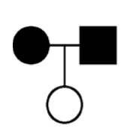
- Is it possible for the pedigree below is for a recessive trait, write the genotype of each individual next to the symbol.

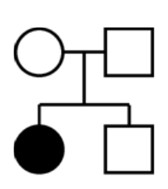
- Is it possible that this pedigree is for an autosomal recessive trait?

- Autosomal Dominant
  - Remember, Autosomal Dominant means you only need a DOMINANT trait to be affected by the disease.
    - Example: Huntington Disease (see page 124 to draw)

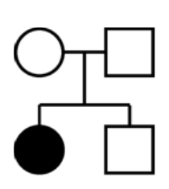
- Look at the following example: is it possible for the pedigree to be for an autosomal dominant trait?

- Is it possible for the pedigree to be for an autosomal dominant trait?
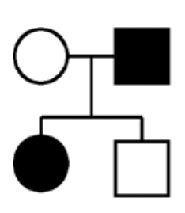

X-Linked Recessive

The conclusions that you made for autosomal recessive traits apply to X-linked traits. In this exercise, we will work on some additional conclusions because males have only one X chromosome and females have two.

We will determine if the pedigrees below can be for a trait that is X-linked recessive. Use the following designations:
X^{A} = normal
Xª = the trait (a genetic disease or abnormality)
Y = Y chromosome (males only)

- Write the genotype of each individual next to the symbol.
- Is it possible that the pedigree is for an X-linked recessive trait?
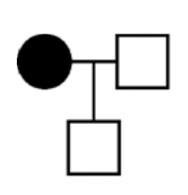

- Write the genotype of each individual next to the symbol
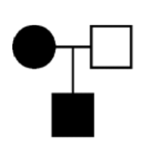
- Is it possible that the pedigree is for an X-linked recessive trait?

Practice Problems: Page 124, Questions 42 and 43

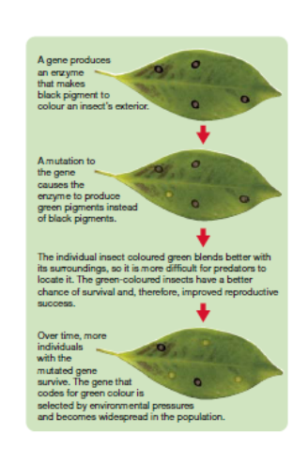

Beneficial Mutations Affect Populations:
- Mutations introduce new alleles into a population
- If the new allele gives to organism a survival advantage, it will become more common in the population.
  - This will eventually change the characteristics of the population – __________________________________
__________________________________

Resistance in Bacteria
- Bacteria that have a mutation that gives them resistance to an antibiotic will be the bacteria to survive and reproduce.
  - __________________________________
__________________________________

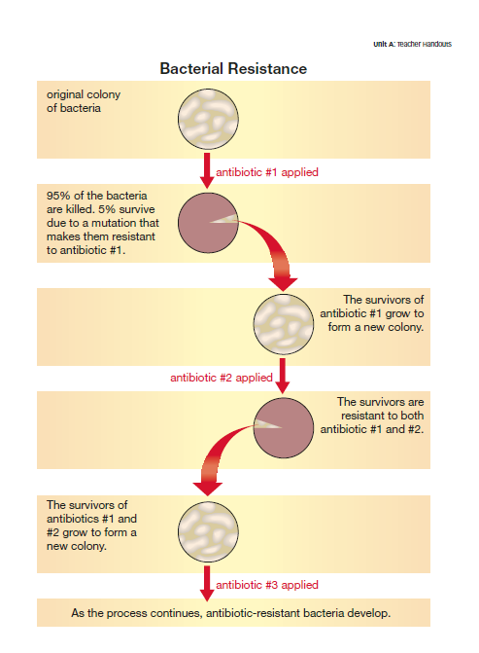
Practice Problems: Page 128, questions 1-5

Section 2.5 – Genetic Technologies
DNA Fingerprinting and Profiling
- Steps in the DNA fingerprinting process:
  - Samples of DNA are collected from a crime scene
  - Add ______________________________________ to cut up the DNA
  - DNA cuts are added to a special __________________ to create a pattern
  - Radioactive substances are added and are used to develop the fingerprints.
Example: Who are the parents?
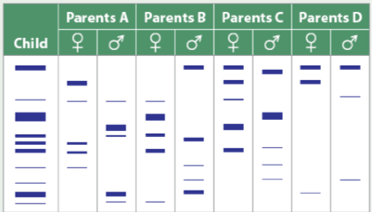
Transgenics:
- _______________________________________________ a type of genetic modification in which the gene from one species are transferred into the DNA of another species
- __________________________________________________________: the modification of genetic material through actions of people (selective breeding and modern techniques outside the normal way of reproduction)
We use transgenics and genetic engineering to create ________________________________________________________________ (GMO)
Examples:
- We are inserting some human genes into pigs in order to make the organs in pigs more compatible with human organs so we can potentially use them for transplants
Questions for review: Pages 142-149

