Unit B: Chemistry and the Environment

Chapter 1: Acid Deposition
Topics 1.1-1.5
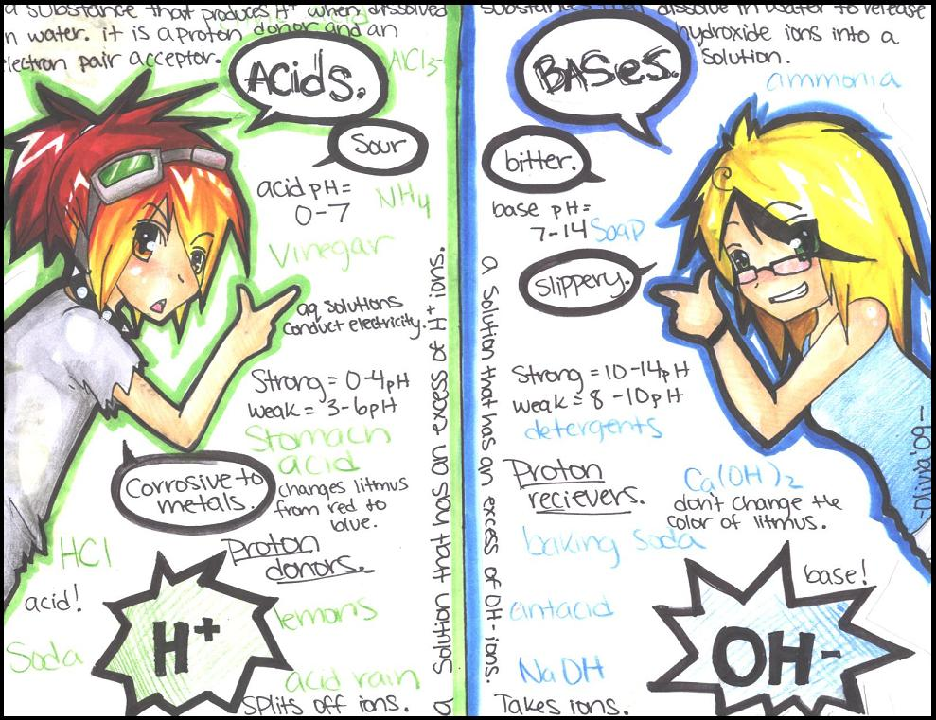
Assessment:
QUIZZES : 1.1-1.2 (S), 1.3-1.5 (F), Chapter 1 (S)
LABS: Cellular respiration (F), Testing Aqueous Solutions (S), Titrations (S)
ACTIVITY: Taking a stand (F)
Name: ____________________________________
Date: _____________________________________
Naming Compounds Review
Ionic, Multivalent, Polyatomic and Molecular

Univalent Binary Compounds # 1

 |  |  | Name |  | Formula
a) silver and iodine |  |  | silver iodide |  | AgI_{(s)}
b) magnesium and oxygen
c) magnesium and bromine
d) calcium and nitrogen
e) zinc and selenium
f) sodium and sulfur
g) barium and phosphorus
h) aluminium and fluorine
i) potassium and chlorine
j) silver and oxygen
a) MgCI_{2(s)}
b) Ag₃N_{(s)}
c) CsF_{(s)}
d) CdO_{(s)}
e) MgBr_{2(s)}
f) Al₂O_{3(s)}
g) NaI_{(s)}
h) K₂S_{(s)}
i) BaS_{(s)}

Multivalent Binary Ionic Compounds 1
Name | Formula
nickel (II) iodide
lead (II) nitride
tin (IV) oxide
antimony (III) chloride
copper (II) oxide

Formula | Metal Ion Charge | Nonmetal Ion Charge | Name
NiCl_{3(s)}
MnO _{(s)}
Cr₂O_{3(s)}
CuCl_{2(s)}
PbO_{2(s)}

Multivalent Binary Ionic Compounds #2

 | Name |  | Formula
a) iron and sulfur | iron(III) sulfide |  | Fe₂S_{3(s)}
b) copper and oxygen
c) manganese and fluorine
d) gold and nitrogen
e) chromium and chlorine
f) platinum and phosphorus
g) nickel and oxygen
h) cobalt and bromine
i) tungsten and iodine
j) manganese and sulfur
Polyatomic Ions Practice 1
Name | Positive Ion Charge | Negative Ion Charge | Formula
sodium chlorate
aluminum sulfate
copper (II) nitrate
lithium hydroxide
magnesium nitrate

COMBINE | IONS (optional) | FORMULA | NAME
iron(II) & nitrate | Fe²⁺ NO₃⁻ | Fe(NO₃)_{2(s)} | iron(II) nitrate
aluminium & nitrate | Al³⁺ NO₃⁻ | Al(NO₃)_{3(s)} | aluminium nitrate
sodium & sulfate
lead(IV) & sulfate
magnesium & carbonate
gold(III) & sulfite
zinc & hydrogencarbonate
ammonium & nitrate
copper(I) & phosphate
silver & hydroxide
aluminium & hydroxide
lead(II) & phosphate
potassium & acetate
manganese(IV) & sulfate

All Ionic Compounds Review
A. Write the formula for each compound.
1) calcium acetate
2) potassium chloride
3) ammonium carbonate
4) sodium nitride
5) titanium(IV) hypochlorite
6) iron(III) sulfide
7) zinc dichromate
8) platinum(IV) oxide
9) aluminium hydroxide
10) mercury(II) nitrate
11) strontium fluoride
12) tin(IV) hydrogenoxalate
13) calcium peroxide
14) gold(I) sulfate
15) lead(IV) thiocyanate
16) nickel(III) sulfide

Molecular Compounds Practice 2

1) BrCl₃
2) BN
3) N₂O₃
4) NI₃
5) SF₆
6) XeF₄
7) PCl₃
8) CH₄
9) PCl₅
10) P₂O₅
11) S₂Cl₂
12) ICl₂

1) chlorine monoxide
2) sulfur hexachloride
3) dinitrogen monoxide
4) nitrogen trifluoride
5) sulfur tetrachloride
6) xenon trioxide
7) carbon dioxide
8) boron trichloride
9) diphosphorus pentoxide
10) phosphorus trichloride
11) sulfur dioxide
12) bromine pentafluoride
Ionic and Molecular Compounds Review

Complete the following: (Remember that the first element of an ionic compound is metallic and the first element of a molecular compound is nonmetallic!)

I or M Formula Name

1. ozone
2. Fe₂O₃
3. gold (I) oxide
4. V₂O₅
5. methane
6. CO
7. sucrose
8. NiI₂
9. aluminum fluoride
10. Al₂O₃
11. tetraphosphorous decaoxide
12. CCl₄
13. iron (II) oxide
14. PtF₄
15. ammonium sulphate
16. K₂CO₃
17. dinitrogen tetraoxide
18. H₂O₂
19. sodium thiosulphate
20. SO₃
21. potassium dichromate
22. P₂O₃
23. sodium nitrite
24. C₆H₁₂O₆
25. calcium hydrogen carbonate

Topic 1.1 – Products of Combustion Reactions
Working as a team in a local dogsled race, Kayla and her dogs challenge the cold and their physical limits. They are all working and breathing hard. With each breather Kayla and her dogs take, they must exhale the products of Cellular Respiration - a process that converts the chemical potential energy within food into a form the body’s muscles can use.

Cellular Respiration – the process by which cells convert the chemical energy stored in organic molecules (sugars) into energy that cells can use.
- Reactants: Glucose (C₆H₁₂O₆) + O₂(g)
- Products: CO₂(g) + H₂O(g) + ATP (energy)

Combustion Reactions:

- _______________________________________________:
  - Requires: Fuel and Oxygen
  - Releases: Energy

- ______________________________________________:
  - Reactants: hydrocarbon (ethane, propane, methane, etc.)
    - __________________________________ are organic compounds that contain _______________________ and _________________________ atoms)
  - Products: CO₂(g) + H₂O(g) (possibly others, depending on impurities found in the reactant)

- ________________________________________________________
  - Complete combustion occurs when there is sufficient enough oxygen O₂(g)

- ________________________________________________________
  - Incomplete combustion occurs when there is a lack of O₂(g)
  - Produces CO (Carbon Monoxide) along with CO₂ (Carbon Dioxide)

- ____________________________________, like any chemical reaction, involves collisions between the molecules of the reactants.
  - This results in the formation of __________________________________________ (products).
Example:
Because we have a hydrocarbon (methane) and it produces carbon dioxide (NOT carbon monoxide), we know this is ______________________________________________________________
CH₄(g) + O₂(g) CO₂(g) + H₂O(g)

Carbon Dioxide
Methane (hydrocarbon)

Emissions and Combustion
- During most combustion reactions, the oxides produced are released into the atmosphere.
  - These are called _______________________________________
    - Emissions include
      - a) oxides of ______________________________
      - b) oxides of ______________________________
      - c) oxides of ______________________________
Oxides of Carbon

1. Carbon Dioxide:
Carbon dioxide can enter our atmosphere through ______________________ and ______________________.
COMBUSTION:
- Burning carbon compounds (like wood and other forms of _____________________ plant matter/agricultural waste or hydrocarbon molecules) creates ___________________________
NATURAL SOURCES:
- Cellular Respiration, forest fires, volcanic eruptions and weather of some rocks releases carbon dioxide into the atmosphere naturally. (CARBON CYCLE)
Problem with a buildup of carbon dioxide in the atmosphere
- CO₂ is a greenhouse gas (it holds in thermal energy. An increase in CO₂ increases thermal energy retention, which increases overall atmospheric temperatures)
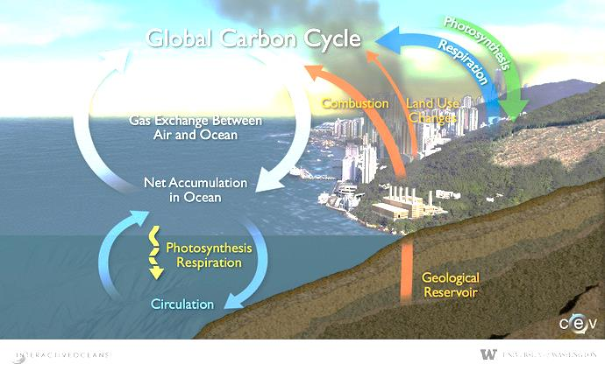
2. Carbon Monoxide
- Carbon Monoxide is produced during combustion with limited O₂(g) (incomplete combustion)
- Where does carbon monoxide come from?
  - ________________________________________ (eg. Car engines)
- Problems with carbon monoxide?
  - bonds to hemoglobin, preventing O₂ from bonding, preventing O₂(g) from reaching body tissues, resulting in cell death
QUESTION:
A. Refer to the diagram of the carbon cycle on page 157. Explain how the increased use of combustion processes by society and deforestation could result in a higher level of atmospheric carbon dioxide, a level that cannot be removed by natural mechanisms.
____________________________________________________________________________________________________________________________________________________________________________________________________________________________________________________________________________________________________________________________________________________________________________________________________________________________________________________________________________________________________________________________________________________________
Oxides of Sulfur

Natural resources:
- Sulfur is an element that is found in small quantities within many _____________________________.
  - Examples:
    - Coal (in Alberta) has low sulfur but in Eastern Canada, Coal has a higher sulfur content
    - Crude oil and oil sands also have sulfur
    - Natural Gas has sulfur in the form of H₂S (sour gas toxic to humans!)
      - ________________ – natural gas that contains greater than 1% hydrogen sulfide
        - ______________________ when processed and sent to your home, removes the hydrogen sulfide through a process called _____________________________. (YOU GET RID OF THE SOUR AND MAKE IT SWEET)
        - 40% of the natural gas reserves in Alberta are SOUR! We have a lot of sweetening to do!
Sulfur dioxide (SO₂) and Sulfur trioxide (SO₃)
- Low quality natural gas is ____________________ this process converts that H₂S (Sour Gas) to SO₂ and SO₃
  - How the flaring process works:
    - Sour gas is mixed with water to produce either sulfur dioxide or sulfur trioxide.
Oxides of Nitrogen

- Earth’s atmosphere is __________________________________ (N_{2(g)} – a normally unreactive gas)
- High temperatures of combustion cause nitrogen to react, producing NO_{(g)} (Nitrogen monoxide) and NO_{2(g)} (nitrogen dioxide)
  - Oxides of nitrogen are commonly referred to as ____________________________________
  - NO_{x} emission levels tend to change depending on:
    - _______________________________ (they are higher near urban areas)
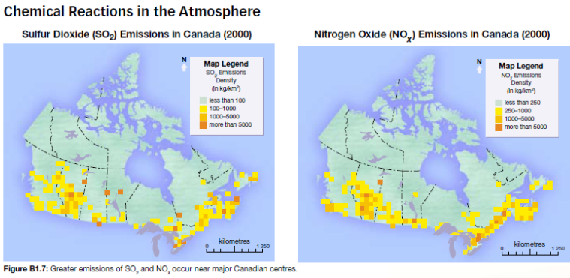
    - __________________________________ (temperature)

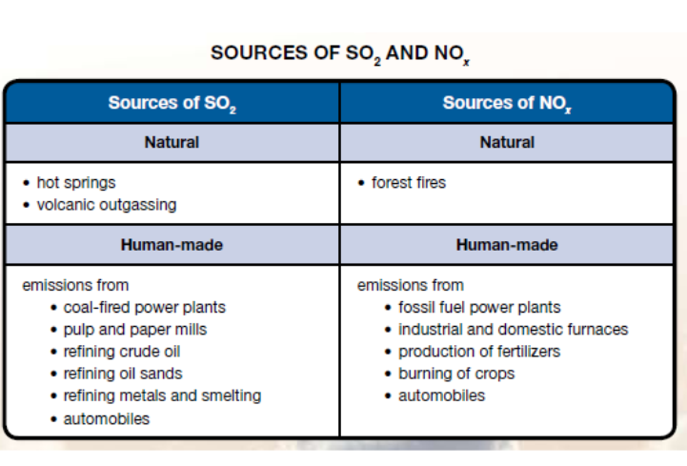
Practice Questions: Page 160, #7 and 8

Issues with Combustion:
- _______________________________________ can be present in combustion emissions
  - Example: Coal contains trace amounts of both ______________________________________
    - THESE POISON YOU!
- ____________________________________________ (small solids suspended in the atmosphere)
  - Soot, smoke, ash (from industry and forest fires), soil particles, pollen…
    - These things contribute to asthma and other lung diseases.
Balancing Chemical Formulas
- All chemical reactions must begin and end with the same atoms, in the same proportions
- Recall from earlier science courses, this requires you to balance all chemical equations
Examples:
- ______ C₂H_{6(g)} + _______ O_{2(g)} ______ CO_{2(g)} + ________ H₂O_{(g)}

- ______ CH_{4(g)} + _______ O_{2(g)} ______ CO_{2(g)} + ________ H₂O_{(g)}

- ______ C₅H_{12(g)} + _______ O_{2(g)} ______ CO_{2(g)} + ________ H₂O_{(g)}

- ______ C₄H_{8(g)} + _______ O_{2(g)} ______ CO_{2(g)} + ________ H₂O_{(g)}

- ______ C₄H_{10(g)} + _______ O_{2(g)} ______ CO_{2(g)} + ________ H₂O_{(g)}

- Combustion of Octane, C₈H_{18(g)}
Topic 1.1 Summary

Combustion processes, both complete and incomplete, involve a reaction with oxygen that results in the formation of oxide compounds. Some of the oxides produced include carbon dioxide, carbon monoxide, sulfur dioxide and NO_{x} compounds. Other emissions that can result from combustion processes include heavy metals and particulate matter.

Because emissions react with elements in the atmosphere that may affect humans and other organisms, monitoring programs have been implemented to measure emissions from combustion processes. These programs provide information that can be used to address issues regarding the quality of the environment.

Questions for Review: Page 164, # 1-8

INVESTIGATION: Comparing the Effects of the Products of Cellular Respiration
Background Info: Cells use molecules within food as an energy source. Cellular respiration is a process similar to the combustion of hydrocarbons in that oxygen is required, carbon dioxide and water are produced, and energy is released.
Purpose: Look at the effects of the products of cellular respiration.
Materials:
- 125-mL Erlenmeyer Flask
- 75-mL of distilled water
- Bromothymol Blue Indicator
- 100-mL graduated cylinder
- Drinking straw
- Eye dropper
- Stop watch
Procedure:
- Use the graduated cylinder to measure 75-mL of distilled water; then transfer the water to the Erlenmeyer Flask.
- Add four drops of bromothymol blue to the distilled water. Note the color of the mixture.
- Insert the drinking straw into the mixture in the flask, and exhale through the straw until the color of the indicator changes to yellow. Record the time taken for the indicator to change color.
Observations:
Color of Indicator before exhaling | Time taken for indicator to turn yellow

Analysis:
- Explain the significance of the color change

- Identify the reason for the mixture to change color. HINT: see ``acid and base indicators`` table on page 184.

- Write the balanced chemical equation for the cellular respiration of glucose C₆H₁₂O₆(aq).

- Hypothesize the effect that carbon dioxide released by many processes could have on water within the biosphere.

ACTIVITY: Taking a stand – Emissions Testing
Albertans have a high dependence on the cars and trucks they drive for pleasure or for work. In addition, Albertans enjoy their recreations vehicles (ie: motorcycles, quads, boats and snowmobiles). Albertans also place a high priority on their health and the health of the diverse habitants that exist throughout the province. As you know, pollution from vehicles affects both society and the environment. Is it time to place standards on the emissions from vehicles? Currently, three Canadian provinces – British Columbia, Ontario and New Brunswick – have emission-testing programs for vehicles. Should Alberta be next?
Purpose:
You will debate the following question: Should Alberta have an emission-testing program for vehicles similar to those used in BC, ON and NB?
Background Information:
Before you begin, use the Internet to answer the following questions:
- Why is emission testing required in some provinces and not in others? In provinces that have emissions-testing programs, are all vehicles tested in all regions of the province?

- Identify the reason for initiating emissions-testing programs in these provinces.

- List the items being tested for during an emissions test.

- What do emissions tests cost consumers in the province with testing programs?

Procedure:
- Prepare a position statement that clearly defines whether you support or do not support mandatory emissions testing of all vehicles in Alberta. When developing your position statement, review the list of perspectives listed on page 590 in the text. Use this list to help justify your position.

- Prepare a rebuttal – a second statement that responds to a criticism of your position. When preparing your rebuttal, imagine you are the opponent in the debate. What part of your position statement would your opponent most likely challenge? Would it be the credibility of the information you present or the conclusions you make? Your rebuttal is your opportunity to develop a plan to further defend your position.

Topic 1.2 – Chemistry of Acids and Bases
Types of Solutions:
- There are four types of solutions we will investigate:
  - A. Neutral Ionic
  - B. Neutral Molecular
  - C. Acidic
  - D. Basic
Neutral Ionic:
- An ionic compound (__________________________________________________________________) that is not acidic or basic
- Litmus paper will not change color as it is NEUTRAL.
Neutral Molecular:
- A molecular compound (____________________________________________________) that is not acidic or basic
- Litmus paper will not change color as it is NEUTRAL.
Acidic:
- Electrolytic (conducts electricity)
- Corrosive
- Turns __________________________ litmus paper ___________________________
- Reacts with active metals (Mg, Zn, and Fe) to produce hydrogen gas
- Tastes _______________________________
- Can be neutralized by bases
- pH less than 7
Basic:
- Electrolytic (conducts electricity)
- Corrosive
- Turns ________________________ litmus _________________________
- Feels __________________________
- Tastes ________________________
- Neutralized by acids
- pH greater than 7

Investigation: Testing Aqueous Solutions
Problem: You will design and perform an experiment to identify acidic, basic, neutral molecular and neutral ionic solutions.
Materials:
0.100-mol/L solutions of:  - HCL(aq)  - HNO₃(aq)  - NaOH(aq)  - Na₂CO₃(aq)  - Na₂SO₄(aq)  - NaCl(aq) | - distilled water  - multiwall dish  - Blue and red litmus  - magnesium turnings  - Stirring rod  - forceps  - conductivity meter

Procedure:

Create a step by step procedure that considers the following: safety, manipulation of apparatus and cleanup.

Observations: (you probably want to create some sort of chart here)

Analysis: (copy these questions down on your lab sheet) you may need to look up the meanings of the underlined words in order to do your analysis.
- Identify the positive and negative controls in the investigation.
- Identify actions taken during the investigation that improved the quality of the data collected
- Describe how the data collected during the investigation demonstrates reliability.
- Describe how the tests completed during the investigation addresses validity.

Testing Aqueous Solutions
/10
Procedure: /3

- Procedures are listed in clear steps; each step is numbered and in a complete sentence; the experiment could be easily replicated based on the procedures provided (3 marks)

- Procedures are listed, but seem to be missing some information that would
allow one to successfully replicate the experiment; some steps are not numbered and/or are in incomplete sentences (2 marks)

- Procedures do not accurately list the steps of the experiment (1 mark)

Observations: /3

- Professional looking and accurate representation of the data in tables, graphs, or written form; graphs and tables are appropriately labeled and titled. (3 marks)
- Accurate representation of the data in all possible forms
(written, graphs, tables); graphs or tables are not appropriately labeled and titled; “something is missing” (2 marks)

- Data are inaccurate; “a lot is missing” (1 mark)

Analysis: /4

- Questions are all correctly answered; answers are detailed. (4 marks)

- 1 or 2 of the questions are not correctly answered. (3 marks)

- Most questions were not answered; or not answered in full sentences (2 mark)

Comments:
________________________________________________________________________________________________________________________________________________________________________________________________________________________________________________________________________________________________________________________________________________________________________________________________________

A chart to summarize:
Solution | Definition | Empirical Properties | Examples
Acidic
Basic
Neutral

Some vocabulary: Use page 169 to help you with these words if you are unfamiliar with them
Solute:
______________________________________________________________________________________________________________________________________________________________________________________________________________________________________________________________________________
Electrolytic Solution:
______________________________________________________________________________________________________________________________________________________________________________________________________________________________________________________________________________
Ionic Compound:
______________________________________________________________________________________________________________________________________________________________________________________________________________________________________________________________________________
Molecular Compound:
______________________________________________________________________________________________________________________________________________________________________________________________________________________________________________________________________________

Acid Naming Rules:

Arrhenius’ Theory of Acids and Bases

Arrhenius and Acids
- Arrhenius said that acids form aqueous solutions that contain ______________________________, H⁺(aq) and a _____________________________________
  - Examples:

Arrhenius and Bases
- Arrhenius said that bases for aqueous solution that contain _________________________________, OH⁻(aq) and a _______________________________________.
  - Examples:

Arrhenius and Neutral Substances:
- Solutions that do not have hydrogen or hydroxide ions are called neutral
  - Example:
    - CaCl₂(aq) Ca²⁺(aq)+ 2Cl⁻(aq)
Practice Problems: Page 171, #12-13

Limitations to Arrhenius’ Theory

- There are some compounds that have basic properties but do NOT have an OH⁻ ion.
  - Examples:
    - Ammonia – NH₃(aq)
    - Sodium Carbonate – Na₂CO₃(aq)
    - Aluminum Chloride – AlCl₃(aq)

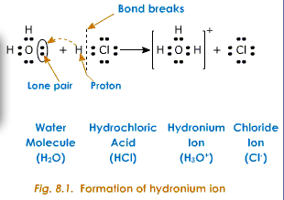
- This theory has H⁺(aq) existing all alone but this cannot happen
  - Hydrogen ions have a very strong positive charge that causes it to combine with a water molecule to form the ___________________________________ H₃O(aq). This is what we believe now causes something to be acidic.
  - This really doesn’t change our definition of an acid because we still needed to have the H⁺ in the first place
BrØnsted-Lowry Theory of Acids and Bases

- These two characters (Bronsted and Lowry) didn’t like that Arrhenius’ theory had limitations. THEY WANTED TO UNDERSTAND THE REASON BEHIND THE LIMITATIONS….
Let’s start with some vocabulary:
- ___________________________: substance that donates/loses a hydrogen ion

- ____________________________: substance that accepts/gains a hydrogen ion
- ____________________________: acid formed when a base accepts a hydrogen ion

- _____________________________: base formed when an acid loses a hydrogen ion

Example:
Loses Hydrogen ion H⁺
HF(aq) + OH⁻(aq) F⁻(aq) + H₂O(l)

__________________________________
Acid
Base
_________________________________

- According to this theory, during acid base reactions, a hydrogen ion is transferred from the acid to a base.
  - The Loss of the H⁺ converts the acid into a __________________________________
  - The gain of the H⁺ converts the base into a __________________________________
Relative strength of selected acids and bases (Page 12 of data booklet)
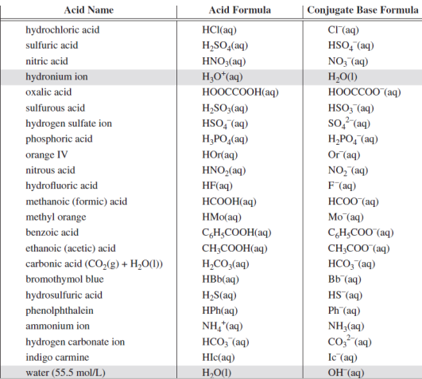
Using the table:
Examples:
- Sour gas contains hydrogen sulfide (H₂S(g)). Hydrogen sulfide can dissolve and react with water in the atmosphere. Write the chemical equation of the reaction between aqueous hydrogen sulfide and water.
  - Step 1: Locate H₂S(g) and H₂O(l) on the table of acids and bases
  - Step 2: You want the STRONGEST ACID (the one that appears higher on the table) so we now know that H₂S(g) is the acid and H₂O(l) is the base.
  - Step 3: Write the reactant side of the chemical equation.

  - Step 4: Identify the conjugate forms of the acid and the base
  - Step 5: Write the conjugate forms on the products side of the chemical equation

- Hydrofluoric acid (HF(aq)) can be neutralized by a reaction with the hydroxide ion OH⁻(aq) of aqueous sodium hydroxide. Write the chemical equation for this neutralization reaction.

- Arrhenius’ theory could not explain bases like sodium carbonate. Bronsted-Lowry can…. Write the chemical equation for the carbonate ion CO₃²⁻(aq) and water.

Practice Problems: Page 175, #14 and Page 176, #15-17

Emissions can react!
- Emissions from combustion reactions _____________________________________________
- Most of these emissions are _______________________________ (coming from human activity)
- Rain is naturally acidic because of CO₂, that is naturally in the atmosphere.
- ___________________________ occurs when precipitation has lower than normal pH
- The following table shows various oxides we have discussed react with water to form acids.
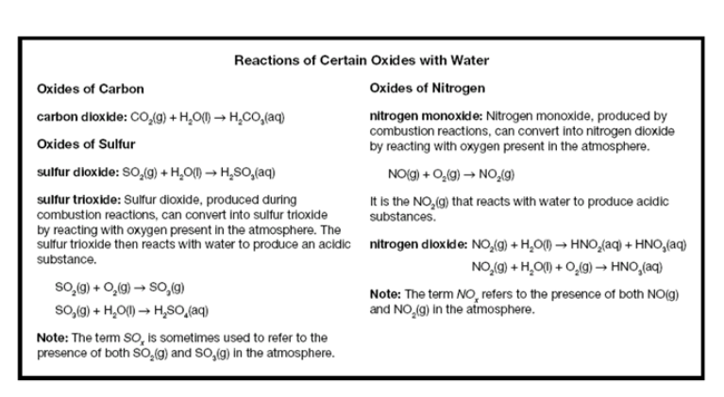Practice Problems: Page 178, #18-20

pH
- A value that represents the concentration of dissolved hydronium ions (H₃O⁺) in a solution
- Concentrated acidic solutions contain a ________________________________________________ of solution than dilute acidic solutions.
- The concentration of H₃O⁺ influences reactions involving acids in the following ways:
  - How quickly the solution will begin to react
  - How much change the acid may cause
  - Amount of base required to neutralize the acid
  - Amount of base of metal it will react with
- pH scale was developed in 1090 as a means to communicate the acidity of a solution.
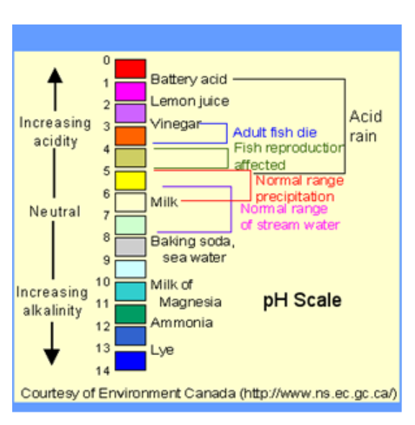

- pH is _________________________________________ – this means a change in pH of 1 is equal to a 10X change in H₃O⁺ concentration.
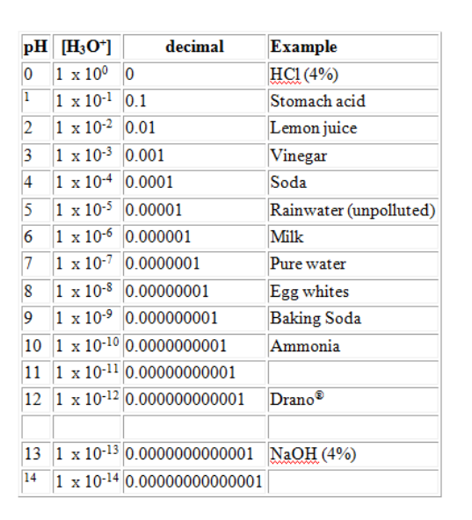
Calculating pH from H₃O⁺ concentration:
pH = -log₁₀[H₃O⁺]
A sample of lake water has a hydronium ion concentration of 2.27 x 10⁻⁷ mol/L. Determine the pH of the lake.

Calculating H₃O⁺ concentration from pH
[H₃O⁺] = 10^{(-pH)}

Calculate the H₃O⁺(aq) concentration in a shampoo with a pH of 5.72.

Practice Problems: Page 183, # 22 and 23

Indicators
- substance that _____________________________________________________ of a solution
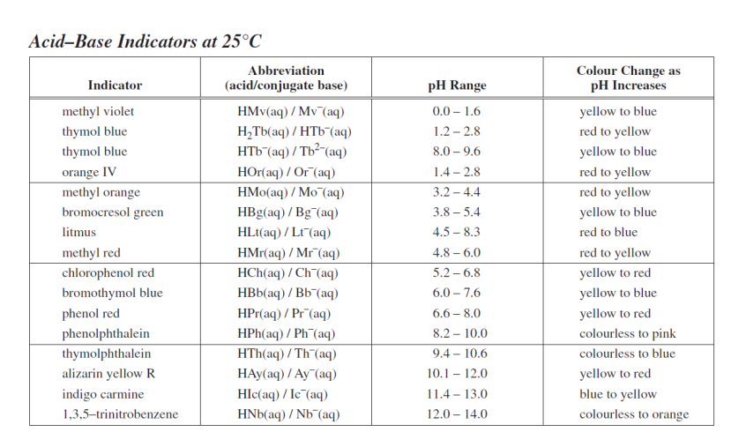

Using indicators to determine pH
- Use the ____________________________________________ to determine the pH range
- Use a ___________________________________________ to narrow down the range of values

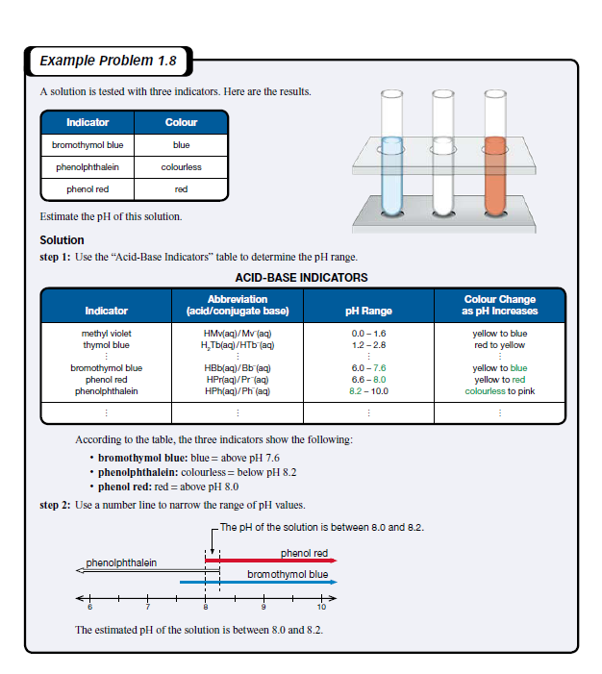
Example:
- What would the pH of a solution be that is: colorless in phenolphthalein, yellow in phenol red, orange in chlorophenol red and blue in indigo carmine.

Practice Problems: page 186, #25-28 and Page 187, #1-5 and 9-11

Topic 1.3 – Impact of Acid Deposition on Ecosystems
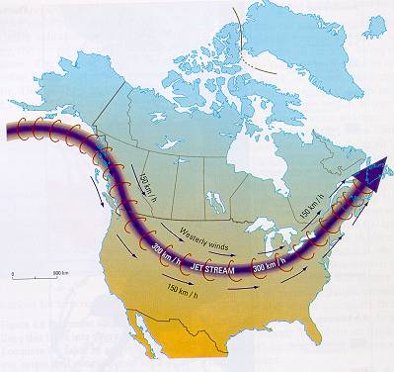
- There are many things that contribute to the production of acid deposition and where that acid will fall.

      - WIND PATTERNS – Jet Steam and Acid Deposition
        - Acid deposition can be transported through wind patterns like ___________________________
        - The predictability of wind patterns provides a way to trace the path of acid deposition back to its source.

      - Effects of Acid Deposition on the Environment and the Ecosystem
        - In Alberta, many lakes are ___________________________________. This is because the bedrock that the lakes sit on is limestone. Limestone contains calcium carbonate and magnesium carbonate.
        - The carbonate ions ______________________________________ and enter the water
        - Much of the soil in Alberta also contains little crystals of calcium carbonate.
        - The carbonate ion can act like a base to __________________________ acidic deposition.

***NOTE: Only a small percentage of soils in Canada have a high potential for neutralizing acid deposition. Much of the soil within the province of Alberta has high potential because of high carbonate.

Practice Questions: Page 193: #29-35
Use the following diagrams labeled “Potential of soils and bedrock to reduce acidity” as well as the diagrams in your textbook on pages 192 and 193 to answer the questions.
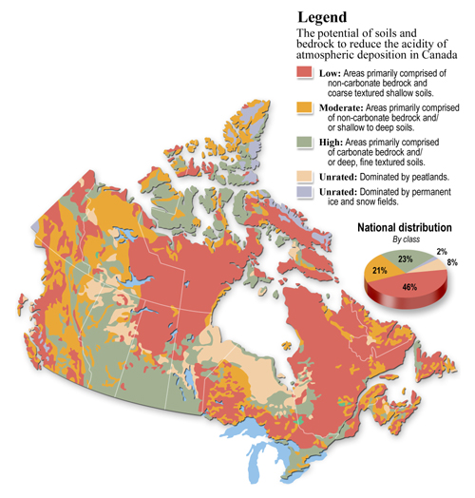

      - Buffering and Buffering Capacity
- The neutralization of acid deposition by bases, such as calcium carbonate, prevents the accumulation of hydronium ions.
    - The neutralization of acids by bases that prevents the change of the pH of soil or lake water is called ____________________________________________.
- Some areas are exposed to acid rain for longer periods of time eventually develop soil or surface water with lower pH values.
  - _________________________________________________________ is a measure of the amount of acid that can be neutralized by soil or surface water.

      - Response of plants to pH
- Different plants have different tolerances to variations in pH
Plant | Soil pH for optimal growth
Alfalfa | 6.5-7.0
Barley | 6.3-6.5
Blueberries | 4.5
Canola | 5.5-8.3
Potatoes | 5.2-8.0
Wheat | 5.5-6.5

      - Plant nutrients, metal leaching and pH
- ____________________________________________________ – a diagram that shows the movement of minerals from living to non-living component in the ecosystem.
- The availability of nutrients in the soil is affected by the soil pH.
- __________________________________________ – the removal of metal ions from the topsoil into the lower level of soil or surface water.
- Hydronium ions in the soil can react with compound in the soil and result in leaching.
- Increased concentration of ____________________________________________ in the soil affect the ecosystem in a variety of ways
  - decreasing the growth of roots
  - preventing the absorption of calcium
  - reduce the population of soil bacteria and therefore slow decomposition rates
  - causes the gills of fish to clog with mucus
- Increased concentration of mercury (II) ions in the soil results in ____________________________
  - mercury (II) ions are converted into methyl mercury by micro-organisms
  - methyl mercury is quickly absorbed by organisms
  - mercury is not needed by living organisms and can’t be excreted
  - this results in biomagnification – the tendency of a pollutant to appear in higher concentrations and higher levels in the food chain
- Other metals that can enter an ecosystem through leaching include: lead, copper, zinc, cadmium, chromium, manganese, and vanadium.

Expressing Concentrations

- There are many ways to express concentrations of a substance:
  - Hydronium ions – mol/L or pH
  - Parts per million (ppm)
  - Parts Per trillion (ppt)
    - The formula for calculating ppm is in the data booklet on page 10
      - To calculate ppm to ppb – change 10⁶ to 10⁹
      - To calculate ppm to ppt – change 10⁶ to 10¹²
Practice Questions: Page 198, #37, Page 201, # 1-5, 7-9

Section 1.4 – Quantifying Acid Deposition and Monitoring its Effects
- Significant data can be collected in 2 ways:
  - Qualitative
  - Quantitative
Use page 203 question 41 to categorize examples of data as either qualitative or quantitative
Qualitative | Quantitative

Titrations

- _________________________________________ - a technique used to determine the concentration of an unknown solution, by using the concentration of another solution of known concentration.
  - uses both quantitative and qualitative data
  - how much of the known concentration is needed to neutralize the unknown substance
  - _____________________________________________________________ (this indicates when complete neutralization has taken place)

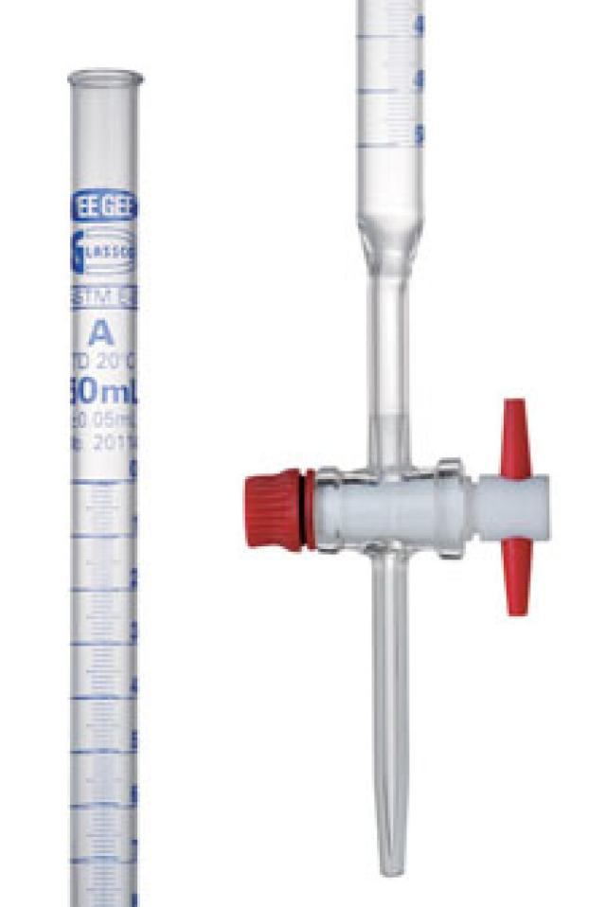
- In order to properly do a titration, you must understand all the materials needed and the steps involved.
  - Materials:
    - 50mL burette
    - Burette clamp
  - Procedure
    - 1. Attach and secure the burette clamp half-way along the ring stand
    - 2. Carefully was the burette with distilled water. Close the stopcock; then fill it one-third full with water. Tilt the burette sideways to wash the inside walls with water; then tilt the burette vertically and drain it using the stopcock.
    - 3. Place the burette into the burette clamp attached to the ring stand
    - 4. Close the stopcock, place the funnel into the upper end of the burette and add approximately 15-20 mL of the base to the burette.
    - 5. Carefully remove the burette from the clamp and tilt and wash the entire burette with the base. Return the burette to the clamp and use the waste beaker to drain the burette.
    - 6. Close the stop cock and replace the funnel in the upper end of the burette. Add your base to fill the burette so that the liquid level is within the range of 0 and 5 mL.
    - 7. Use your pipette to transfer 10.0 mL of the acid solution to the 125mL Erlenmeyer flask.
    - 8. Add 3 to 4 drops of bromothymol blue.
    - 9. Position the flask containing the acid under the burette and then open the stopcock so just a small amount comes out. 3-5 mL at a time.
    - 10. SWIRL the flask after each time you add the base to the acid.
    - 11. Once a permanent colour change has been reached, measure the position on the burette where the solution has stopped and record this.
    - 12. Transfer the contents of the flask to the waste beaker and repeat steps 6-12 for two more trials.

Formula for molar concentration

$$C= \frac{n}{V}$$

C = molar concentration (mol/L)

n = number of moles of dissolved substance (mol)

V = total volume of solution (L)

C_{acid}V_{acid} = C_{base}V_{base}
****IF YOUR VOLUME IS IN mL, CONVERT TO L!!
Examples:
What volume of 0.300M (mol/L) HNO₃ will be required to react with 24 ml of 0.250mol/L KOH?

30 mL of 0.10M NaOH neutralised 25.0mL of hydrochloric acid. Determine the concentration of the acid.

Use the following information to calculate the hydronium-ion concentration in a sample of lake water titrated using a standardized solution of sodium hydroxide.
Concentration of hydroxide ions: 0.000125 mol/L
Initial burette reading: 2.25 mL
Final burette reading: 12.13 mL
Volume of lake water in titration: 10 mL

Practice Problems: Page 211, # 42-44

Strong and weak acids and bases
- Two solutions can have identical molar concentrations, but have different pH.
  - This means that they have different abilities to form H₃O⁺(aq)
- Strength of an acid or base is determined only by the extent to which an acid or base will react with water to produce H₃O⁺(aq) or OH⁻(aq)
- The strength of an acid (or base) can be determined by its position on the "Table of Acids and Bases" (Page 12 of data booklet or page 214 in textbook)
Titrations with Strong and Weak Acids and Bases
- When designing titrations, it is best to titrate an acid using a strong base (or to titrate a base using a strong acid)
Practice problems: Page 215, #45 and 48

Example Problems:
A 25.00mL sample of methanoic acid, HCOOH(aq) was titrated with a standard solution of 0.250-mol/L sodium hydroxide, NaOH(aq). If 17.5 mL of sodium hydroxide was required to react with the methanoic acid, calculate the initial concentration of the acid solution.

Calculate the volume of a 0.150-mol/L solution containing hydrogen carbonate ions required to react with the hydronium ions present in 75.5 mL of a 0.200-mol/L hydrobromic acid solution.

Practice Problems, Page 217, # 49 – 51

Performing a Titration

Purpose: To perform a titration to determine the concentration of H₃O⁺ in an acid solution (HCl).

What to do:
- Review the titration procedure that you were given in your Section 1.4 booklet yesterday.
- Remember to read the burette carefully to ensure that you are getting accurate measurements.
- Record all data carefully in the data table provided.
- Answer the questions that follow.

Materials:
Bromothymol Blue | HCl solution | NaOH solution  (V = 10mL, C = 0.100mol/L)
Distilled Water | 250mL beaker (waste) | 50 mL beaker
125 mL Flask | 10 mL graduated cylinder | Small funnel
50mL burette | Burette clamp | Ring stand
Grease pencil

Observations: (2 marks)
Trial | Volume of Standard Solution (mL) |  |  | Endpoint colour
 | Final | Initial | Added
1
2
3

Analysis:

- Using Bronsted-Lowry, write the balanced chemical equation for this titration. Identify the acid, base, conjugate acid and conjugate base. Be sure to include states. (2 marks)
- Determine the average amount of base required to neutralize the acid.
(2 marks)
- The HCl(aq) that you used had a concentration of 0.100mol/L and a volume of 10mL. Using this information, determine the number of moles of NaOH(aq) that needed to neutralize the acid. (2 marks)

- Determine the concentration of hydronium ions present in your acid solution. (2 marks)

Name: _____________________
Titration Lab Marking Guide
/12

Procedure: /3

- Procedures are listed in clear steps; each step is numbered and in a complete sentence; the experiment could be easily replicated based on the procedures provided (3 marks)

- Procedures are listed, but seem to be missing some information that would
allow one to successfully replicate the experiment; some steps are not numbered and/or are in incomplete sentences (2 marks)

- Procedures do not accurately list the steps of the experiment (1 mark)

Observations: /3

- Professional looking and accurate representation of the data in tables, graphs, or written form; graphs and tables are appropriately labeled and titled. (3 marks)
- Accurate representation of the data in all possible forms
(written, graphs, tables); graphs or tables are not appropriately labeled and titled; “something is missing” (2 marks)

- Data are inaccurate; “a lot is missing” (1 mark)

Analysis: /3

- Questions are all correctly answered; answers are detailed, provides sufficient analysis of data, trends/patterns are logically analyzed, questions are answered in complete sentences, analysis is thoughtful (3 marks)

- 1 or 2 of the questions are not correctly answered. provides some analysis of the data, trends/patterns are logically analyzed for the most part, questions are answered in complete sentences, analysis is general and brief (2 marks)

- Most questions were not answered correctly; or not answered in full sentences, provides limited analysis of the data, trends/patterns are not analyzed, answers to questions are incomplete, analysis is inconsistent (1 mark)

Conclusion: /3

- accurate statement of the results of the lab indicates whether results support the hypothesis, draws valid conclusions based on the data, shows a strong understanding of the purpose of the lab, provides sufficient evaluation of methods used (3 marks)

- a statement of the results of the lab indicates a support of the hypothesis, incomplete analysis and reflection, demonstrates some ability to draw conclusions based on the data, conclusions misstated indicating a lack of understanding, basic understanding of the purpose of the lab, provides some evaluation of methods used (2 marks)

- no conclusion was included or shown little effort and reflection on the lab, demonstrates limited ability to draw conclusions based on data, does not understand the purpose and meaning of the lab, missing important points, provide limited evaluation of methods used (1 mark)

Comments:
________________________________________________________________________________________________________________________________________________________________________________________________________________________________________________________________________________________________________________________________________________________________________

Buffering Capacity
- Buffering refers to the ability of a substance to be exposed to an acid or a base and not experience a
_______________________________________________________________.
  - Carbonate ion (CO₃²⁻) is a common buffer in soil and in water.
Buffering in Living Organisms:
- Blood contains carbonic acid (H₂CO₃(aq)) and hydrogen carbonate (HCO₃⁻(aq)). Each of these helps to buffer excess bases or acids in the blood.
- This is important because even a change in pH of 0.5 can be fatal to most organisms.

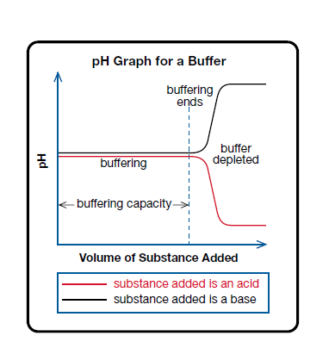
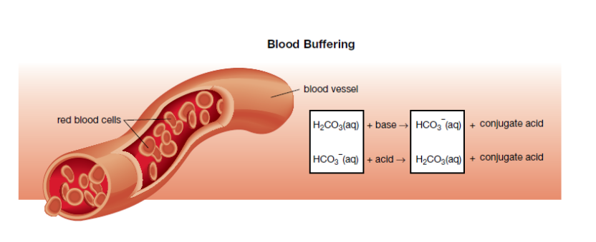
***NOTE: Buffering does not last forever...eventually all of the
buffering material will have reacted and the pH of the system will change.

Practice Problems: Page 221, #1-8

Section 1.5 – Learning from Acid Deposition
Use your textbook on page 222-235 to answer the following questions. This section is YOUR responsibility so please use your time wisely.
- Reducing Acid Depostion
1. What was the purpose of a superstack?

2. Two things that studies of lakes in Ontario have shown are:
a)

b)

- Reducing Emissions
1. Electrostatic Preciptiation
a) fly ash - What it is and why it is a concern.

b) electrostatic precipitator -
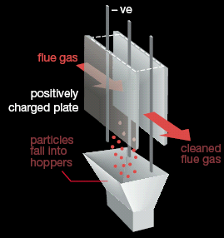

- Scrubbing Emissions –
a) scrubbing -

b) What substances are capable of scrubbing or absorbing acid-forming emissions?

c) Sketch a cross section of a scrubber.

C. NO_{X} -
1. What are the two types of nitrogen oxides?

2. catalyst –

- catalytic converter
a) definition -

b) Catalytic Converter Process - diagram

D. Photochemical Smog -
a) troposphere –

- photochemical smog –

- Reactions and descriptions
i) Reaction 1

ii) Reaction 2

iii) Reaction 3

- Volatile organic compounds (VOC’s)

E. Preventing the Production of SO₂, NO_{X}, and H₂S
1. SO₂

2. H₂S

3. NO_{X}

F. Recovering from Acid Deposition – liming

Practice Problems: Page 235, #1-7

Chapter 1 Review Question: Page 236, #1-10

